Statement of Advice Wizard User Guide
This guide outlines the process for using the Statement of Advice wizard to prepare advice for both Individual and related Non-Individual Entities within Xplan.
16/06/2025

Table of contents
Overview 2
Before using the Wizard 2
Statement of Advice Wizard 3
Document Controls page 3
Scope of Advice page 4
Goals & Objectives page 6
Strategy Recommendations page 7
Products & Services page 12
Product Replacement page 16
Xplan Content page 18
Fees & Disclosure page 19
Merge your SOA 25
Download and Open/Save the SoA 25
SoA for Non-Individual Entities 26
Combined Entity SoA 28
Non-Individual Entity Advice Only 31

Overview
The Statement of Advice (SoA) Wizard User Guide outlines how to use the SoA Advice Wizard to generate your advice in an SoA.
The SoA wizard has been designed to enable you to produce SoAs in an efficient manner with the use of smart coded strategy text based on data entered to client focus as well as scenarios modelled within the various Xplan modules.

Before using the Wizard
The SoA wizard has been designed to enable you to produce SoAs in an efficient manner with the use of smart coded strategy text based on data entered to client focus as well as scenarios modelled within the various Xplan modules.
Prior to commencing the Wizard, the following checkpoints and modelling within Xplan need to be completed to ensure the quick and efficient production of the SoA for your client:

Set up Client
- Client Relationships - Ensure your client relationships have been correctly set up i.e. link your non-individual entities to the individual master entity – (refer to the Managing Client Relationships (Client Groups) User Guide for more guidance.)
- If you only wish to generate the advice at the Non-Individual Entity instead of the master entity level, you will still need to set up individual details to be linked to the Non-Individual Entity as the Trustee/Director to ensure your document is addressed correctly.
- Ensure your client details are updated within the Client Focus area of Xplan or imported from Wealth Central. Ensure any Investment assets are updated within Portfolio > Position menu in Portfolios (IPS) and linked to the Client Focus area of Xplan.

Prepare Portfolio Recommendations
- Research and Portfolio Recommendations – ensure that you have completed your research analysis and portfolio recommendations in the relevant Xplan modules such as WealthSolver and/or Portfolios (IPS). For insurance recommendations Risk Researcher and/or Insurance Needs Analyser in Wealth Central.
- Financial Modelling – ensure that you have completed your financial modelling either within Xplan via XTOOLS and/or XTOOLS+/CALM. Or the Wealth Projector in Wealth Central.

Please refer to the relevant training material on AdviserONE for more guidance on using any of the Advice Tools within Xplan and/or Wealth Central.
Once you have entered your client’s information, made any necessary investment recommendations, and completed any financial modelling, it is time to use the SoA Wizard to combine your work into an SoA document.

Statement of Advice Wizard
Access your client in Xplan and navigate to the Statement of Advice Wizard within the Client menu > Wizards > Statement of Advice (New). Enter a scenario name and select Create Scenario.
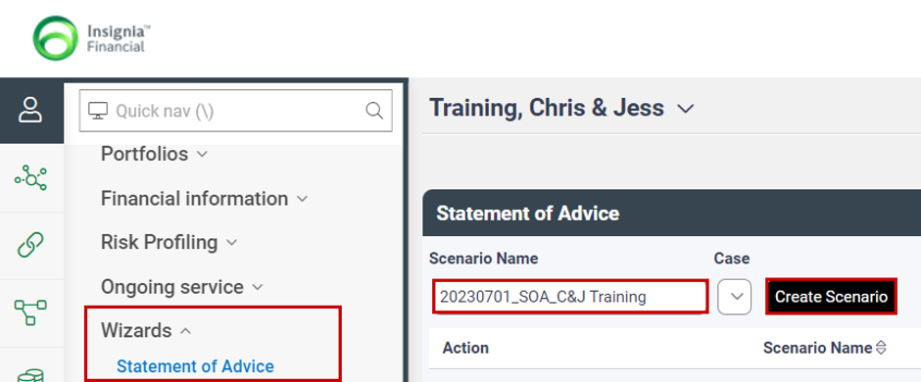

Document Controls page
The Document Controls page allows you to set up the type of SoA – Initial or Review, for whom the advice is to be provided to Client, Partner, or Client & Partner.
You also have the option to add a related entity by ticking on the relevant entity to be included in your advice document from SMSF, Trust, Company and/or Partnership. Refer the SoA for Non-Individual Entity section later in this guide for further guidance.
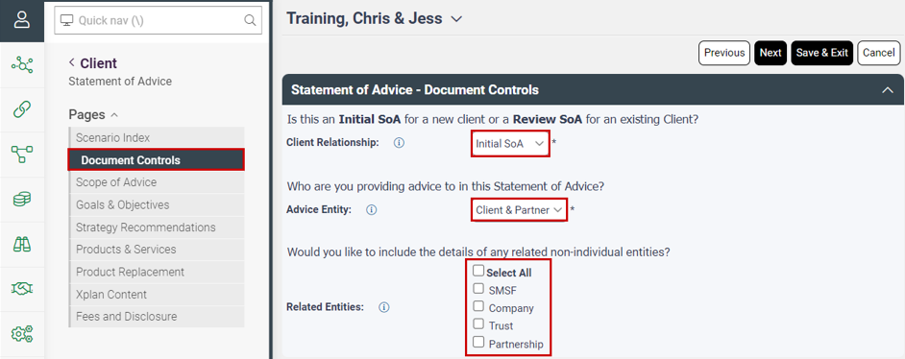

Select Next to continue through the wizard.

Scope of Advice page

Incomplete Information
Confirm if your advice is based on Incomplete or Inaccurate Information in relation to the client’s personal circumstances or financial position. Where you have selected Yes, the appropriate warning will be included in your SoA.
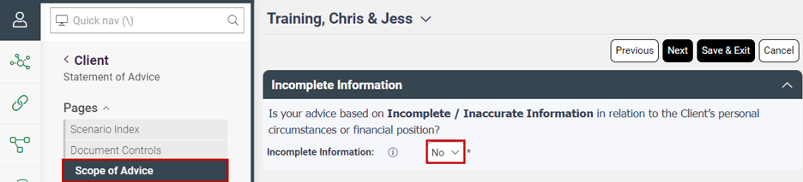

Scope of Advice & Limitations
For each advice area select whether it’s ‘Relevant and In Scope’, ‘Relevant and Not In Scope’ or ‘Not Relevant’.
- For the areas that are ‘Relevant and Not In Scope’, a box will appear for you to enter an explanation as to why it’s not in scope.
- For the areas that are ‘Relevant and In Scope’, sub scope options will appear below for confirmation of whether they’re in or out of scope with an explanation box. The Explain box is to be used in two ways:
For advice that is ‘Relevant and In Scope’, enter any limitations on that area here which will pull through to the ‘About this advice’ section of the SoA.
For advice that is ‘Relevant and Out of Scope’, enter the reason why it is out of scope which will appear in the ‘What our advice doesn’t cover’ section of the SoA.
For further guidance on scoping please refer to the Best Interests Duty and Related Obligations standard on AdviserONE.

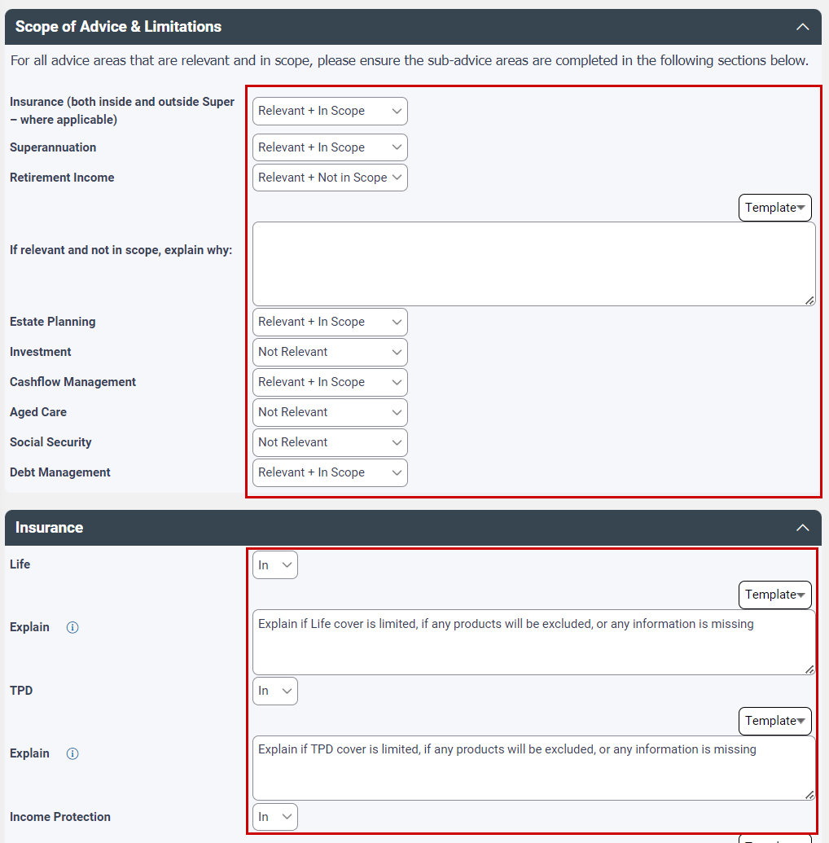

Select Next to continue working through the wizard.

Goals & Objectives page
The Goals and Objectives page will pull through the Goals/Objectives as entered into the Client Focus area of Xplan. You have the option to Add new Goals/Objectives as well as Edit an existing Goal/Objective in here.
 | Important: Any changes, deletion, or addition of goals here will also be applied at the Client Focus area.

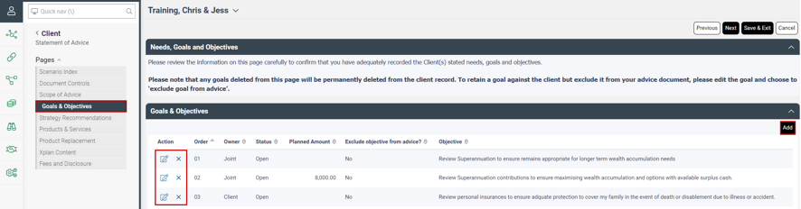

Within the Goals window, you can enter/review the order the goal appears, the ownership, status, planned amount, and provide a detailed description which will be used in the Executive Summary.
Select Yes if you wish to exclude a Goal from the advice, for example where it’s not in scope or has already been fulfilled.
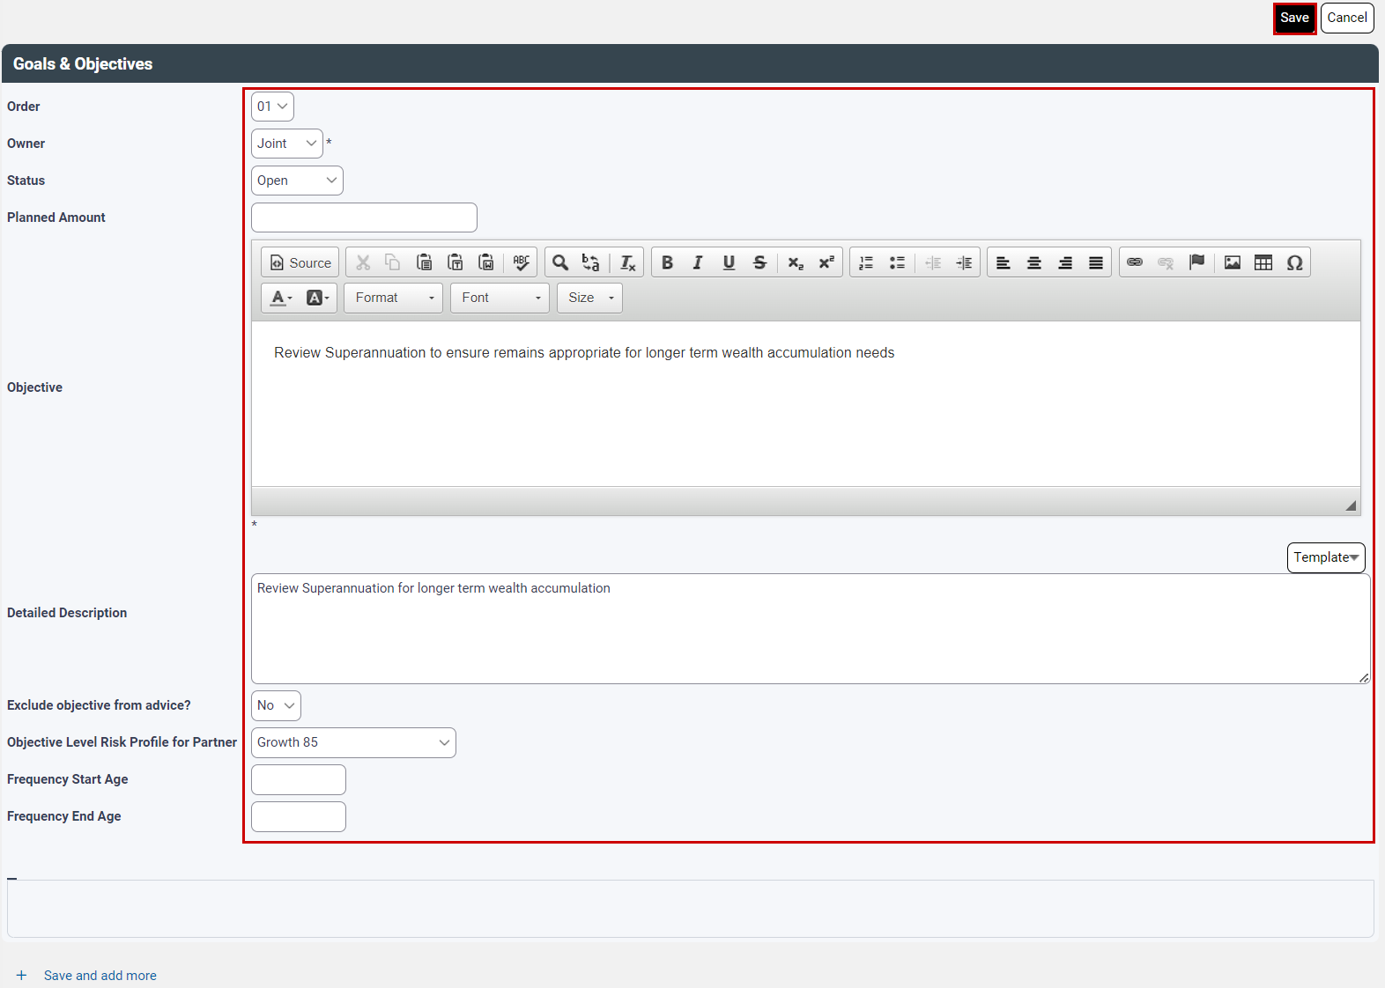

Strategy Recommendations page

Strategy Text Library
When selecting strategy recommendations within the Wizard, the default text for the Strategy is not visible within the wizard. This approach was taken so that smart coding can be introduced, reducing edit points in the SoA and so that formatting consistency could be maintained in the merged output document.
To familiarise yourself with the strategy text output prior to making selections within the wizard you can generate a quick merge ‘strategy text library’ document by clicking in the search field to open the righthand menu options. Select the right arrow next to the first client in the recent client list
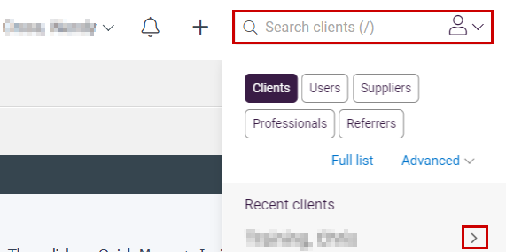

Select the Quick Merge dropdown arrow, then select Insignia - Advice Tools > Strategy Text Library. This will generate in the background and appear in your notification bell when ready to download.
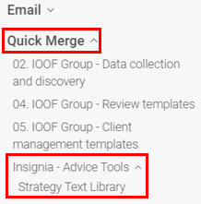

For a detailed look at where the smart coding in your strategy text comes from, please reference the Smart Coded Strategy Text Library Guide on AdviserONE.

Strategy Recommendations
The Strategy Recommendations page allows you to select the recommended strategy, whether you wish to include any alternative strategies considered and any future recommendations.
To enter your strategy recommendation, select > Add
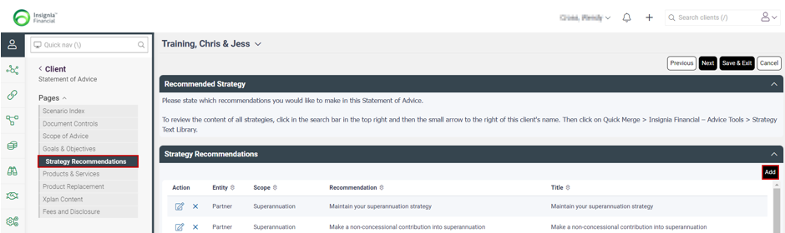

Within the strategy recommendations you can select the Entity that the strategy is for being Client, Partner or Joint. (Where you wish to include strategies for a related Non-Individual Entity, please reference the SoA for Non-Individual Entity section later in this guide.
Select the Scope, this will then open the relevant recommendation options available for that strategic area of advice. Select the recommendation to be applied.
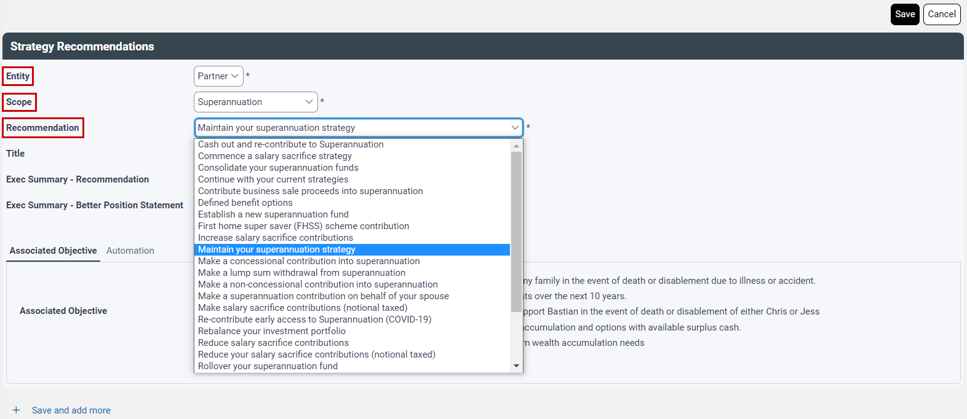

 | Note: - The User Defined scope is for manually entering strategy recommendations that are not currently supported in the strategy text library. Selecting this option will automatically populate generic text as a guide for you to tailor within the wizard under the Automation Tab.

The ‘Title’ will automatically populate – you have the option to amend/tailor this text. This information will all then appear in the Strategy Recommendation area within the main document.
A summary of the recommendation to be included in the Executive Summary needs to be added under the ‘Exec Summary – Recommendation’ box and will appear in the Executive Summary under the section ‘Summary of our recommendations’.
Your Better Position Statement needs to be added under the ‘Exec Summary – Better Position Statement’ box and will appear in the Executive Summary under the section ‘How our recommendations help to achieve your goals’
You do have the option to add managed field content here for any templated text that you may wish to use – please reference the tool tip for the field name or the Managed Field Content guide for more detailed information.
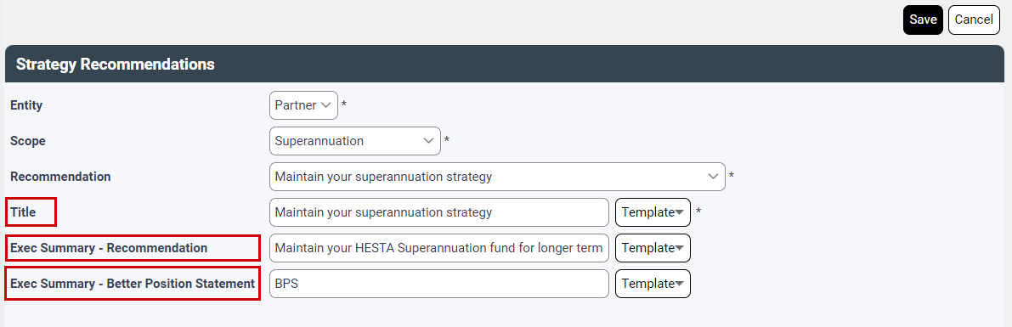

Note: - The free text boxes allow for unlimited text even though not fully displayed on screen.

Associated Goals tab
You will need to link your strategy to the associated goals by simply ticking the relevant goal.
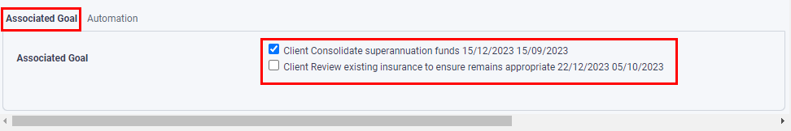

Automation tab
Within the Automation tab, selecting Yes to Automate Recommendation, this will ensure that relevant information will be used from Client Focus or from the relevant Xplan modules to help automate the strategy and reduce postproduction editing.
Where relevant, selecting yes may also raise further questions relating to the recommended strategy that may be required to drive further automation of strategy text.
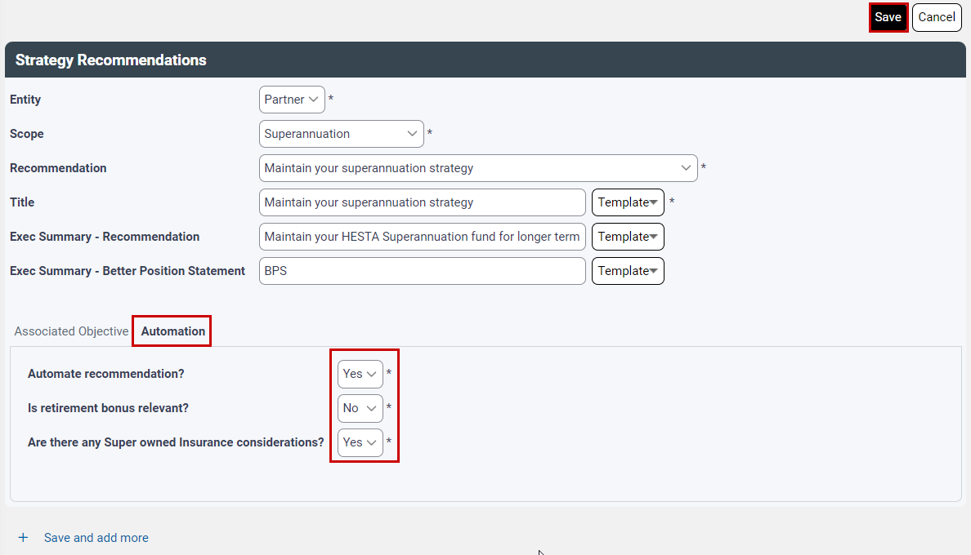

Select Save to apply the strategy.

Once you’ve selected all your strategies, the priority can be set using drag and drop functionality.
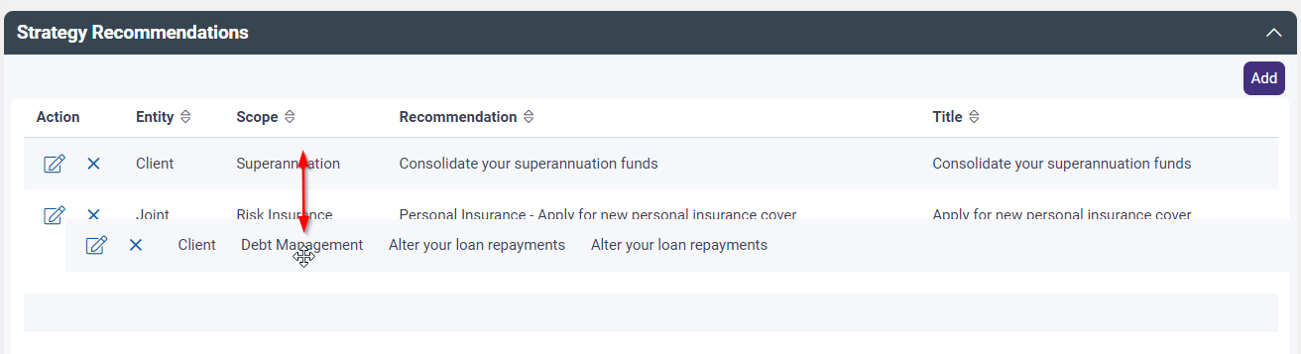

Future Recommendations
Where you wish to include recommendations that are expected to occur at a future date and the clients’ circumstances will need to be reviewed prior to implementation, selecting Yes here will open the Future Recommendations text box with sample text ready for you to tailor. This text will appear under the Cashflow and Other Considerations section of your advice document.
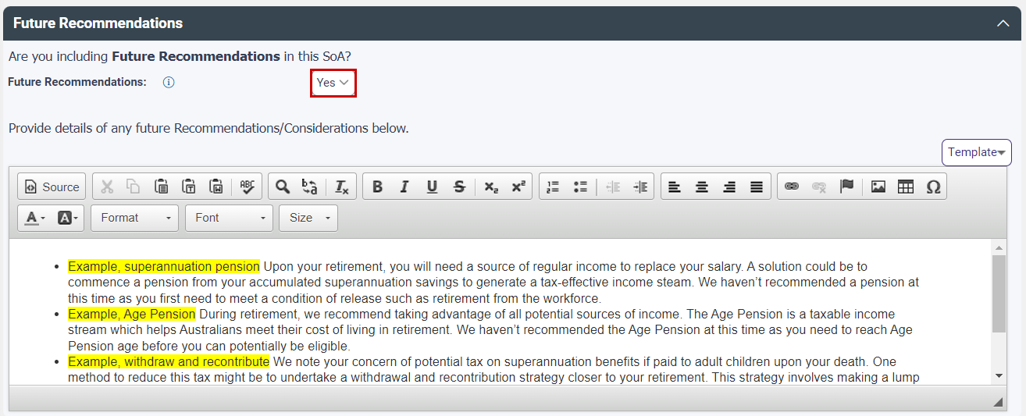

Select Next to continue through the wizard.

Products & Services page
The Products and Services page allows you to add the recommended products, any alternative products considered, and where relevant, Investment commentary for Model Portfolios and the Adviser Online Transaction Authority.
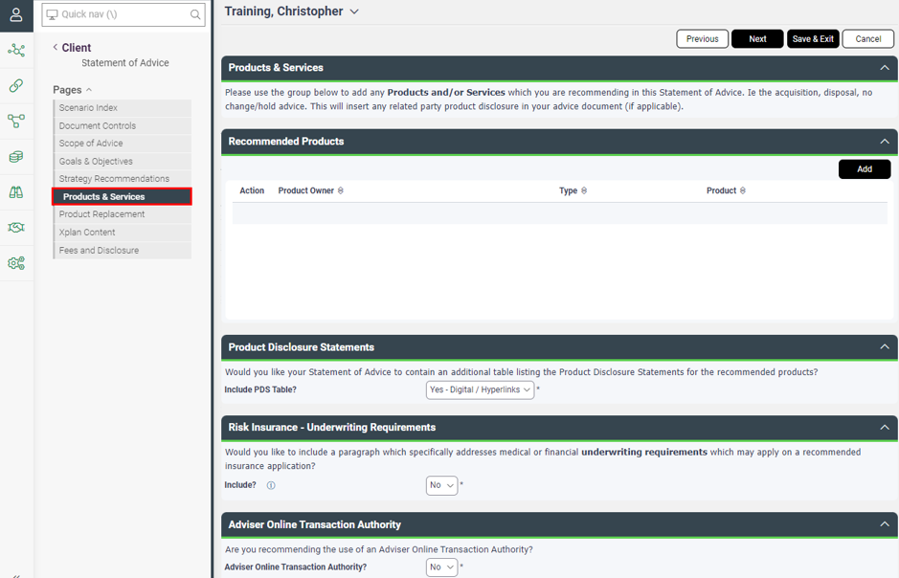

Recommended Products
Where applicable, select the relevant recommended products to be included in your SoA by selecting the Add button to open the product recommendation field.
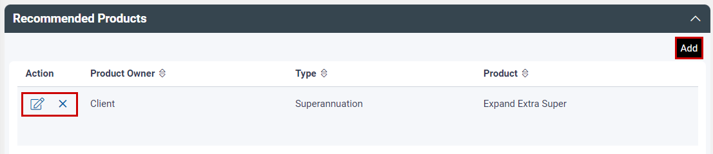

Within the Recommended Product screen, select the Owner, Type, Product, whether you wish to include Product Text and select the relevant Portfolio Construction text to be included in the Investment Rationale section of your advice.
Within the Strategy tab, the selected product will determine the type of questions to be answered for inclusion in your advice with regards to Portfolio Management, Investment Strategy, Investment Timing, and Investment Instructions.
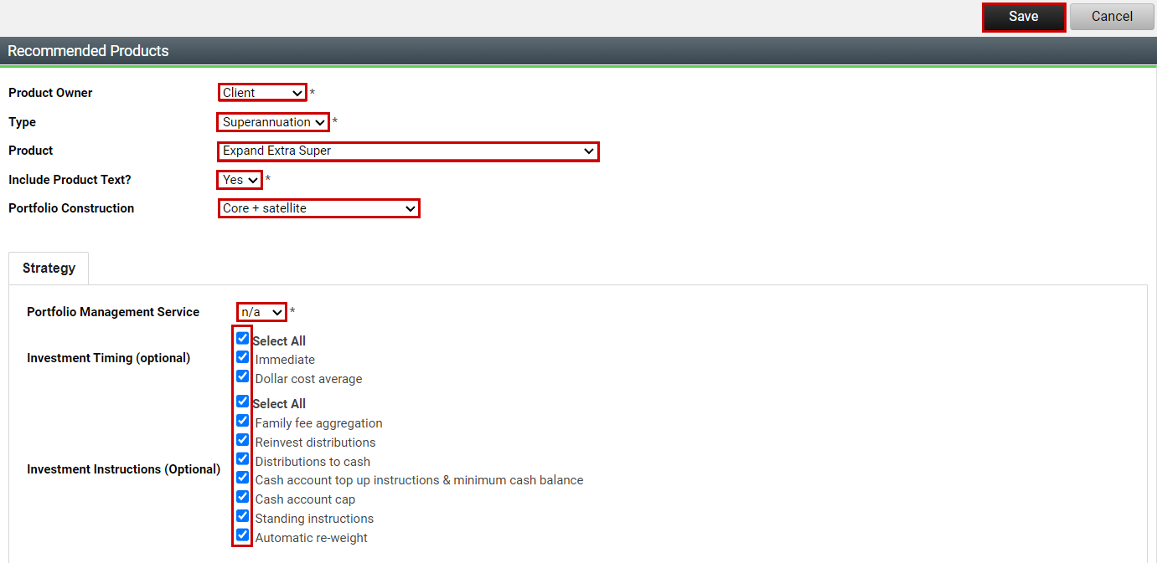

User Defined Product Text
Where you are recommending a product that is not supported within the Wizard, please select the Type as Investment, Super or Pension and select the Product as Other. This will bring up the product text shell as a guide to complete for the product that you are recommending. This can be tailored either within the Wizard or post merge within Word.
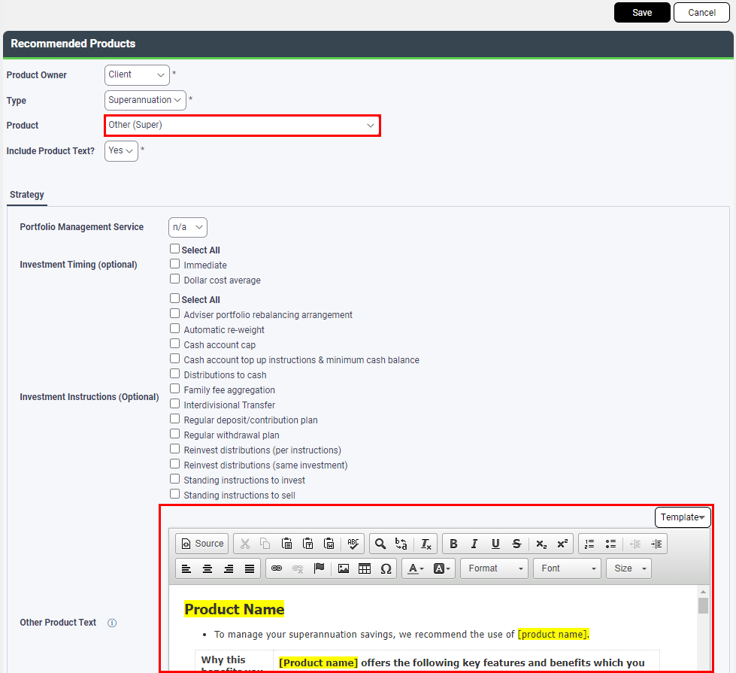

Product Disclosure Statements
This area allows you to select whether you wish to include a PDS table within your SoA, yes or no. The default option is Yes – Digital/Hyperlinks, which includes a PDS table with hyperlinks to the relevant PDS. You can also select Yes – Print, which includes the PDS table when providing the actual printed PDS with the SoA.

Risk Insurance – Underwriting Requirements
This question will only appear when Insurance is selected as In Scope.
Select Yes here if you would like to include a paragraph that addresses medical or financial underwriting requirements which may apply on a recommended insurance application.

Additional Information
- Adviser Online Transaction Authority
Select Yes where you are recommending the use of an Adviser Online Transaction Authority. This will populate the Important Information with the relevant disclosure.
- Internally Geared Funds Acknowledgement
Select Yes where you are recommending the use of an investment with internally geared funds making up more than 20% of the portfolio. This will populate the Important Information with the relevant disclosure.
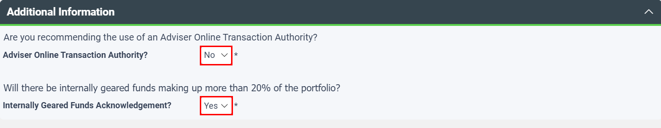

Select Next to continue through the Wizard.

Product Replacement page
The product replacement page allows you to confirm the inclusion of replacement comparison tables such as Like for Like and/or Investment Switch Analysis, the inclusion of product costs and disclosures and implications for CGT and Stamp Duty.
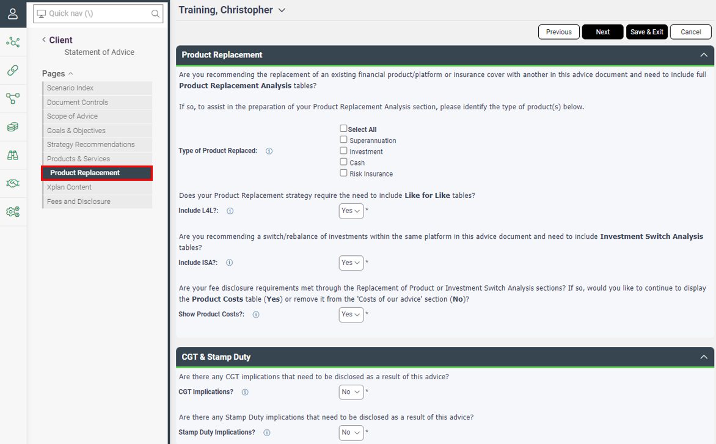

Product Replacement
Where you are recommending a replacement of product/platform or insurance cover and need to include full product replacement analysis tables, select the appropriate product types being replaced for both client and partner. This will tell the system where to obtain the product replacement information from with regards to WealthSolver or Risk Researcher modelling.
Confirm whether you require Like for Like and/or an Investment Switch Analysis tables to be included in your advice.
And where your fee disclosure requirements have been met through the Replacement of Product or Investment Switch Analysis sections, then the Product Costs table under the fee disclosure section becomes optional for inclusion. Select Yes to include or No to remove.
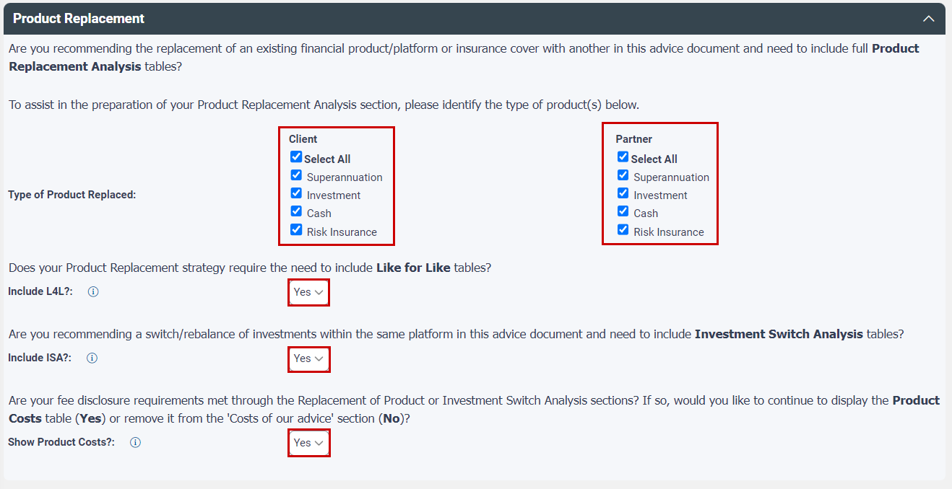

Note: - Where you select No for any of the tables, a warning will appear urging you to double check whether the tables are required before proceeding.

CGT & Stamp Duty
Where the replacement of product will incur a CGT or Stamp Duty impact, selecting yes to either of these questions here will include the relevant disclosure under the Cashflow and Other Considerations area of your advice.
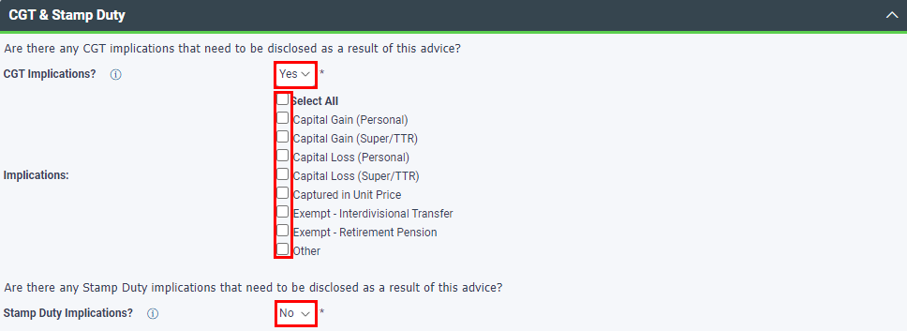

Select Next to continue through the wizard.

Xplan Content page
The Xplan Content page allows you to include recommendations and financial modelling you have undertaken from any of the Xplan Advice Tools such as Portfolio (IPS), WealthSolver, Risk Researcher, XTOOLS or XTOOLS+/CALM or from Wealth Central (incorporation by reference only) where you are using the Wealth Projections and/or Risk Insurance Needs Analysis.
Select the relevant Advice Tool and scenario you wish to include. The relevant screen will then open allowing you to select which items you wish to pull through to your advice document.
To expedite plan production in this area, we have defaulted on the appropriate tick box options for Portfolios (IPS) and WealthSolver, ensuring the required items are included in SoA output, eliminating confusion around what to include.
The remaining non-defaulted options are optional for inclusion.
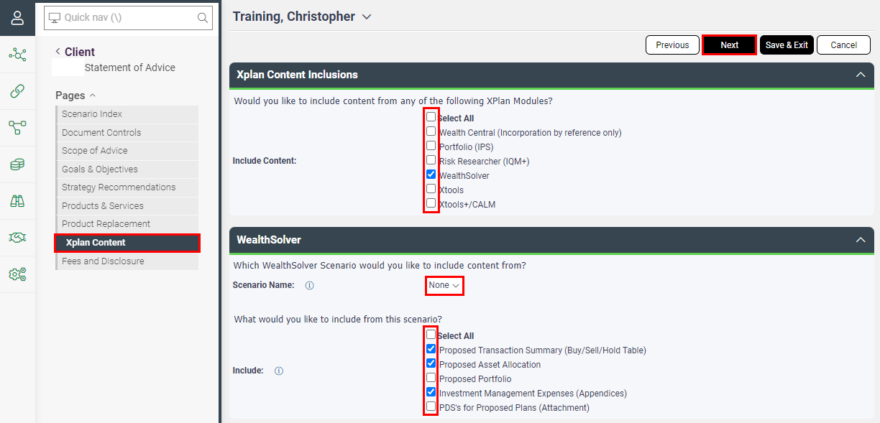

Please refer to the Advice Tools Content Guide for an example of the available report outputs.
And where you are including recommendations and modelling for a related entity, please reference the SoA Wizard for Non-Individual Entities guide for more detailed information.

Select Next to continue working through the Wizard.

Fees & Disclosure page
The Fees and Disclosure page captures all relevant areas that need to be disclosed from Initial and Ongoing Advice Fees, Ongoing Services, Remuneration Splits, Referral Arrangements and Product Fees.
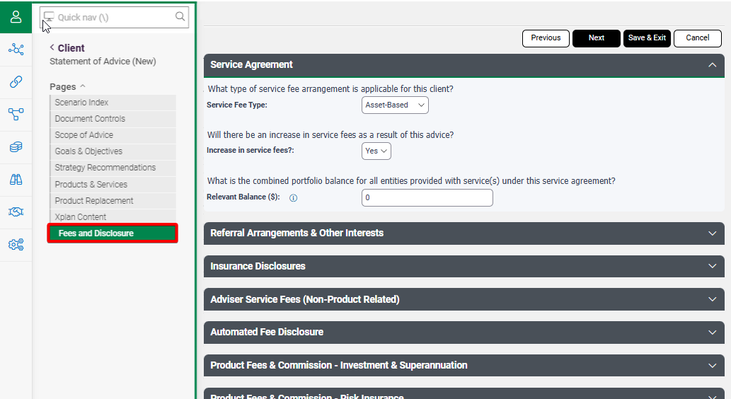

Service Agreement
You must select the type of service fee arrangement that is in place for the client.
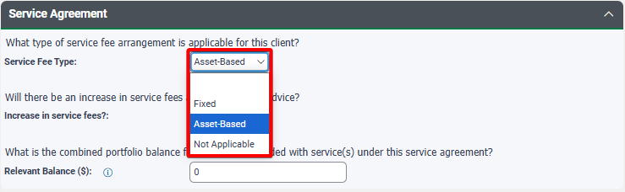

Service item: | When to select:
Fixed | Fixed dollar fee amount for ongoing services
Asset-based | Percentage based fee calculated on portfolio holdings for ongoing services
Not Applicable | No ongoing services arrangement in place for client(s)

If Asset-based is selected, you will need to confirm if there is an increase in fees as a result of the advice and confirm the balance amount of the client(s) portfolios.
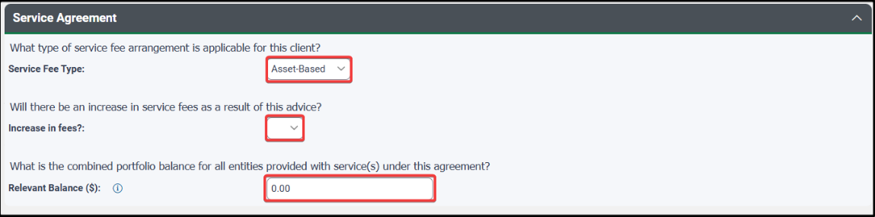
Please note if you have entered your service arrangement fees within the product selection in WealthSolver these will NOT pull through to your disclosure tables.

Referral Arrangements & Other interests
Where you may need to disclose other interests or referral arrangements, select the appropriate option, and then tailor the templated text accordingly.
The Other Interests and Associated Parties text is set up in Document Preferences. Navigate to My Preferences > My Details to customise this text. This is set up at an Adviser level.
You have the option to include templated text as Managed Field Content – refer to the Managed Field Content guide for more detailed instructions.
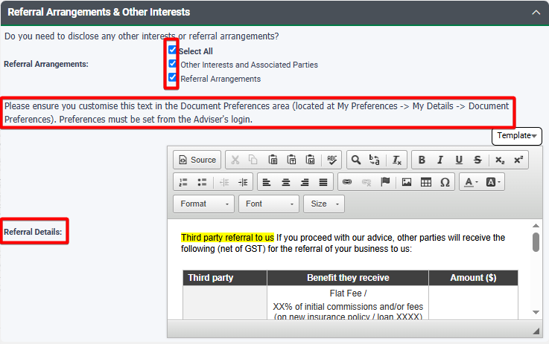

Insurance Disclosures
The Insurance Disclosures section only appears when Insurance has been selected as ‘In Scope’.
Where you are recommending insurance and wishing to dial down the insurance commission to 0%, please select Yes. This will calculate the dialled down insurance commission in the product fee disclosure table output.
Where consent to receive insurance commissions is required, please select Yes. This updates the Authority to Proceed, confirming client(s) consent via their ATP signature. Text in the product disclosure notes will also be adjusted accordingly.
Please ensure you add details of the services you provide as part of receiving insurance commissions. To set this up, navigate to your Document Preferences.
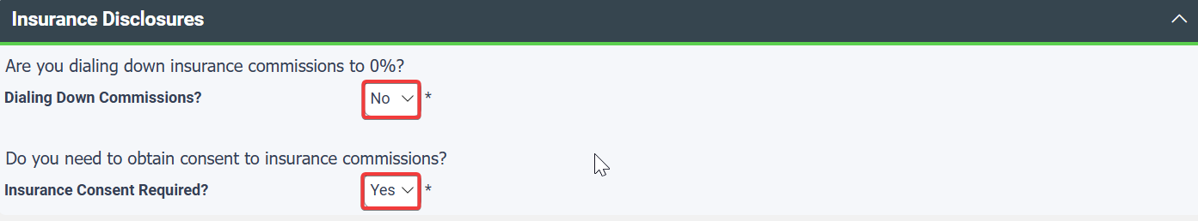

Adviser Service Fees (Non-Product Related)
Where you are not taking Adviser Service fees from recommended products or have not modelled your product recommendations within WealthSolver or Risk Researcher as outlined earlier, you can use the following sections to capture your Adviser Service Fees and Product Costs manually.
For your Adviser Service Fees you have the option to enter amounts being charged for the preparation of the SoA, the Implementation of the SoA and the Fee for Service – Service Agreement.
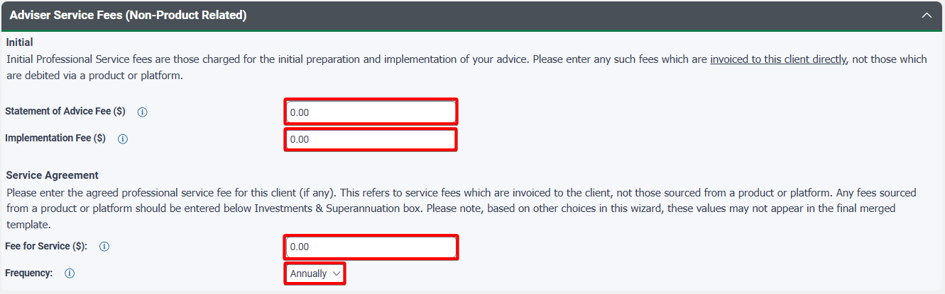

Automated Fee Disclosure
The automated fee disclosure panel will appear where you have used WealthSolver and/or Risk Researcher modelling, in which case your product fees will automatically be generated. You will ONLY need to manually enter product fees in the following panels where they have NOT been included in WealthSolver and/or Risk Researcher.

Product Fees & Commissions – Investment & Superannuation
Product costs for Investment, Superannuation & Pension can be selected by using the Add button to enter in the relevant adviser service fees and product cost details manually.
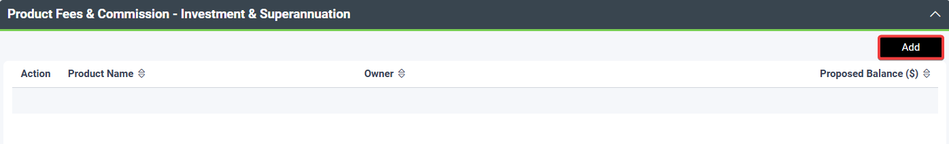

Select the product details from the available dropdown menus for Type, Product and Owner, enter the proposed balance to be invested and complete the associated costs under the Benefits Received and Product Costs tabs.
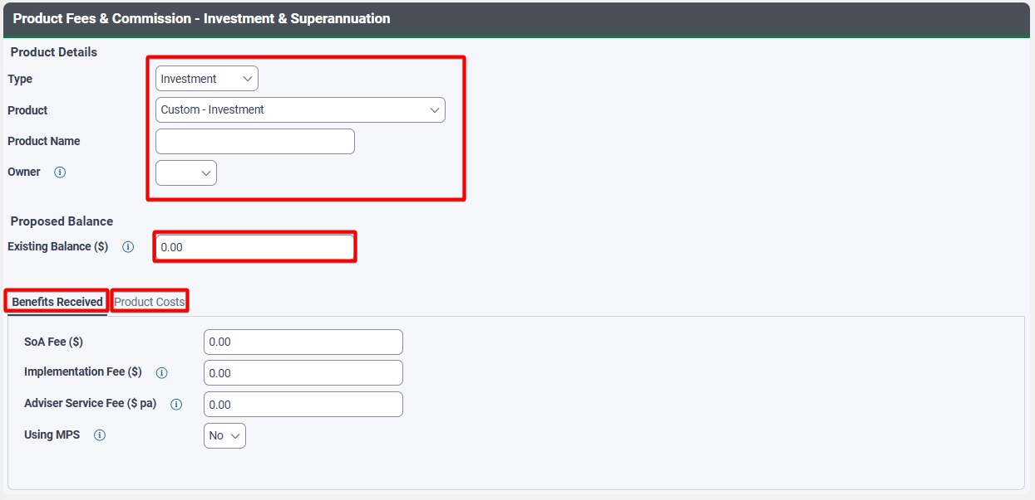

Product Fees & Commissions – Risk Insurance
Risk Insurance commission fees can be entered by selecting the Add button to enter in the relevant insurance product commission details manually.
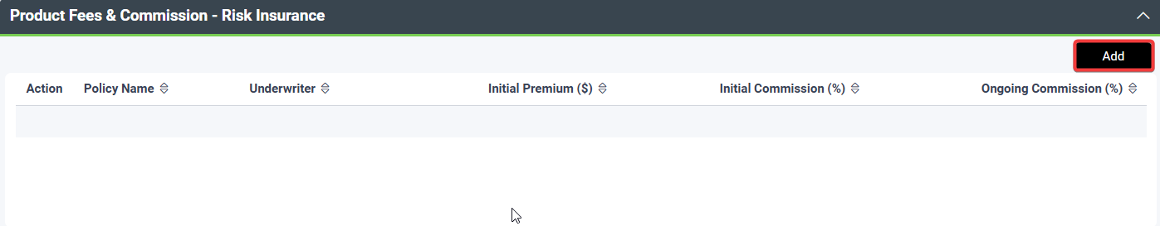

Select the underwriter details from the available dropdown menu for Underwriter and enter the Policy Name and Life Insured, enter the $ amount for Initial & Renewal Premiums and % amount for Initial and Ongoing Commissions.
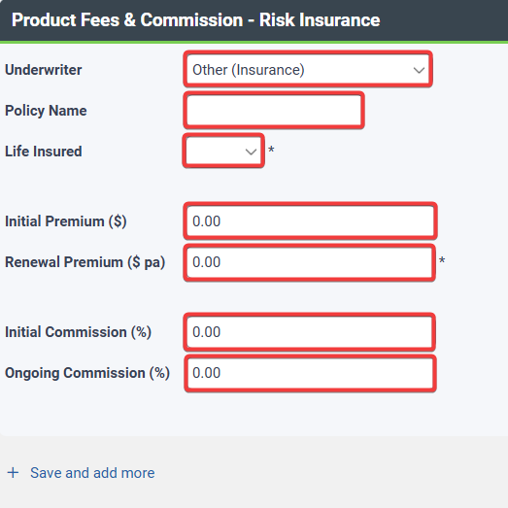

Merge your SOA
After completing the wizard to your satisfaction, you will then need to Merge the SoA.
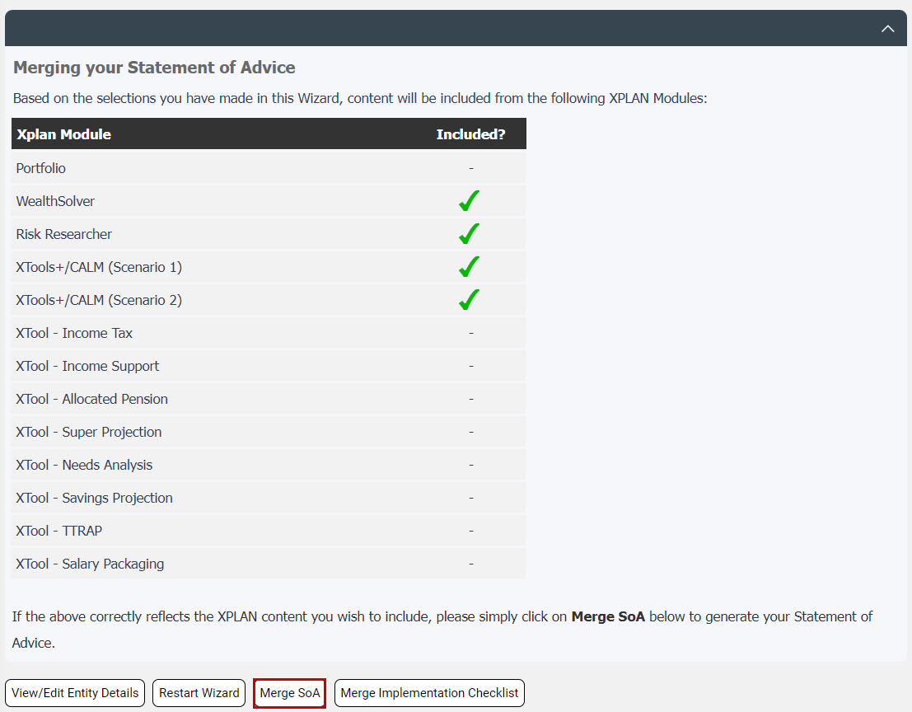

 | Before following this step and generating your SoA, please ensure that you have taken time to read and complete the Wizard carefully. There are a few questions in this Wizard and taking the time to answer each of them correctly will ensure that your SoA is as close to complete as possible when you are finished within Xplan.

Download and Open/Save the SoA
Once you have followed the instructions on screen to Merge your SoA and included any required variables, Xplan will begin preparing your SoA. This may take up to a minute or two to complete depending upon how much Xplan content (such as XTOOLS modelling) you have opted to include.
Once complete, the notification bell on the top right of your screen will have a number 1 displayed next to it. Click on the notification bell and then click on the Download Report.
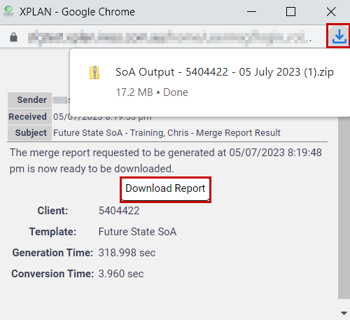

We strongly recommend that you Save As the resulting file into a location on your hard drive.

SoA for Non-Individual Entities
Preparing an SoA for Non-Individual Entities can be done based on addressing the advice to the Non-Individual Entity ONLY or combined advice to BOTH the Individual Entity and the Non-Individual Entity.

Combined Entity advice
The SoA Wizard (at the individual master entity level) supports the output of combined entity advice and is supported by WealthSolver and Risk Researcher, providing automated completion of the replacement of product and fee disclosure tables.
Advice being addressed to: | SoA Wizard at entity level:
Members of the SMSF only | Individual | Part 1
Combined Personal and Related Entity advice | Individual | Part 1

Your advice output will be addressed as follows:
Combined Entities:
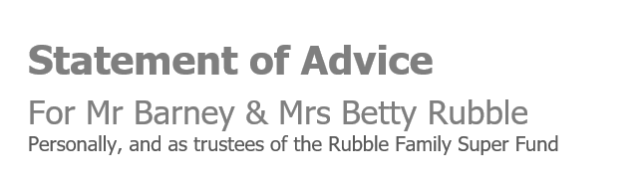

Non-Individual Entity advice
The SoA Wizard is also available at each of the SMSF, Trust and Company levels however is not supported by WealthSolver or Risk Researcher resulting in limited automation. If you choose to complete the wizard at this level, you will need to manually complete your replacement of product and fee disclosure tables.
Advice being addressed to: | SoA Wizard at entity level:
Trustees of the SMSF only | SMSF | Part 2
Directors of a Company only | Company | Part 2
Directors/Trustees of Trust only | Trust | Part 2

Your advice output will be addressed as follows:
Non-Individual Entity:


Combined Entity SoA
For combined entity advice, follow the steps as outlined earlier in this guide, ensuring that in the:

Document Controls page
Select the related Non-Individual Entity.

Scope of Advice page
For Related Entities in combined entity advice the scope will not pull through from the Related Entity, all scope must be entered at the Master Individual Entity level, for example, select scope Superannuation > sub scope SMSF for a related SMSF entity, or for a Family Trust/Company/Partnership select scope Investment.

Goals and Objectives page
To include your related entity goals and objectives, you can toggle into the Related Entity from within this screen to check the details of goals and objectives listed or add them at this point.
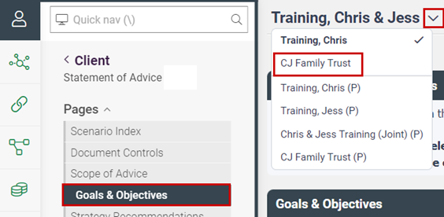

Strategy Recommendations page
To include your related Non-Individual Entity strategy recommendations, you can toggle into the related Non-Individual Entity from within this screen to select the appropriate strategy recommendations to be applied.
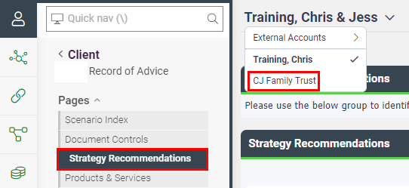

Toggle back to the Individual Entity to continue through the remainder of the wizard.
The remaining pages cater for both Individual and Non-Individual Entities.

Products & Services
Enter the recommended products by for the Non-Individual Entity by selecting the owner from the dropdown menu.

Product Replacement page
Related Entities modelled in WealthSolver will populate Replacement of Product tables based on their selection within WealthSolver, as well as selecting the related Client and/or Partner in the Product Replacement page. For example, if the SMSF is related to the Partner Only, then make sure you select Partner in this page to ensure the SMSF tables appear.

Xplan Content page
XTOOLS+/CALM projection tables/charts will only appear for non-individual entities when the entity has been selected in the document controls page.
SMSF selections available:
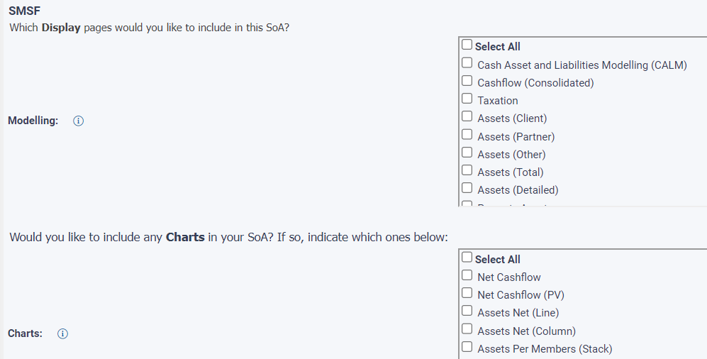

Company selections available:
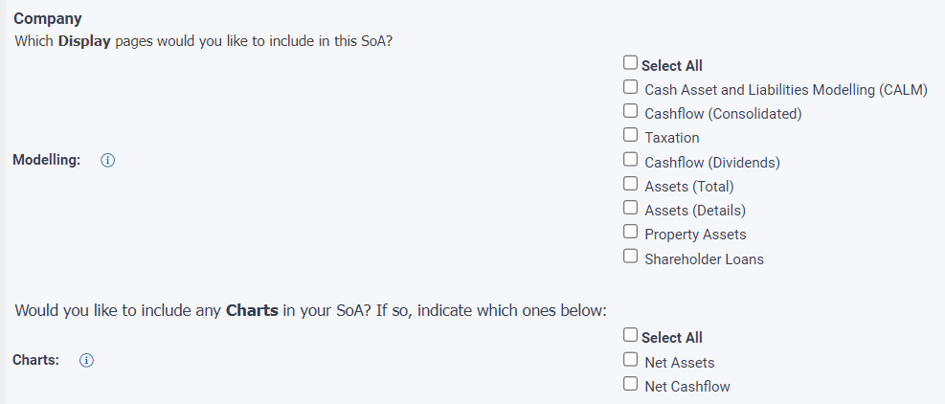

Trust selections available:
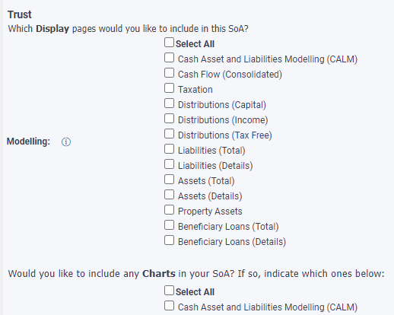

Fees and Disclosure page
Automated fee disclosure will apply where the related Non-Individual Entity has been modelled within WealthSolver and/or Risk Researcher.
Where manual entry is required, complete by selecting the relevant Entity as the owner for each fee to be entered.

Non-Individual Entity Advice Only
Within the Non-Individual Entity client menu, commence completing the SoA Wizard as outlined earlier in this guide.
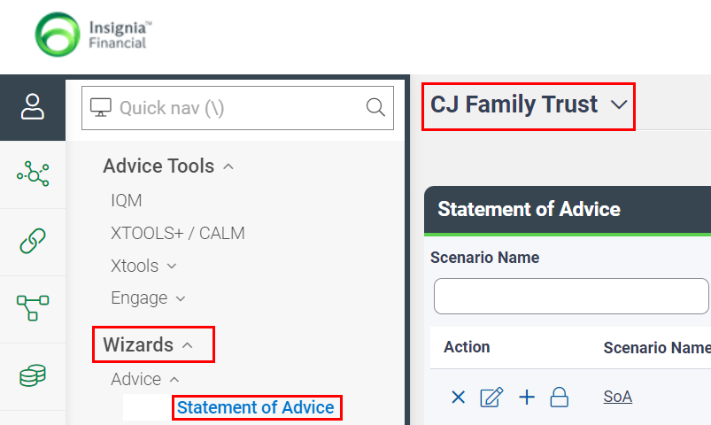

Note however that as WealthSolver and Risk Researcher are not supported at this level, there will be limited automation and blank tables for manual completion. You can choose to model WealthSolver/Risk Researcher at the Individual Entity level and copy the tables in from there.

