Record of Advice Wizard User Guide
This guide outlines the process for using the Record of Advice wizard within Xplan to prepare advice.
16/06/2025

Table of contents
Overview 2
Record of Advice Wizard 3
Standard RoA 4
Document Controls page 4
Strategy Recommendations page 6
Products & Services page 9
Product Replacement page 10
Xplan Content page 12
Fees & Disclosure page 13
Merge your ROA 17
Defined Purpose RoA Options 18
Contributions Advice 19
Hold & Adjust Pension Payments 21
Hold Recommendation 23
Hold & Continue MPS 23
Hold & Rebalance Portfolio 25
Hold & Investment Switch 25
Lump Sum Withdrawal 28
Product Replacement – Super Only 31
Term Deposit Renewal & Rollover 33
RoA for Non-Individual Entities 36
Combined Entity advice 36
Non-Individual Entity advice 36
Standard RoA 37
Defined Purpose RoA 39

Overview
The Record of Advice (RoA) Wizard user guide outlines how to use the RoA Advice Wizard to generate your advice in an RoA.
The RoA wizard has been designed to enable you to produce RoA’s in an efficient manner with options for generating either a Standard RoA or one of several Defined Purpose RoA’s. The Standard RoA option provides access to a full range of advice scenarios, whereas a Defined Purpose RoA is a set strategy template that is heavily automated based on common advice scenarios.
This guide has been laid out into 2 sections outlining how to produce:
- A Standard RoA
- A Defined Purpose RoA

Before using the Wizard
Prior to commencing the Wizard, the following data entry, and modules within Xplan need to be completed to ensure the quick and efficient production of the RoA for your client:
- Client fact find data – ensure that your clients’ personal and financial information has been updated either via the Fact Find within Xplan.
- Research and Portfolio Recommendations – ensure that you have completed your research analysis and portfolio recommendations in the relevant Xplan modules such as WealthSolver and/or Portfolios (IPS). For insurance recommendations use Risk Researcher.
- Financial Modelling – ensure that you have completed your financial modelling either within Xplan via XTOOLS and/or XTOOLS+/CALM.
Please refer to the relevant support material for more guidance on using any of the Advice Tools within Xplan.
Once you have entered your client’s information, made any necessary investment recommendations, and completed any financial modelling, it is time to use the RoA Wizard to combine your work into an RoA document.

Record of Advice Wizard
Access your client in Xplan and navigate to Wizards > Record of Advice within the Client menu. Enter a scenario name and select Create Scenario.
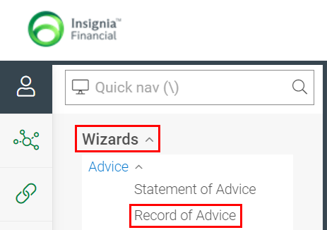

Standard RoA

Document Controls page
The Document Controls page allows you to select the type of RoA you wish to create. Selecting the Standard option from the dropdown menu opens the standard RoA in the wizard which provides you with full access to all available strategies and items available for inclusion in the RoA.
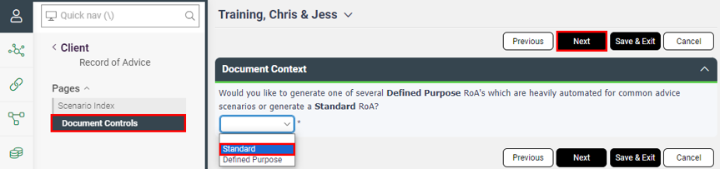

This opens the remaining document controls items for selection, commencing with the previous SoA date.
The date of the SoA being used to incorporate by reference will automatically be populated from the Last SoA date field in the Administration section.
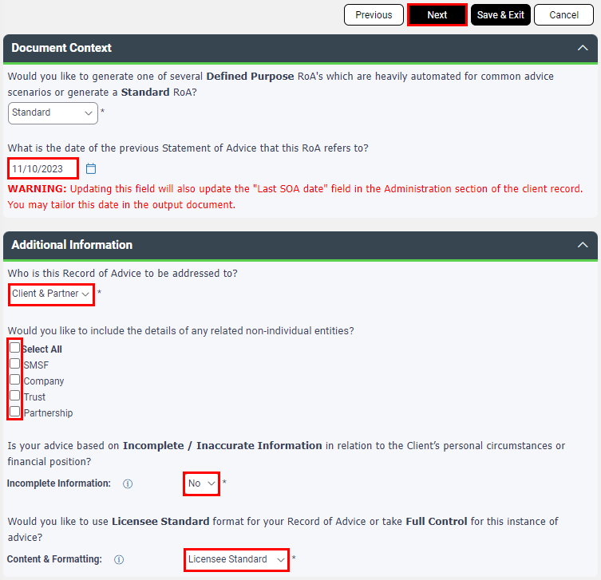

 | Note: If you update this field, it will automatically update the Last SoA date field under the Administration section of your client record.

Additional Information
Select whom the advice is to be addressed to and whether your advice is based on incomplete/inaccurate information. Then select the document formatting option to be applied based on options as outlined in table below.

Content & Formatting Item | Description
Licensee Standard | Format output in line with Licensee format options.
Adviser Preferences | Format output in line with selections within Adviser Document Preferences
Full Control | Format output in line with selections made within the RoA Wizard.

Full Control option:
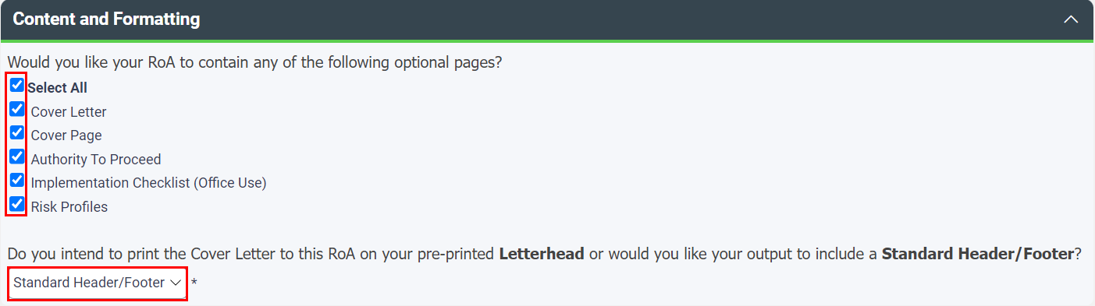

Select Next to continue through the wizard.

Strategy Recommendations page
The Strategy Recommendations page allows you to select your recommended strategies.
Select Add to open the Strategy Recommendation screen.
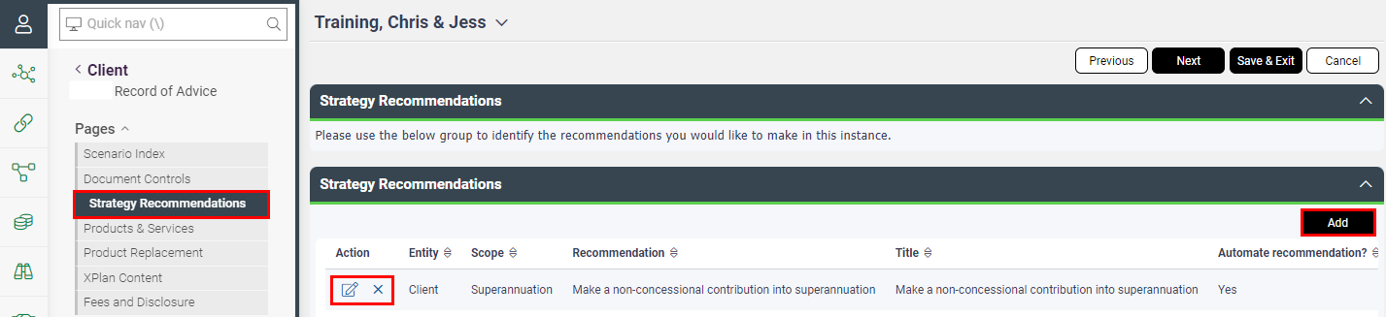

Within the Strategy Recommendation screen, select whom the strategy is for, the scope (area of advice) and this will open the applicable recommendations in the Recommendation dropdown list for that area.
Then select the relevant recommendation from the Recommendation dropdown list and this will automatically populate the Title field – you have the option to amend/tailor this text. You also have the option to add Managed Field Content here for any templated text that you may wish to use – please reference the tool tip for the field name or the Managed Field Content guide for more detailed information.
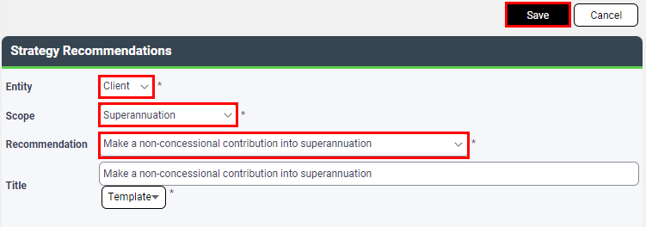

Automation tab
Within the Automation tab, selecting Yes to Automate Recommendation will instigate the smart coding using relevant information from Client Focus or Xplan modules to help automate the strategy and reduce postproduction editing.
Where relevant, selecting yes may also raise further questions relating to the recommended strategy that may be required to drive further automation of strategy text.
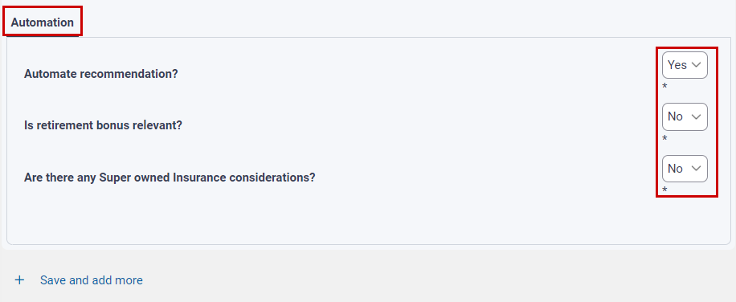

Select Save to apply the strategy.
Once you’ve selected all your strategies, the priority can be set using drag and drop functionality.
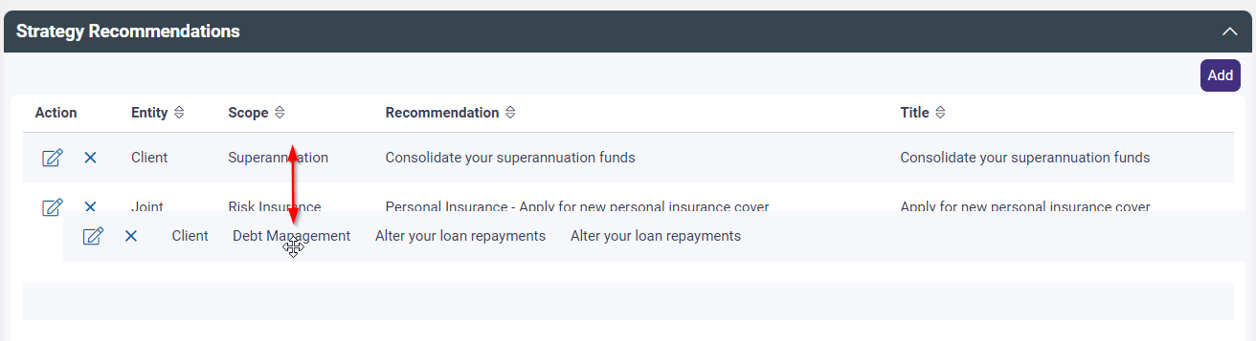

MPS Recommendations
Where the investment strategy involves an MPS Investment Program, the strategy text options to be used within an RoA are as follows:
Strategy text option: | When to use:
MPS – Continue to invest through the MPS | At review if the service continues to remain appropriate
MPS – Retain your existing MPS Investment Program | At review when recommending retaining existing MPS portfolio option
MPS – Change your MPS Investment Program | When changing to an alternative MPS portfolio option
MPS – Discontinue use of the MPS | When recommending the discontinuation of the service

If the MPS remains appropriate, the advice should always include two of the MPS Strategy recommendations as follows:
- ‘Continue to invest through the MPS,’ and
- Either: ‘Retain your existing MPS Investment Program’ OR ‘Change your MPS Investment Program’

Products & Services page
Where applicable, select the relevant products to be included in your RoA.
Select Add to open the product recommendation field.
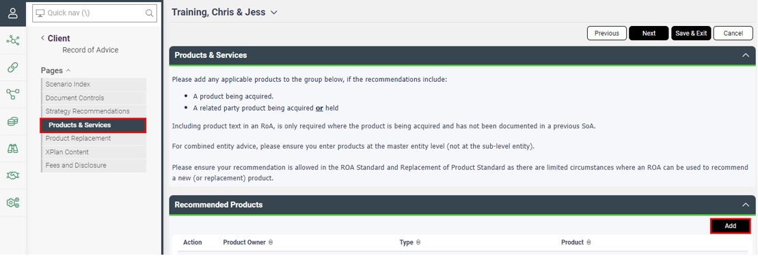

Select who the product is for, the product type, product selection and if you would like to include Product related text. Where the recommendation is to retain an existing investment leave as No to exclude Product related text in your RoA. The product selection here will ensure the related party product disclosure appears in the RoA, where applicable. Select if a Portfolio Management Service applies.
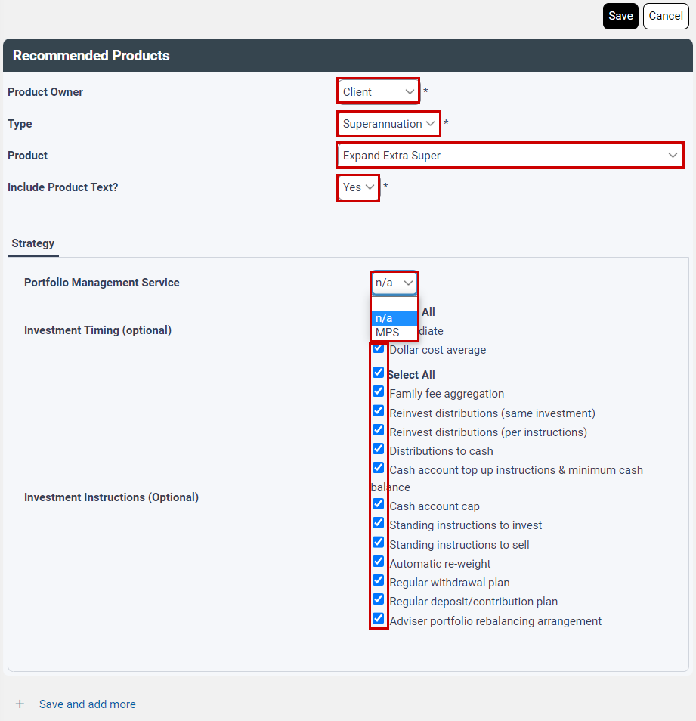

Product Replacement page
The product replacement page allows you to confirm the inclusion of replacement comparison tables such as Like for Like and/or Investment Switch Analysis, the inclusion of product costs and disclosures and implications for CGT and Stamp Duty.
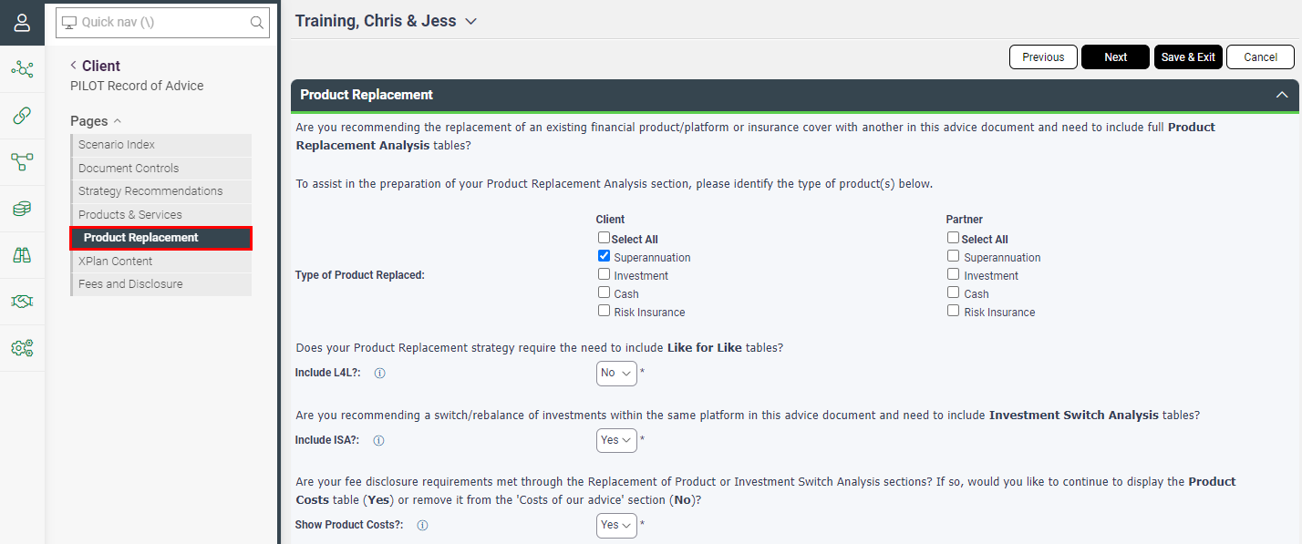

Product Replacement
Where you are recommending a replacement of product/platform or insurance cover and need to include full product replacement analysis tables, select the appropriate product types being replaced for both client and partner. This will tell the system where to obtain the product replacement information from with regards to WealthSolver or Risk Researcher modelling.
Confirm whether you require Like for Like and/or an Investment Switch Analysis tables to be included in your advice.
And where your fee disclosure requirements have been met through the Replacement of Product or Investment Switch Analysis sections, then the Product Costs table under the fee disclosure section becomes optional for inclusion. Select Yes to include or No to remove.
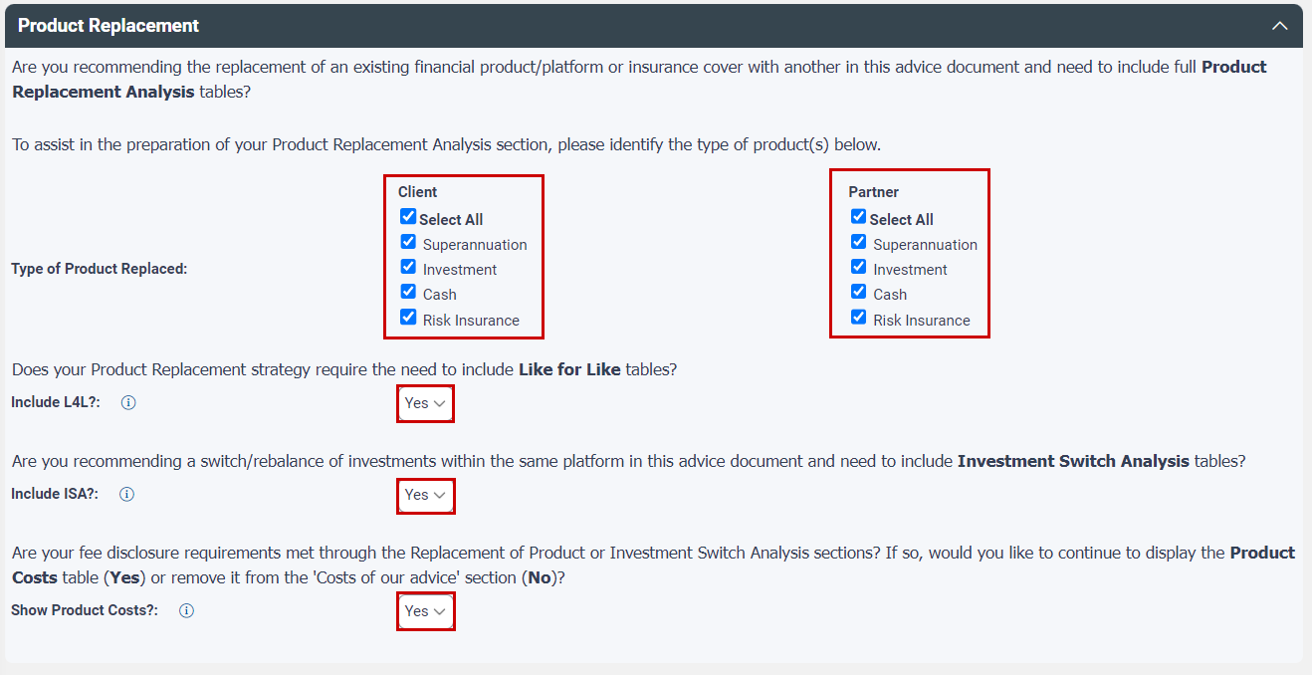

Note: - Where you select No for any of the tables, a warning will appear urging you to double check whether the tables are required before proceeding.

CGT & Stamp Duty
Where the replacement of product will incur a CGT or Stamp Duty impact, selecting yes to either of these questions here will include the relevant disclosure options for selection and/or relevant disclosure under the Cashflow and Other Considerations area of your advice.
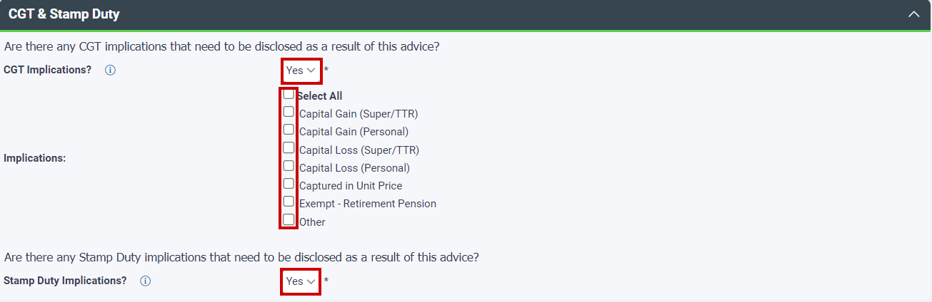

Xplan Content page
The Xplan Content page allows you to include recommendations and financial modelling you have undertaken from any of the Xplan Advice Tools such as Portfolio (IPS), WealthSolver, Risk Researcher, XTOOLS or XTOOLS+/CALM.
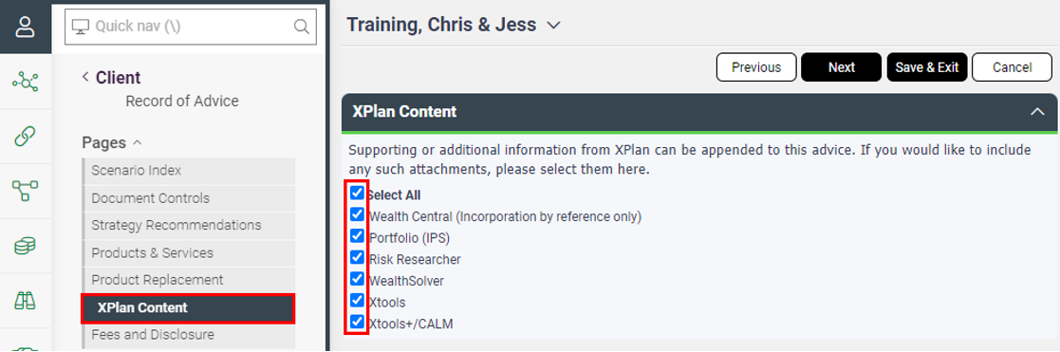

Select the relevant Advice Tool and scenario you wish to include. The relevant screen will then open allowing you to select which items you wish to pull through to your advice document.
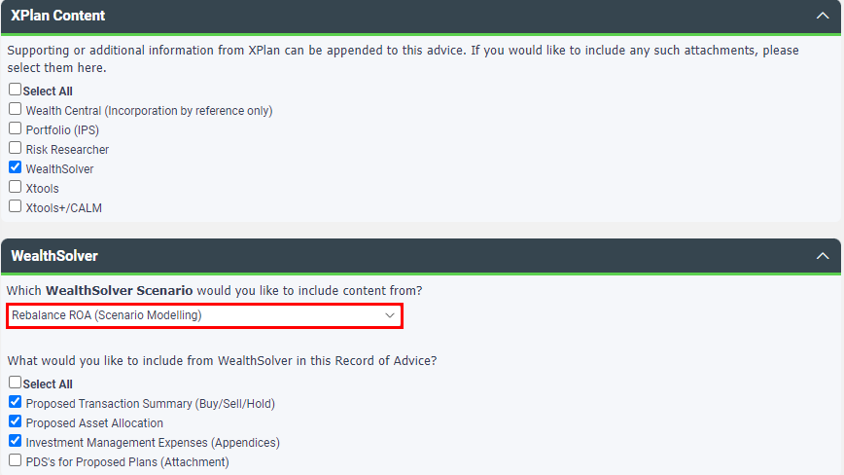

Note: Where IPS/WealthSolver are used, the tick box options for the relevant output that is required has been defaulted on for each to avoid doubling up on options.
Please refer to the Advice Tools Content Guide for an example of the available report outputs.

Select Next to continue working through the Wizard.

Fees & Disclosure page
The Fees & Disclosure page enables you to indicate if there is any change or additional Adviser fees as part of this advice, selecting yes opens the Adviser Fees area for completion.
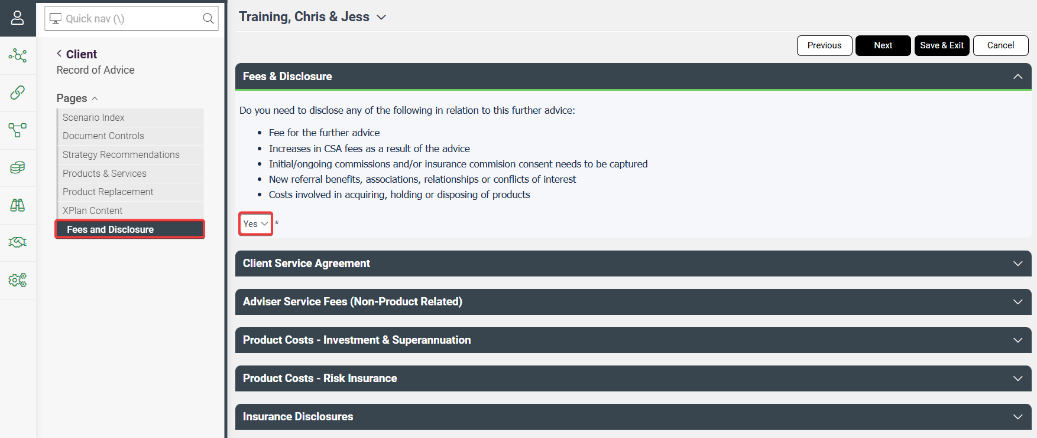

Service Agreement
You must select the type of service fee arrangement that is in place for the client.
Service item: | When to select:
Fixed | Fixed dollar fee amount for ongoing services
Asset-based | Percentage based fee calculated on portfolio holdings for ongoing services
Not Applicable | No ongoing services arrangement in place for client(s)

If Asset-based is selected, you will need to confirm if there is an increase in fees as a result of the advice, and confirm the balance amount of the client(s) portfolios.

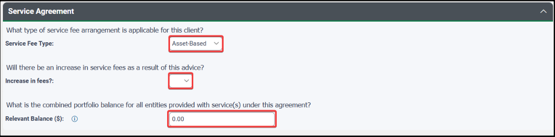
Please note if you have entered your Service Arrangement fees within the product selection in WealthSolver these will NOT pull through to your disclosure tables.
Selecting a Fee Type, the Service Arrangement fees entered under the Benefits Received tab within the Product Costs section below to pull through to your disclosure tables accordingly.

Adviser Fees (Non-Product Related)
Where you are not taking professional fees from recommended products or have not modelled your product recommendations within WealthSolver or Risk Researcher as outlined earlier, you can use the following sections to capture your Adviser Service Fees and Product Costs manually.
For your Adviser Service Fees you have the option to enter amounts being charged for the preparation of the RoA and the Implementation of the RoA, as well as Service Arrangement fees being invoiced to a client (not sourced from a product or platform)

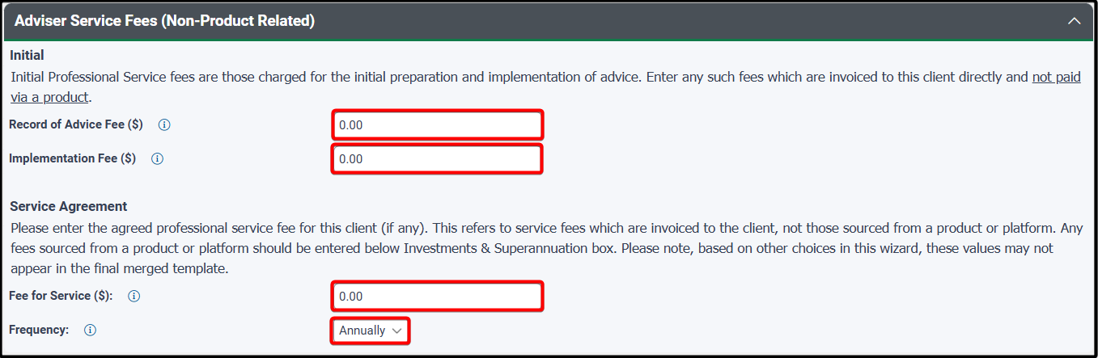

Automated Fee Disclosure
The automated fee disclosure panel will appear where you have used WealthSolver and/or Risk Researcher modelling, in which case your product fees will automatically be generated. You will ONLY need to manually enter product fees in the following panels where they have NOT been included in WealthSolver and/or Risk Researcher.

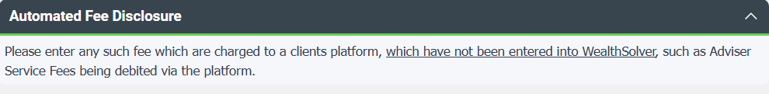

Product Costs – Investment & Superannuation
Product costs for Investment, Superannuation & Pension can be selected by using the Add button to enter in the relevant adviser service fees and product cost details manually.
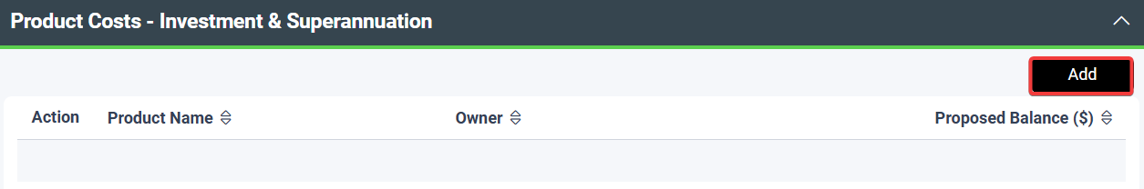

Select the product details from the available dropdown menus for Type, Product and Owner, enter the proposed balance to be invested and complete the associated costs under the Benefits Received and Product Costs tabs.

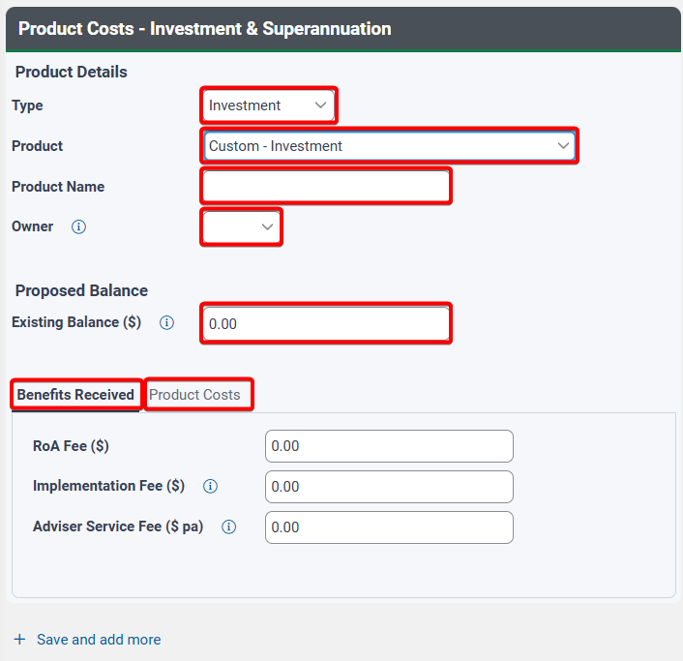

Note – As noted earlier, Service Arrangement fees entered under the Benefits Received tab will only pull through to your disclosure tables if a Service Arrangement Fee type is selected.

Product Costs – Risk Insurance
Risk Insurance commission fees can be entered by selecting the Add button to enter in the relevant insurance product commission details manually.
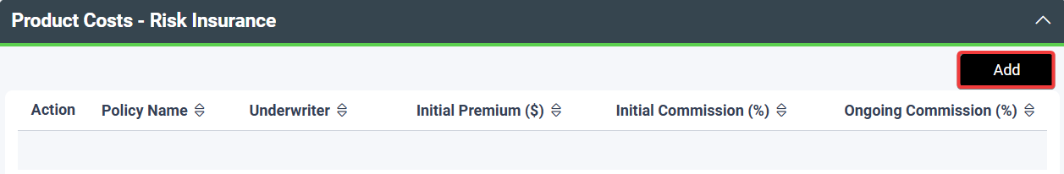

Select the underwriter details from the available dropdown menu for Underwriter and enter the Policy Name and Life Insured, enter the $ amount for Initial & Renewal Premiums and % amount for Initial and Ongoing Commissions.
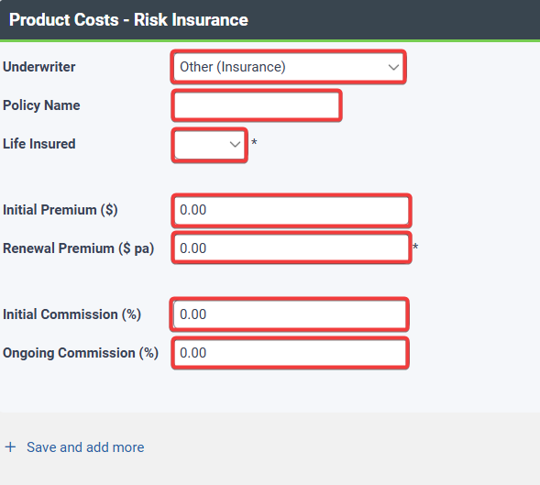

Insurance Disclosures
Where you are recommending insurance and wishing to dial down the insurance commission to 0%, please select Yes. This will calculate the dialled down insurance commission in the product fee disclosure table output.
Where consent to receive insurance commissions is required, please select Yes. This updates the Authority to Proceed, confirming client(s) consent via their ATP signature. Text in the product disclosure notes will also be adjusted accordingly.
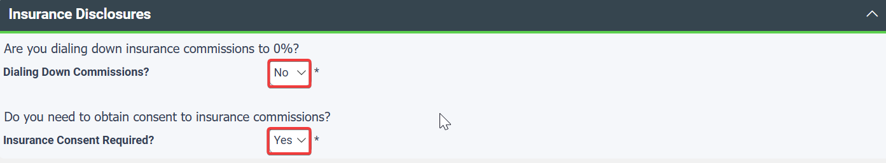

Merge your ROA
After completing the wizard to your satisfaction, you will then need to Merge the RoA by selecting Merge RoA.
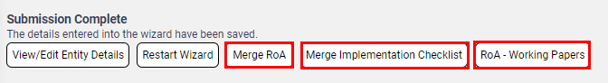

Download and Open/Save the RoA
Once you have followed the instructions on screen to Merge your RoA and included any required variables, XPLAN will begin preparing your RoA. Once complete, the notification bell on the top right of your screen will have a number 1 displayed next to it. Click on the notification bell and then click on the Download Report.
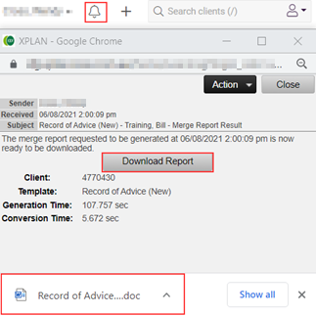

We strongly recommend that you Save As the resulting file into a location on your hard drive.

Defined Purpose RoA Options
Selecting Defined Purpose opens optional selections under the Document Controls page.
- The date of the SoA being used to incorporate by reference will automatically be populated from the Last SoA date field in the Administration section. Note: If you update this field will automatically update the Last SoA date field under Administration.
- Select the Defined Purpose RoA option from the dropdown menu:
  - Contributions Advice
  - Hold & Adjust Pension Payments
  - Hold Recommendation
  - Hold & Continue MPS
  - Hold & Rebalance Portfolio
  - Hold & Investment Switch
  - Product Replacement – Super Only
  - Lump Sum Withdrawal
  - Term Deposit Renewal & Rollover

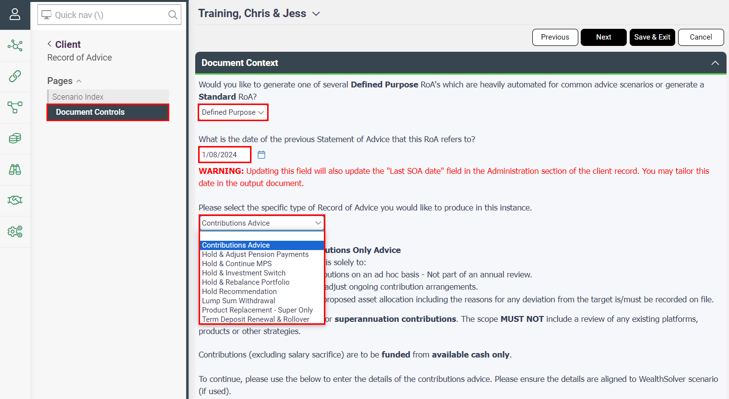

Contributions Advice
Select the Contributions Advice where your advice is solely to:
- Make superannuation contributions on an ad hoc basis – Not part of an annual review.
- Make one-off or commence/adjust ongoing contribution arrangements.
- Commentary regarding the proposed asset allocation including the reasons for any deviation from the target is/must be recorded on file.

The scope of this advice is solely for superannuation contributions. The scope MUST NOT include a review of any existing platforms, products or other strategies.
Contributions (excluding salary sacrifice) are to be funded from available cash only.

The wizard opens additional panels in the Document Controls page for completion.

Recommended Products panel
Select the Add button to add details of the contributor, the clients’ existing superannuation products and details of the contribution/s to be made and how it’s to be invested.
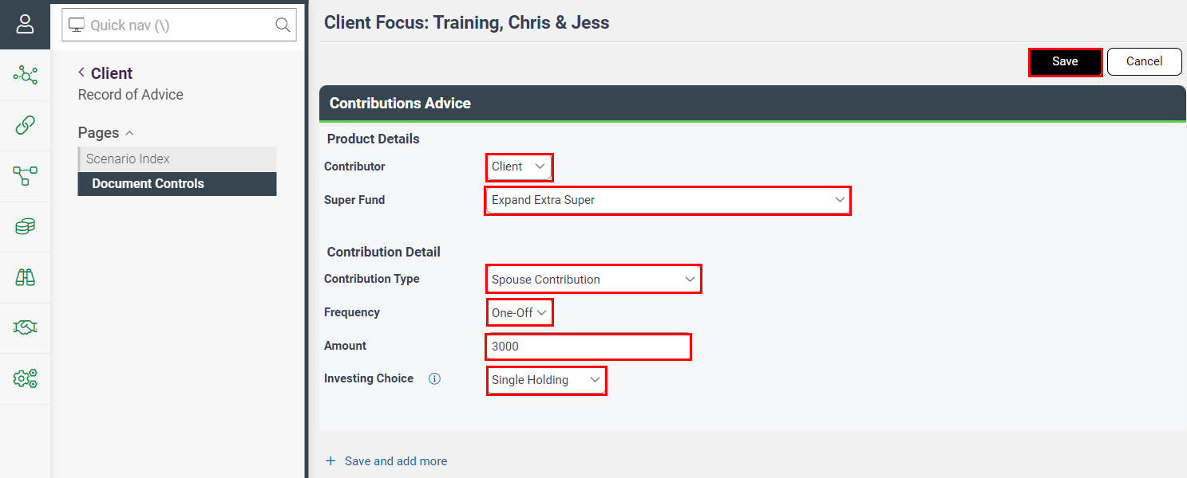

Investing Choice
Where the investing choice type selected is Specific Options, then a Specific Options Reasons field will open for you to enter the reasons for selecting the relevant specific option for investing into.
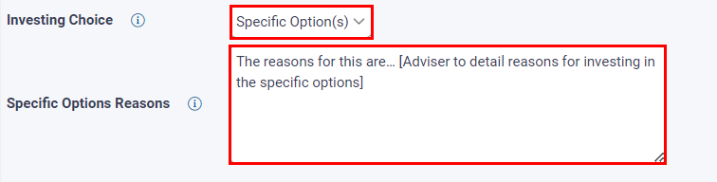

Additional Information panel
- Select the WealthSolver scenario that contains the contributions advice.
- Insert the reasons for the contributions advice and why the contribution is suitable with regard to the client’s needs and objectives.
- Confirm if this advice will impact the client’s overall service agreement fee – select from yes, no or not on service agreement. If yes – enter in the updated total service agreement fee as a result of the contributions advice.
- Confirm if you are charging an additional fee for this advice. If no, select if it forms part of the service agreement. If yes – ad hoc fee, then enter a description of the nature of the fee being charged in the free text field.
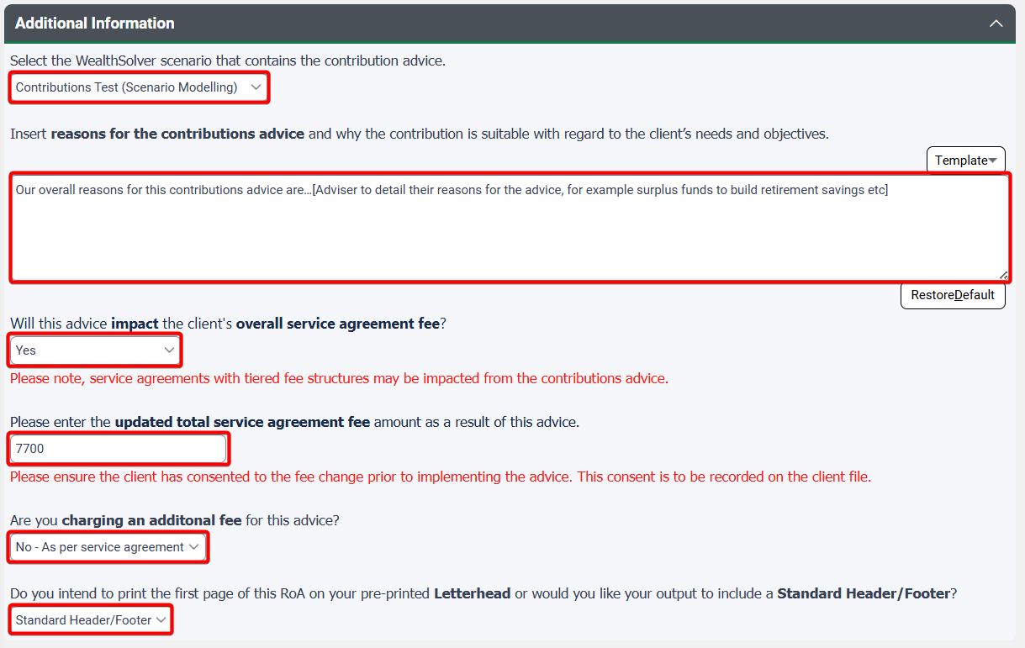
- Select the relevant Letterhead option for the first page of the RoA to be applied.

Select Next to move through to the merge screen and merge your RoA.

Hold & Adjust Pension Payments
Select the Hold & Adjust Pension Payments where your advice is solely to:
- Retain/Hold any existing platforms and policies.
- Adjust pension payments to meet updated living needs.
- Continue all other existing strategies as previously advised (Hold advice)
- Commentary regarding the proposed asset allocation including the reasons for any deviation from the target is/must be recorded on file.

The wizard opens additional panels in the Document Controls page for completion.

Recommended Products panel
Select the Add button to add the clients’ existing product/s – this ensures the relevant detail appears in the RoA.
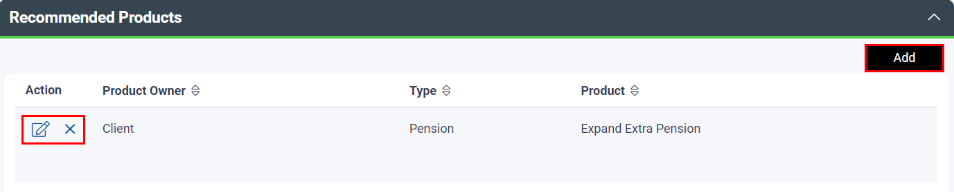

Note: Only add recommended Platforms, Products and/or Policies that are continuing to be held by the client(s). You DO NOT need to add each individual security or asset holding.

Additional Information panel
- Enter reasons for the hold advice and why the strategies and products remain suitable with regard to the clients’ needs and objectives.
- Detail the reasons for the change in pension payments with regard to the clients’ needs and objectives.
- Confirm if you are charging an additional fee for this advice and confirm if you are currently receiving insurance commissions as a result of the previous advice for the relevant disclosure to be applied.
- Select the relevant Letterhead option for the first page of the RoA to be applied.
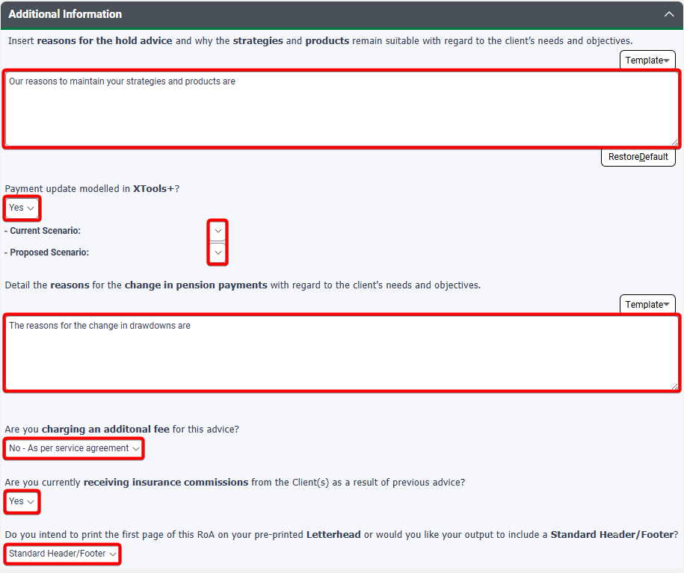
Select Next to move through to the merge screen and merge your RoA.

Hold Recommendation
Select the Hold Recommendation where your advice is solely to:
- Retain/Hold any existing platform, policies, or investments held.
- Continue all existing strategies as previously advised.
OR

Hold & Continue MPS
Select the Hold & Continue MPS option where your advice is solely to:
- Retain/Hold any existing platforms and policies.
- Retain/Hold all current underlying investments.
- Continue to use the Managed Portfolio Service and retain existing Investment Program(s).

The wizard opens additional panels in the Document Controls page for completion.

Recommended Products panel
Select the Add button to add the clients’ existing product/s – this ensures the relevant related party disclosure is captured.
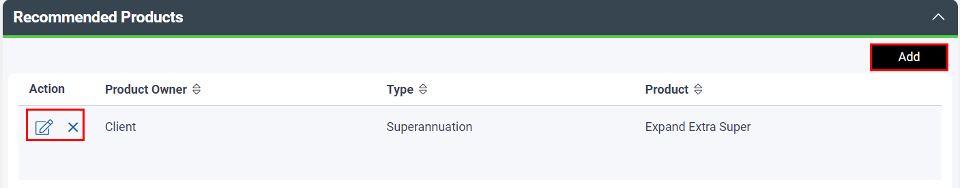

 | Note: The ‘Hold’ and ‘Hold & Continue MPS’ defined purpose ROA template now supports multi-entity advice. To ensure the correct output, please add all products where the advice applies to related entities.  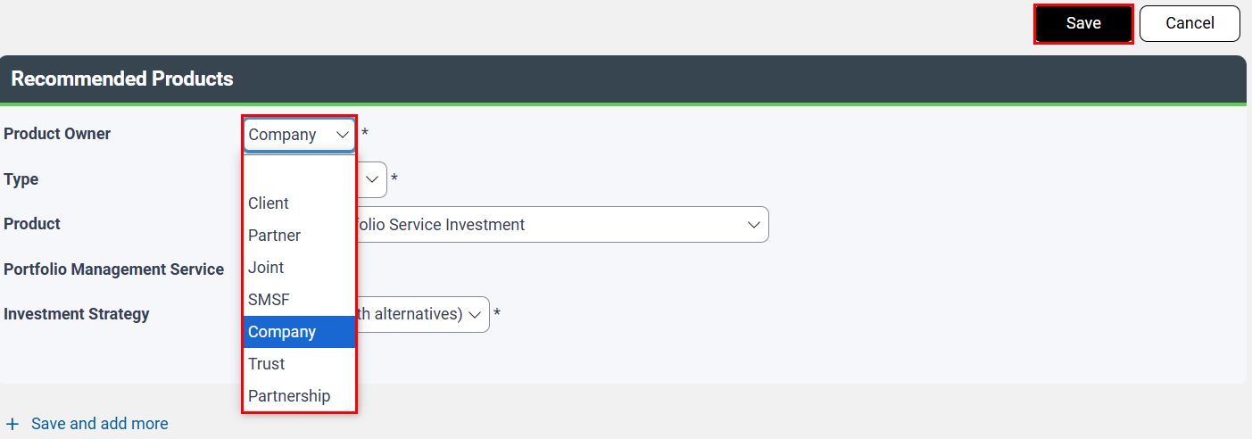

Note: Only add recommended Platforms, Products and/or Policies that are continuing to be held by the client(s). You DO NOT need to add each individual security or asset holding.

If your Product contains MPS, make sure MPS is selected for the Hold & Continue MPS option.
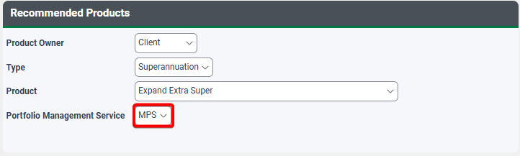

Additional Information panel
- Enter reasons for the hold advice and why the strategies and products remain suitable with regard to the clients’ needs and objectives.
- Confirm if you are charging an additional fee for this advice and confirm if you are receiving insurance commissions as a result of the previous advice for the relevant disclosure to be applied.
- Select the relevant Letterhead option for the first page of the RoA to be applied.
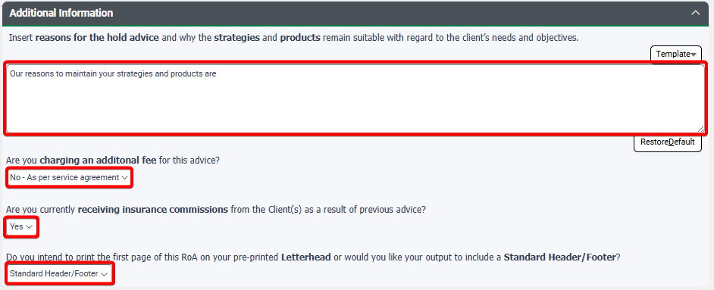

Select Next to move through to the merge screen and merge your RoA.

Hold & Rebalance Portfolio
Select Hold & Rebalance Portfolio option where your advice is solely to:
- Retain/Hold any existing platforms and policies.
- Rebalance your portfolio within the existing platform back to the last advised allocations (i.e. no new investment options).
- Continue all other existing strategies as previously advised.
OR

Hold & Investment Switch
Select Hold & Investment Switch option where your advice is solely to:
- Retain/Hold any existing platforms and policies.
- Switch investments within the portfolio of your existing platform (this can include adding new investment options)
- Continue all other existing strategies as previously advised.
Requires a WealthSolver scenario to be completed.
This Defined Purpose option does not cover a change in investment program for MPS – you will need to utilise the Standard RoA to ensure you get the relevant recommendation when switching MPS programs.
The wizard opens additional panels in the Document Controls page for completion.

Recommended Products panel
Select the Add button to add the clients’ existing product/s – this ensures the relevant related party disclosure is captured.

Note: Only add recommended Platforms, Products and/or Policies that are continuing to be held by the client(s). You DO NOT need to add each individual security or asset holding.

Additional Information panel
- Enter reasons for the hold advice and why the strategies and products remain suitable with regard to the clients’ needs and objectives.
- Select the relevant WealthSolver scenario that contains the portfolio rebalance OR the investment switch scenario
- Confirm if the retirement bonus is relevant for your product.
- Confirm if you are trading at a specific price (investment switch only).
- Confirm if there are any CGT implications that need to be disclosed – select the appropriate scenario from the tick box options.
- Confirm if you are charging an additional fee for this advice and confirm if you are receiving insurance commissions as a result of the previous advice for the relevant disclosure to be applied.
- Select the relevant Letterhead option for the first page of the RoA to be applied.
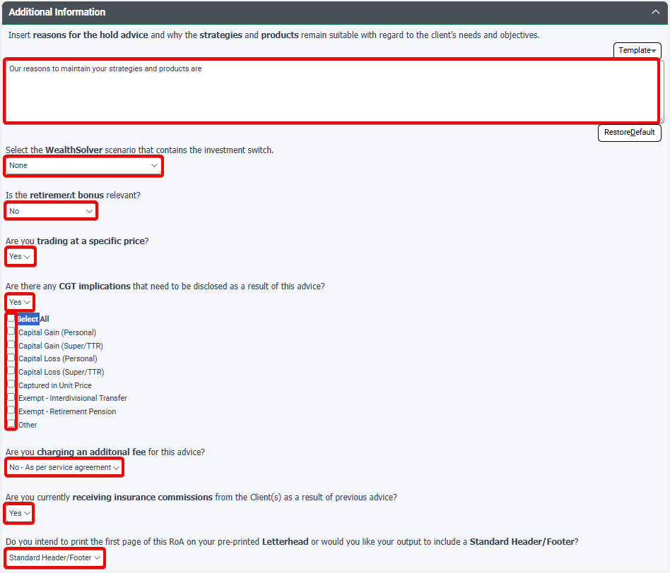

Select Next to move through to the merge screen and merge your RoA.

Lump Sum Withdrawal
Select Lump Sum Withdrawal option where your advice is solely to make a lump sum withdrawal from an existing product(s) to a client’s bank account on their request.
This includes selling down directly to the bank account or selling down to the portfolio’s cash account before transferring the funds to the bank account.
The withdrawal must allow the client’s portfolios to continue to be invested in line with their most recent assessed risk profile.
The scope of this advice does NOT include a review of any existing platforms, products or strategies. Withdrawals under compassionate or hardship grounds are also NOT supported.
The wizard opens additional panels in the document controls page.
A modelling scenario from either WealthSolver or Portfolios (IPS) is NOT required where your withdrawal funding type is based on a proportional sell down of underlying investments, cash or from a single investment holding. And IS required where the funding type selected is specific options.

Withdrawal Advice panel
Select the Add button to enter the product details from where the withdrawal is being made.
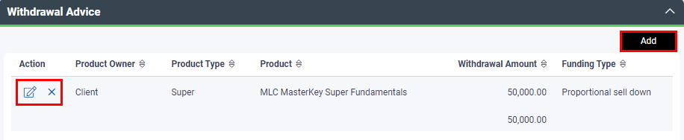

The Withdrawal Advice panel will open, and you will need to select the Product Owner, the Product Type, the Product, enter the amount being withdrawn and then select the Funding Type.
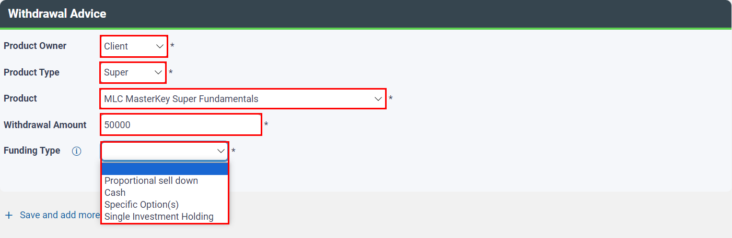

Funding Type
Where the funding type selected is Specific Options, then a Sell Down Reasons field will open for you to enter the reasons for selecting the relevant specific option for drawing from. And the inclusion of a Withdrawal Detail menu, allowing you to select which tool, WealthSolver or Portfolio (IPS), your modelling scenario is to be referenced from or whether you will add one manually.
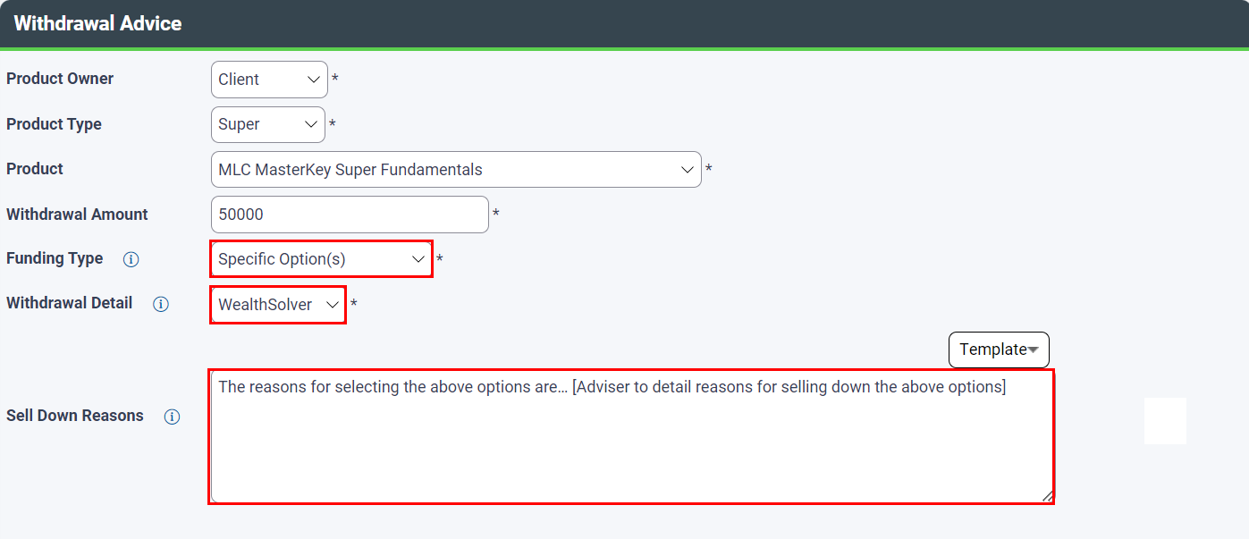

Select Save to apply and move back to the main document controls screen.

Additional Information panel
Answer the additional information questions, as follows:
- Confirm if the client and/or partner hold any other accounts, and the reason for withdrawing from the selected account.
- Where Specific Option has been chosen, select the relevant modelling scenario from either WealthSolver or Portfolios (IPS)
- Confirm if Centrelink considerations are relevant – this question will only appear if the product is a superannuation or pension account.
- Confirm if the retirement bonus is relevant for your product – this question will only appear if the product is a superannuation or pension account.
- Confirm if there are any CGT implications that need to be disclosed – select the appropriate scenario from the tick box options.
- Confirm if there is a need to disclose an untaxed element in the super fund
- Confirm if you are charging an additional fee for this advice or if it’s part of an existing service agreement fee.
- Select the relevant Letterhead option for the first page of the RoA to be applied.

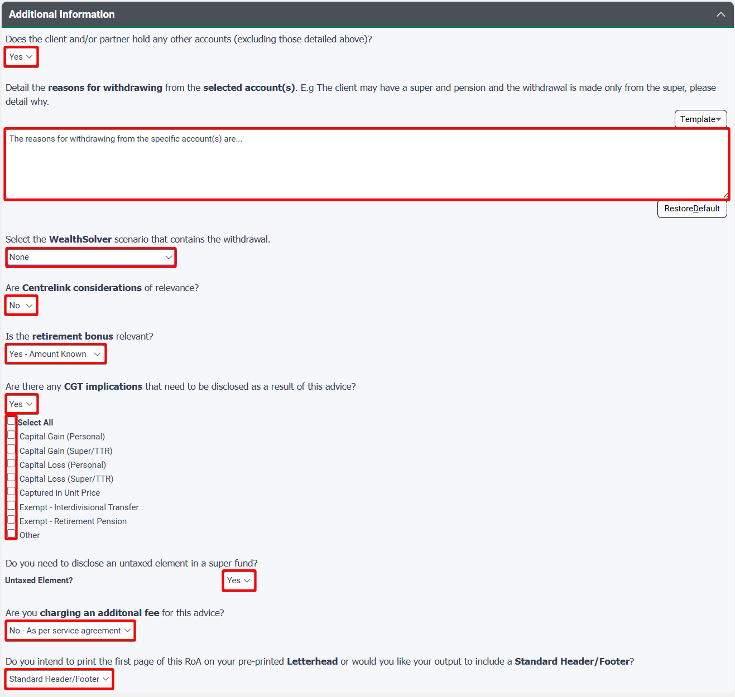

Select Next to move through to the Merge screen.
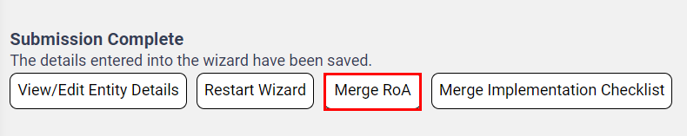

Product Replacement – Super Only
Select Product Replacement – Super Only option where your advice is solely to:
- Continue all existing strategies as previously advised including no changes to Risk Profile.
- Rollover an existing super fund/platform to a new super fund/platform.
The scope of this advice does NOT include a review of all other existing products and policies that the client(s) may be holding. It is limited to a single super to super replacement per person.
This Defined Purpose RoA should NOT be used for Super Funds that are internally holding insurance.
Requires a WealthSolver scenario to be completed.
The wizard opens additional panels in the Document Controls page for completion.

Recommended Products panel
Select the Add button to add the clients’ existing product/s – this ensures the relevant related party disclosure is captured.

Note: Where products are not supported and the ‘Other’ product selection is used and the product is a related party product, the disclosure will not generate when using this option.

Additional Information panel
- Enter reasons for the product replacement advice and why this is suitable with regard to the clients’ needs and objectives.
- Select the relevant WealthSolver scenario that contains the product replacement scenario and confirm if there are any limitations to the comparison of like for like products. If yes, provide details.
- Confirm if the retirement bonus is relevant for your product.
- Confirm if there are any CGT implications that need to be disclosed – select the appropriate scenario from the tick box options.
- Confirm if there is a need to disclose an untaxed element in the super fund
- Confirm if you are charging an additional fee for this advice.
- Select the relevant Letterhead option for the first page of the RoA to be applied.

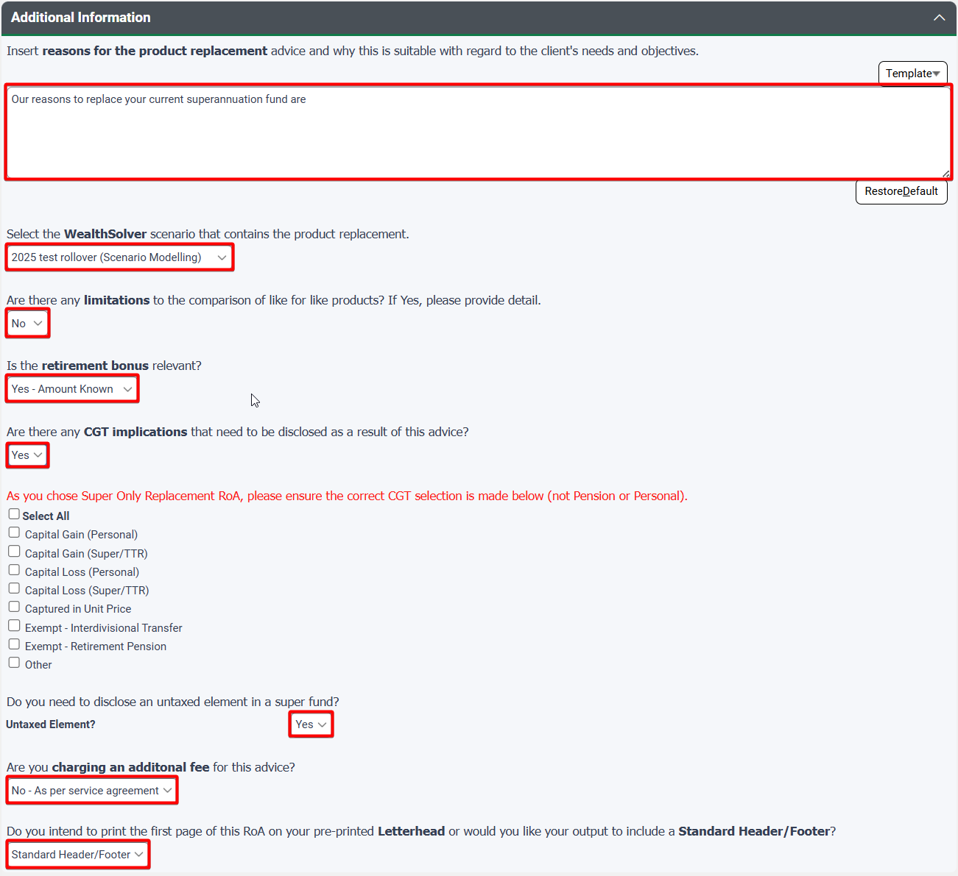

Select Next to move through to the merge screen and merge your RoA.

Term Deposit Renewal & Rollover
Select Term Deposit Renewal & Rollover where your advice is solely to:
- Renew a Term Deposit for another term with the same provider OR
- Rollover/Replace your current maturing Term Deposit for another term with a new provider.
The scope of this advice does NOT include a review of any existing platforms, products or strategies or the overall portfolio. It does not include advice on Bank Bills or a combination of Term Deposits with other financial products.
Any Term Deposits that are renewed or rolled over/replaced must be of the same total value or less as the existing Term Deposit. You may split or combined Term Deposits that are maturing soon. There cannot be any top-up of investment from Cash.
The wizard opens additional panels in the document controls page.

Term Deposit Advice panel
Select the Add button to enter the Term Deposit details.
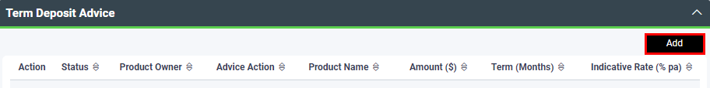

Select the Product Owner, the status of the Term Deposit and the Advice Action (see table below) and whether the Term Deposit is to be held on Platform or not. If held on Platform, enter platform details accordingly.
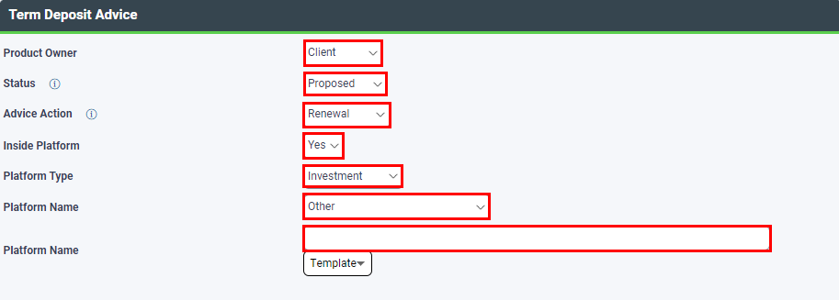

Type of Advice | Description
Renewals (same provider) | Add the Proposed Term Deposit only.
Replacement (to a different provider) | Add the Proposed, Existing and Like for Like Term Deposits.  Note - No Like for Like is required when replacements are one to one and the same amount.

Within the Details Tab, enter the Product Name, $ Amount, Term (Months) and the indicative rate (% pa). Select Save to apply the Term Deposit details.
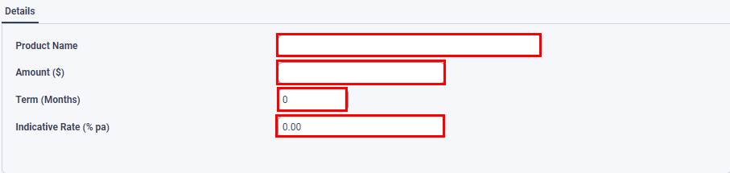

Additional Information
- For renewal, enter reasons for continuing to recommend a Term Deposit with regard to the client’s needs and objectives.
- For replacement, enter reasons for continuing to recommend a Term Deposit with another provider, with regard to the client’s needs and objectives. And provide further details of the Term Deposit replacement.
- Provide any additional consequences from this advice including any redemption restrictions.
- Confirm if you are charging a fee for this advice.
- Select the relevant Letterhead option for the first page of the RoA to be applied.

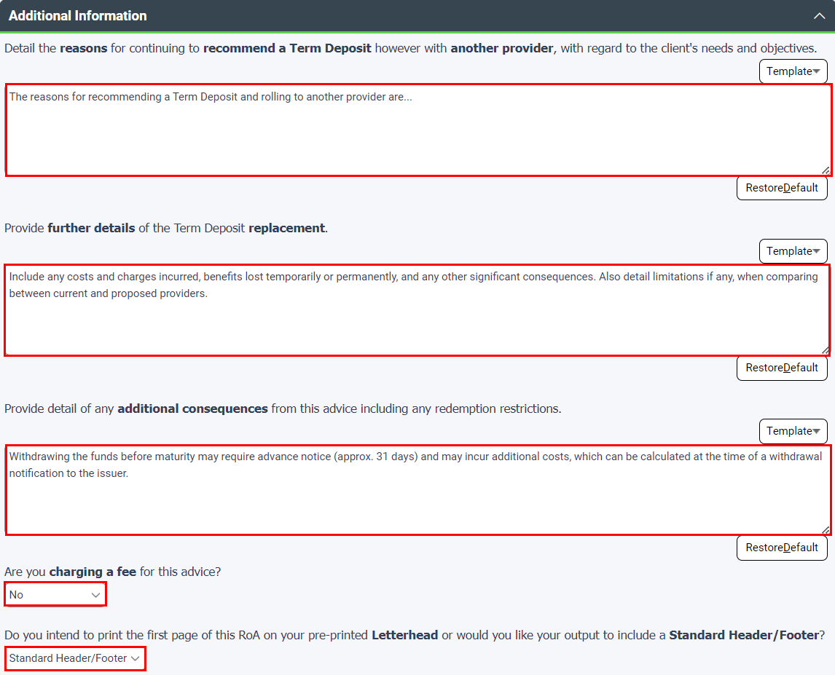

RoA for Non-Individual Entities
Preparing an RoA for Non-Individual Entity can be done based on addressing the advice to the Non-Individual Entity ONLY or combined advice to BOTH the Individual Entity and the Non-Individual Entity.

Combined Entity advice
The RoA Wizard (at the individual master entity level) supports the output of combined entity advice and is supported by WealthSolver and Risk Researcher, providing automated completion of the investment switch analysis/replacement of product and fee disclosure tables.
Advice being addressed to: | SoA Wizard at entity level:
Members of the SMSF only | Individual
Combined Personal and Related Entity advice | Individual
Your advice output will be addressed as follows:
Combined Entities:


Non-Individual Entity advice
The RoA Wizard is also available at each of the SMSF, Trust and Company levels however is not supported by WealthSolver or Risk Researcher. If you choose to complete the wizard at this level, you will need to manually complete your replacement of product and fee disclosure tables.
Advice being addressed to: | SoA Wizard at entity level:
Trustees of the SMSF only | SMSF
Directors of a Company only | Company
Directors/Trustees of Trust only | Trust
Your advice output will be addressed as follows:
Non-Individual Entity:


Standard RoA
For combined entity advice, follow the steps as outlined earlier in this guide, ensuring that in the Document Controls page you have selected the related Non-Individual Entity.
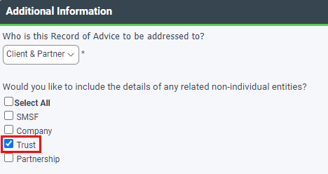

In the Recommendations page you have the option of toggling from the master Individual Entity to the related Non-Individual Entity. The page will open into the Non-Individual Entity, and you can select the appropriate recommended strategies to be applied.
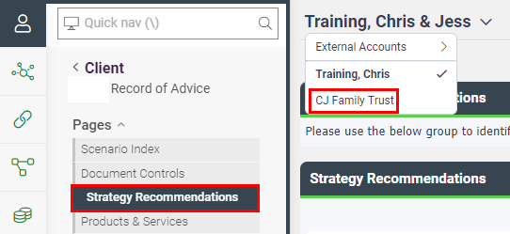

Toggle back to the Individual Entity to continue through the remainder of the wizard.
The remaining pages cater for both Individual and Non-Individual Entities.

Products & Services
Enter the recommended products by for the Non-Individual Entity by selecting the owner from the dropdown menu.

Product Replacement page
Related Entities modelled in WealthSolver will populate Replacement of Product tables based on their selection within WealthSolver, as well as selecting the related Client and/or Partner in the Product Replacement page. For example, if the SMSF is related to the Partner Only, then make sure you select Partner in this page to ensure the SMSF tables appear.

Xplan Content page
XTOOLS+/CALM projection tables/charts will only appear for non-individual entities when the entity has been selected in the document controls page.
SMSF selections available:
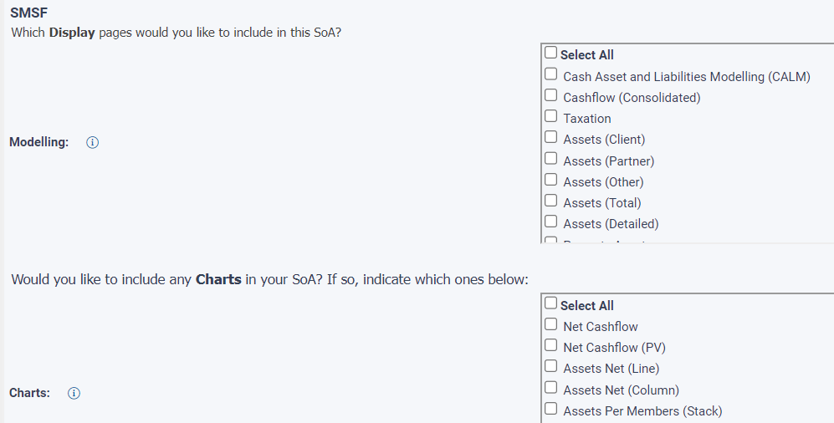

Company selections available:
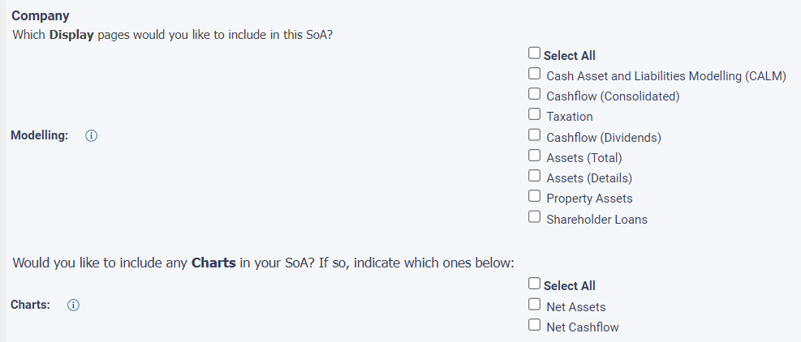

Trust selections available:
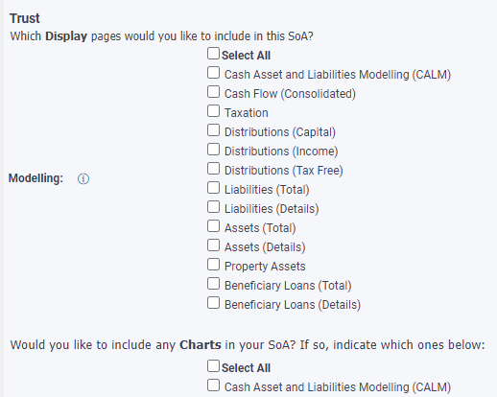

Fees and Disclosure page
Automated fee disclosure will apply where the related Non-Individual Entity has been modelled within WealthSolver and/or Risk Researcher.
Where manual entry is required, complete by selecting the relevant Entity as the owner for each fee to be entered.

Defined Purpose RoA
Defined Purpose RoA options can be used with related Non-Individual Entities as follows:
Defined Purpose Option | Entity Level
Hold Recommendation | Combined Entity at Individual
Hold & Continue MPS | Combined Entity at Individual
Hold & Rebalance Portfolio | Combined Entity at Individual supports WealthSolver
Hold & Investment Switch | Combined Entity at Individual supports WealthSolver
Lump Sum Withdrawal | Combined Entity at Individual supports WealthSolver
Product Replacement – Super Only | Combined Entity at Individual supports WealthSolver
Term Deposit Renewal & Rollover | Combined Entity at Individual

For combined entity advice, the defined purpose RoA’s will pick up the details of the Non-Individual Entity based on product selection within the wizard, or where indicated through the WealthSolver modelling.
Please note, that where Non-Individual Entity details are picked up through WealthSolver, these are not reflected in the ROA address details.

