Client Service Agreements Xplan Guide
Generating Agreements via the CSA Wizard
1/07/2025

Table of contents
Generating and managing Client Service Agreements 2
Navigating the Client Service Model menu 2
Generating Agreements 2
Scenario Index 2
Generating the next Agreement 11

Generating and managing Client Service Agreements

Navigating the Wizards – General menu
To easily access your client service tools, you will notice that your XPLAN Client Menu contains a Wizard - General menu, which provides quick links to the related areas for Client Service tools – including the CSA Wizard and OFA Consent.
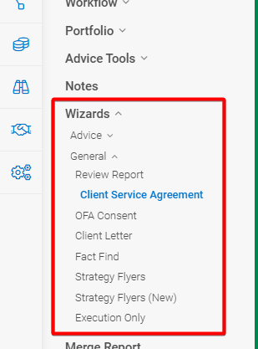

Generating Agreements

Using the CSA Wizard
Each time you run the CSA Wizard, you will have the choice of generating an Agreement only or a new CSA Case whether for the first or subsequent Agreements.
In the event a CSA Case is used, if, for any reason, you need to re-produce or change an existing Agreement you must follow the steps outlined in the Re-producing, changing and aborting Agreements section of the CSA Case Guide before re-running the CSA Wizard. If you do not do this, it will result in (a) a duplicate CSA Case; and (b) the new CSA Wizard scenario not auto-linking to the replacement CSA Case. This will create issues in the future that will need to be resolved.
An Agreement needs to be set at the master client entity even where the service provided is for a related entity. Within the Client menu, navigate to Client Service Model > Client Service Agreement

Scenario Index
- Enter a scenario name based on the commencement date of your Agreement and then select create scenario.
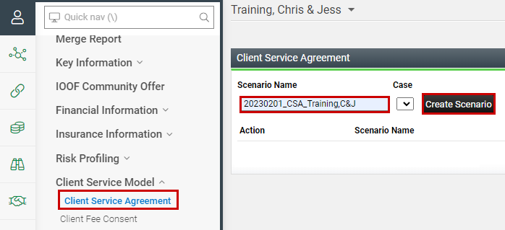

Within the Wizard you will be asked a series of questions which need to be completed before selecting Next to move through the Wizard.

Client Service Agreement Page
The first page of the Wizard outlines the main details of who the Agreement is for, the commencement date, the end date, and the selection of services.
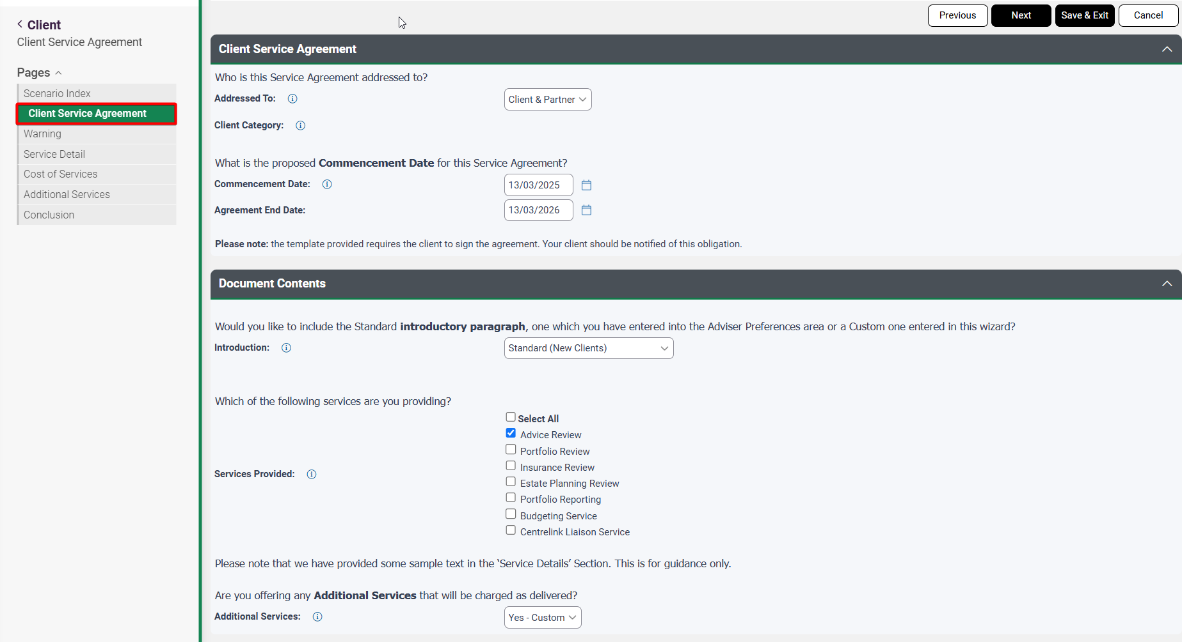
- Complete each of the fields as outlined in the table below.
Client Service Agreement page
Field | Action/Options
Addressed To | Confirm details of entity the Client Service Agreement is being made out to, choices being Client Only, Partner Only or Client & Partner
Commencement Date | Please identify the commencement date for the proposed Service Agreement. We suggest commencing your Agreement on the 1st of each month if practical. The Agreement will be considered to have ceased 12 months after this date (e.g. Commences 1 Feb 2023 ends on 31 Jan 2024).
Introduction for Cover Letter (Optional) | You will have the choice of using;  - Standard (New/Existing Clients) – a standard introductory paragraph provided to introduce the agreement. This is the default option and can be used for both New and Existing Clients.  - Standard (Continuing Relationship) - a standard introductory paragraph provided to introduce the agreement to Existing Clients only.  - Adviser Preferences – use this to bring through a template set at the adviser level that can be used across many clients – refer to My Preferences or Managed Field Content guidance.  - Custom – to manually enter an introductory paragraph for this client only.  - No Cover Letter – No cover letter will be included with your Agreement.
Services Provided | Select the appropriate services from the list of core services that you will be providing to the client.
Additional Services | Select whether you wish to list additional services:  - No – where no additional services are being provided as part of the agreement.  - Yes – Custom - to create your own custom list at time of creating the Agreement for this client only  - Yes – Adviser Preferences (include Fees) - to bring through services already created within the Adviser Preferences including the fees associated with the services.  - Yes – Adviser Preferences (exclude Fees) - to bring through services already created within the Adviser Preferences excluding the fees associated with the services.

Service Detail Page
This screen displays each of the Services Provided as selected on the previous screen.
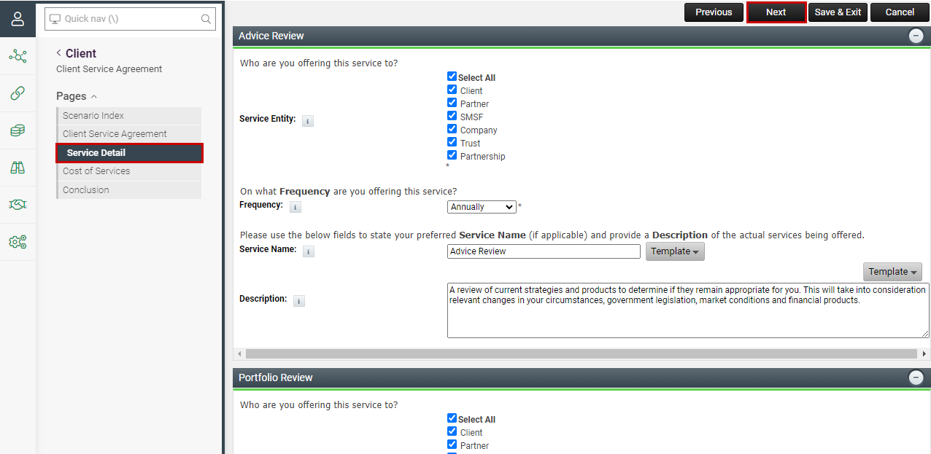

- Complete the fields as outlined in the following table:
Service Detail page
Field | Action/Options
Service Entity | Confirm details of entity the service is being provided for, choices being Client Only, Partner Only, Client & Partner, SMSF, Company or Trust
Frequency | Enter the frequency of the service being provided, Monthly, Quarterly, Four Monthly (3 per year), Half-Yearly or Annually. This will be used to drive the workflow tracking within the Case
Service Name | Review the wording and, if needed, you can customise the Standard Text for this client only or use pre-saved Managed Field Content.
Description | Similar to the service name, you can customise if required or use Managed Field Content.

Cost of Services Page
This screen allows you to set up the cost of services being provided based on the complexity of the fee structure you wish to use.
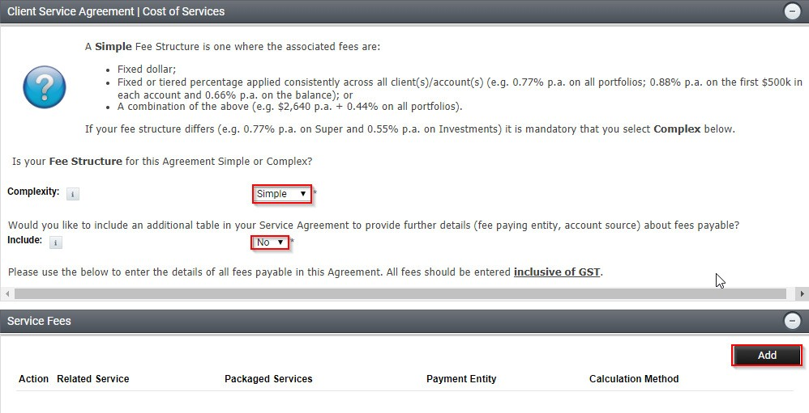

- Complete the fields as outlined in the following table
Cost of Services page
Field | Selection/Options | Action/Options
Complexity | Simple | You will have a choice to nominate simple or complex fee structures.  This fee structure is based on a flat dollar or asset-based fees and provides the option of including an additional Fee Breakdown table for completion.  E.g.: Flat Dollar amounts, Single Fixed % or Tiered Calculation  across all FUM.
Complexity | Complex | This fee structure is based on a mix of payment options and includes an additional Fee Breakdown table for mandatory completion.  E.g.: Multiple variable rates across FUM, combination of  tiered/variable/flat dollar.
Include (appears only if “Simple” is selected above) | Yes
Include (appears only if “Simple” is selected above) | No | This field provides the option of including an additional Fee Breakdown table for completion which outlines further information in relation to fees payable and how they will be paid.
* Refer to examples of client scenarios in the Client Scenarios guide.
- Select Add to open the Service Fees screen and then enter details of the services you have selected as outlined in the following table and then select Save.
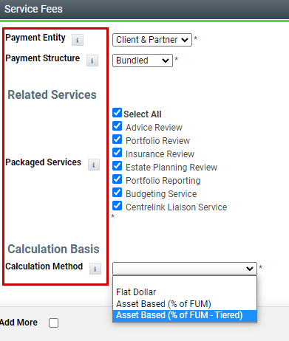

Service Fees
Field | Options | Action/Options
Payment Entity | Client | Select the entity the fee relates to
Payment Entity | Partner | Select the entity the fee relates to
Payment Entity | Client & Partner | Select the entity the fee relates to
Payment Entity | Other entity e.g. SMSF | Select the entity the fee relates to
Payment Structure | Bundled | Allows you to select a list of services combined as a package with one set fee whether that’s based on flat dollar or asset-based fees, fixed % or tiered model.
Payment Structure | Unbundled | Allows you to itemise services with their own individual fee whether that’s based on flat dollar or asset-based fees, fixed % or tiered model.
Related Service(s) | Service List | - For Bundled arrangements – You will need to choose from the list of Packaged services to relate the fee to the service.  - For Unbundled arrangements – You will need to choose each service from the list of Related service to enter the fee associated to that service.
Calculation Basis – Calculation Method | Flat Dollar | For arrangements where a flat fee is being used. You will then be required to enter the Flat Dollar Amount ($pa)
Calculation Basis – Calculation Method | Asset Based | This would be used where a flat percentage applies across the clients FUM. Also enter the Asset Based Fee (% pa)
Calculation Basis – Calculation Method | Asset Based Thread | To be used where a tiered fee structure is recommended/in place. These need to be set at the adviser preferences level.
Expected FUM | $ Amount | Enter the FUM that the applicable fee is being charged on. Only relevant for Asset Based arrangements.
Payment Details | Simple | Where you have selected complexity of Simple fee structure and Yes to include a fee table – complete details of Payment Source and Payment Frequency. Note - where you have selected not to include a table, you are not required to complete the Payment  Details fields.
Payment Details | Complex | Where you have selected complexity of Complex, an extra table outlining the breakdown of fees will be included, and Payment Details fields must be completed.
Payment  Source | Invoice | Select where the fee will be paid from.
Payment  Source | Direct Debit | Select where the fee will be paid from.
Payment  Source | Product (Super/Investment/Pension) | Select where the fee will be paid from.
Payment Platform | List of product/platforms | This field only appears if product chosen from the payment source. Select applicable platform fee being paid by product.

 | A note on Payment Source - where you have selected to take payment from a Superannuation or Pension product, please ensure that you meet the Sole Purpose Test obligations.

Additional Services Page
Where you have chosen to add Additional Services by selecting Yes - Custom on the Client Service Agreement page, an Additional Services page opens within the Wizard where you can Add your Additional Services manually.
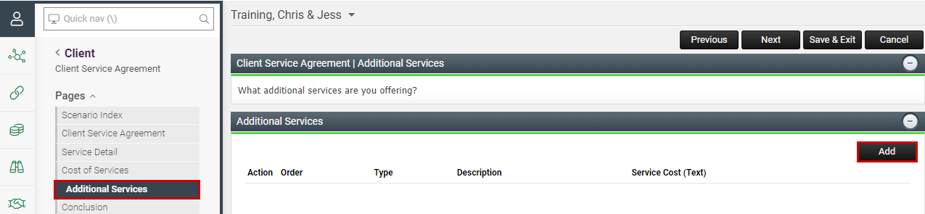

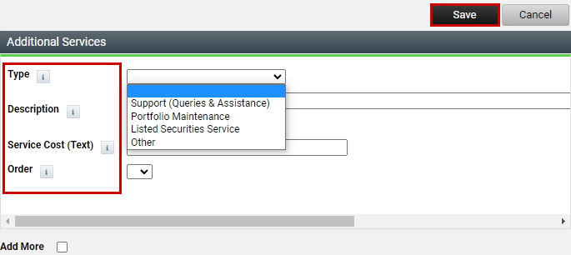

Enter the criteria for your Additional Service and select Save. Tooltips have been provided to explain each entry. If you have multiple additional services, you can select Add More.

Conclusion Page
This screen provides the option to choose a draft or final version of the Agreement to be merged for new Agreements. It also provides options for reprinting existing Agreements where amendments are being made part way through the Agreement period.
Selecting Agreement only (new CSA) / Draft Copy – case not generated will allow you to generate an Agreement document only. This could be the final version if you are not needing a Case, or a draft version so you can check that all details of your Agreement have been entered correctly without the system generating a Case.
Selecting Final (new CSA) – case generated and Next, a new Case will be created, and the Agreement will be ready to merge.
At any time you wish to simply re-print an existing Agreement, select either Agreement only (new CSA) / Draft Copy – case not generated or Re-print existing CSA (no amendments) – case not generated, and this will allow you to generate the Agreement without generating a duplicate Case.
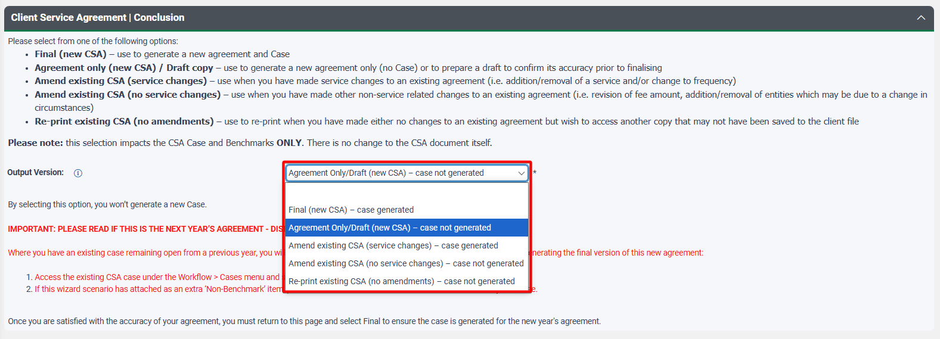

Refer to the Re-producing, changing and aborting Agreements section in the CSA Cases guide for more information regarding amending Agreements.

Select Next to move through to the merge screen and select Merge CSA to generate your Agreement. It will appear in the notification bell when ready for downloading.
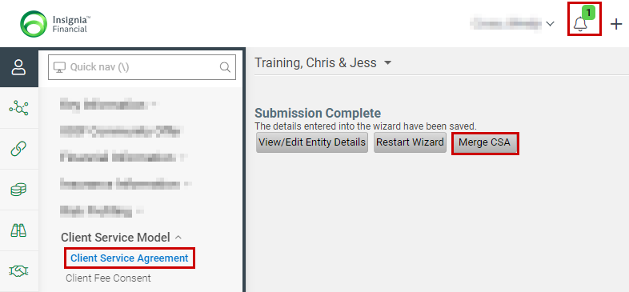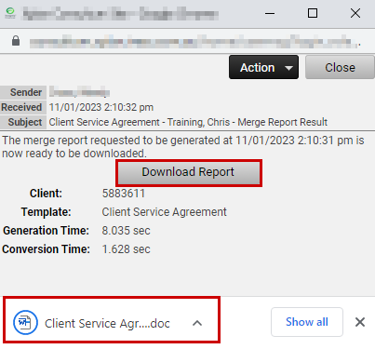

Generating the next Agreement
Prior to the end of the Agreement period, typically within the final 90 days, you will need to generate the next Agreement ready for re-engaging with the client for the next 12 months. The current CSA Wizard scenario can be copied within Xplan so all services within the current agreement will come across to the next CSA Wizard scenario for you to edit the criteria to reflect new commencement and end dates and any changes to service and fee information as required.
- Within the CSA Wizard scenario index, select the icon. This will save a copy of the scenario for renaming. Rename your scenario. Select Save.
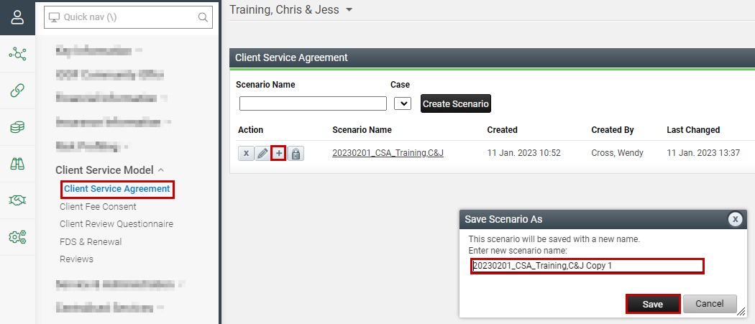

2. Update the commencement and end dates to reflect the next Agreement period.
- Review and update any change to services or fees.
- Generate the Final version as per earlier instructions.

NOTE – If you are using Cases, generating the next Agreement using the CSA Wizard can create a new CSA Case and Tasks. For a brief period of time you may have two sets of active CSA Cases and Tasks. The first relates to the current Agreement and will remain open until you have completed any outstanding services and uploaded evidence to the benchmark items at which point the CSA Case and Task can be completed. The second relates to the next Agreement and will remain active until completion over the next period.
January 2021 – Next Agreement CSA Wizard scenario linking issue:
Where a ‘Draft’ version is generated in 2nd and subsequent years, the CSA Wizard scenario is auto- linking as a ‘Non Benchmark’ item to the current active CSA Case. Before generating the ‘Final’ version, navigate to the current CSA Case and de-link the ‘Non Benchmark’ item. Navigate back to the CSA Wizard scenario and run the Final Agreement – the CSA Wizard scenario will then auto-link to the new CSA Case correctly. Refer Troubleshooting Guide for detailed instructions.
If you are confident of the accuracy of your ‘Final’ Agreement, you could bypass the step of running a ‘Draft’ in the 2nd and subsequent years Agreements and the issue will not present.

