Client Service Agreements Xplan Guide
CSA Troubleshooting
1/07/2025

Table of contents
Identifying and fixing common issues 2
Duplicated Cases 2
Cases missing CSA Wizard scenario 4
Commencement Dates set into the future 7
Overdue Client Authorisations 13

Identifying and fixing common issues
Some common issues that you may check for within your reporting are:

Duplicated Cases
Duplicated Cases occur when a CSA Case has already been generated and the same CSA Wizard scenario is re-run in order to get a more recent cover page or to make changes in dates, services, or fees. Clients should only have one ‘correct’ CSA Case per agreement period.
You can check for duplicated Cases at C2 in Tab 1 – ‘All Cases’ in the CSA Management Report.

Any clients with duplicated Cases will need to have the ‘redundant’ Case(s) aborted and ensure that the CSA Wizard scenario is linked to the ‘correct’ Case as follows:
- Navigate to the Client’s Case filter screen and identify which Case should be the ‘correct’ Case and which Case should be the ‘redundant’ Case.
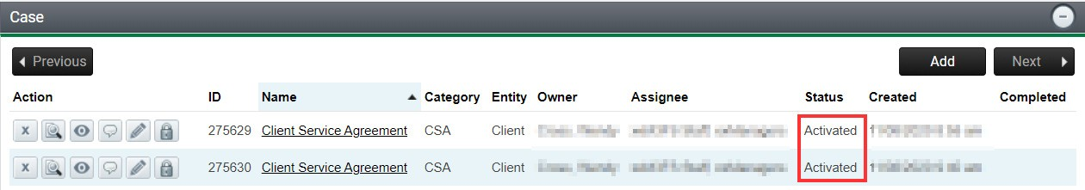

If the CSA Wizard scenario is linked to the ‘redundant’ Case and not to the ‘correct’ Case, then you will need to de-link the CSA Wizard scenario from the ‘redundant’ Case and then abort the ‘redundant’ Case, as follows:
- Enter the ‘redundant’ Case and de-link the CSA Wizard scenario and any other completed benchmark items by selecting the icon and then selecting OK to the question do you want to remove this item?
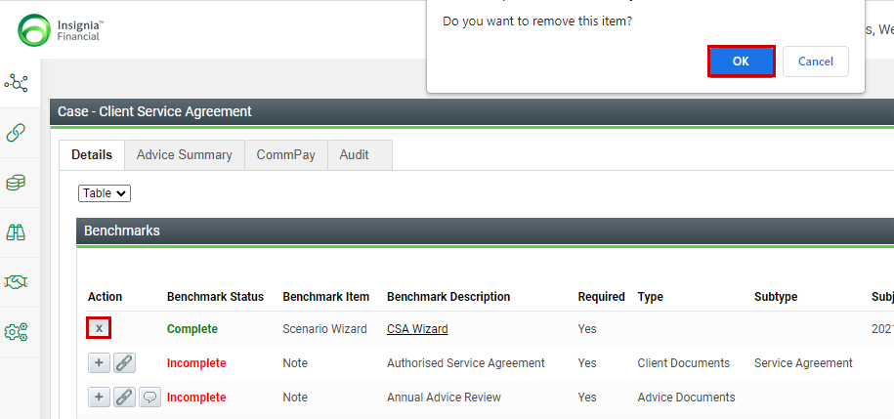
The benchmark items will convert back to incomplete status.
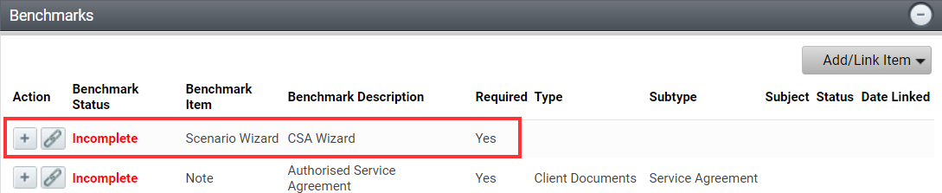

Once all items have been delinked the Case is ready to be aborted.

- Navigate to the Workflow Menu > Threads, select Case as the type and select the action dropdown arrow and select Abort.
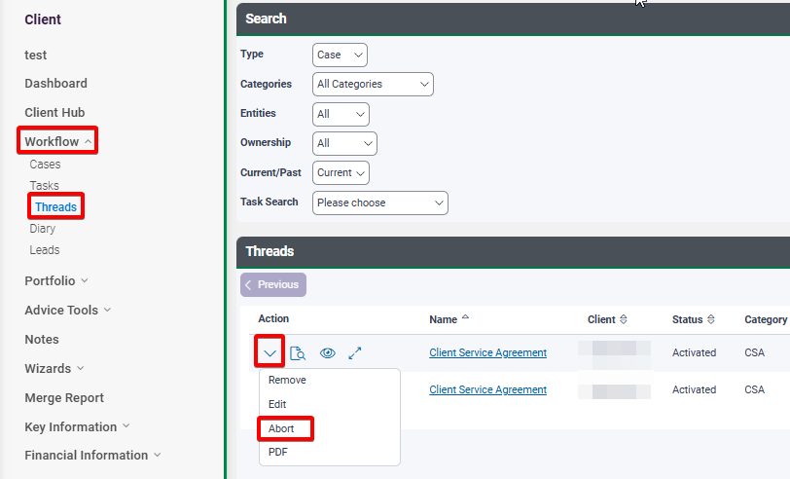

This will abort the associated Tasks and you can then enter the ‘correct’ CSA Case to link the CSA Wizard scenario to the ‘correct’ Case, as follows:

- Enter the ‘correct’ CSA Case and select the .
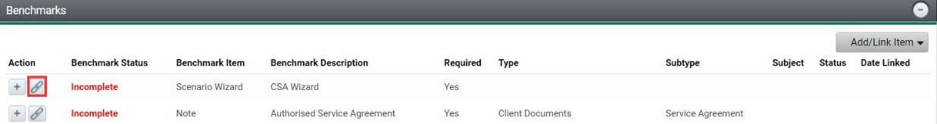

- The link existing scenario wizard will open, and you can select the appropriate scenario wizard.
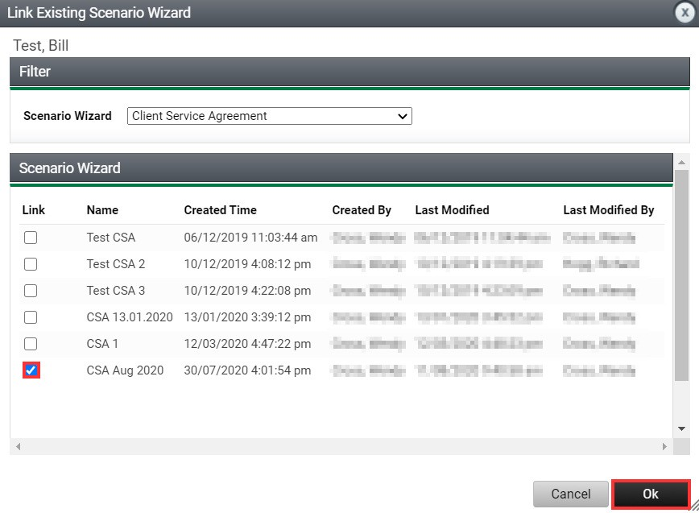

- The benchmark status for the CSA Wizard scenario will change to complete.
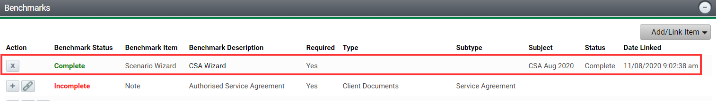

- Back in the Cases filter screen, your ‘redundant’ Case status will show as aborted and your ‘correct’ Case status will remain as activated.
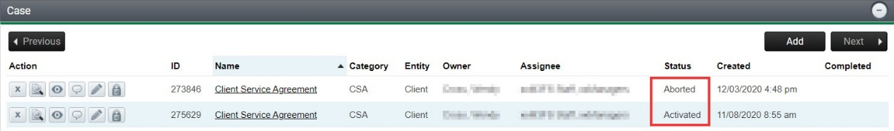

Cases missing CSA Wizard scenario
In the instance that you have Cases activated that are missing a CSA Wizard scenario (that leads to them missing a commencement date), this could be because you have re-run the CSA Wizard scenario without de-linking the scenario from an earlier generated Case and linking this to the newly activated Case.
You can check for missing CSA Wizard scenarios/commencement dates at Agreement Start Date in Tab 1 – ‘All Cases’ in the CSA Management Report.

Cases with missing CSA Wizard scenarios will need to have any ‘redundant’ Cases aborted (if not already) and ensure that the CSA Wizard scenario is linked to the ‘correct’ Case as follows:
- Navigate to the Client’s Case filter screen and identify which Case should be the ‘correct’ Case and which Case should be the ‘redundant’ Case.

If the CSA Wizard scenario is linked to the ‘redundant’ Case and not to the ‘correct’ Case, then you will need to de-link the CSA Wizard scenario from the ‘redundant’ Case and then abort the ‘redundant’ Case, as follows:
- Enter the ‘redundant’ Case and de-link the CSA Wizard scenario and any other completed benchmark items by selecting the icon and then selecting OK to the question do you want to remove this item?

The benchmark items will convert back to incomplete status.

Once all items have been delinked the Case is ready to be aborted.

- Navigate to the Workflow Menu > Threads, select Case as the type and select the action dropdown arrow and select Abort.

This will abort the associated Tasks and you can then enter the ‘correct’ CSA Case to link the CSA Wizard scenario to the ‘correct’ Case, as follows:
- Enter the ‘correct’ CSA Case and select the icon.

- The link existing scenario wizard will open, and you can select the appropriate scenario wizard and
Ok.
- The benchmark status for the CSA Wizard scenario will change to complete.

- Back in the Cases filter screen, your ‘redundant’ Case status will show as aborted and your ‘correct’ Case status will remain as activated.
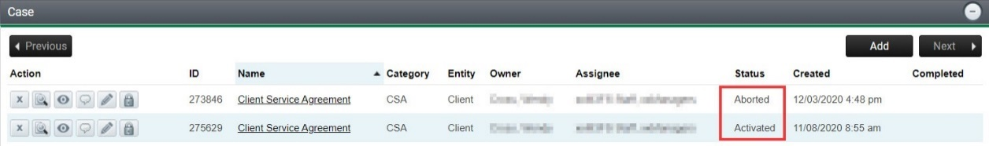

Commencement Dates set into the future
Typically, fees are being paid in advance and the annual review is being provided at the end of the service period. This is based on how most service agreements were established off the back of initial advice. Therefore, when seeing a client for their final review under the service agreement is when the adviser should position the new Agreement (where it is appropriate to do so).
The Agreement provides for a commencement date, enabling you to commence the service period at a future date (i.e. when existing Agreement expires or when you want to start initial Agreement). If a commencement date is not inserted into the Agreement and the client signs remotely (e.g., they may be posting it back) then their consent should trigger the commencement date. If an Agreement is to commence at a date in the future, the Agreement must state the commencement date.
Whilst you may specify a future date for the commencement date in the Agreement you will be restricted by any product provider requirements when deducting the fee from a product.
You can check the validity of your Agreement dates by running the CSA Management report. We have set the criteria for flagging on this report as Cases that have a commencement date greater than 120 days from the Case creation date which provides a bit of leeway – refer to M5 in Tab 1 ‘All Cases’.

Agreement created too early
If the commencement date relates to setting up agreements well into the future ready for supply to clients, you will need to abort the Case as follows.

- Navigate to the associated Case and Delink the CSA Wizard scenario and any other completed benchmark items by selecting the icon and then selecting OK to the question do you want to remove this item?

The benchmark items will convert back to incomplete status.

Once all items have been delinked the Case is ready to be aborted.

- Navigate to the Workflow Menu > Threads, select Case as the type and select the action dropdown arrow and select Abort.

This will abort the associated Tasks and you can run the Agreement closer to when the client is due to re- negotiate the next Client Service Agreement.

Commencement Date Error
If the commencement date entered was an error and you need to reset the Agreement date to reflect the correct Agreement period, re-running the CSA Wizard will instigate a new Case. You will need to de-link the CSA Wizard scenario from the initial Case and then link to the newly run Case as follows:

1. Navigate to the associated Case and Delink the CSA Wizard scenario and any other completed benchmark items by selecting the icon and then selecting OK to the question do you want to remove this item?

The benchmark items will convert back to incomplete status.

Once all items have been delinked the Case is ready to be aborted.

- Navigate to the Workflow Menu > Threads, select Case as the type and select the action dropdown arrow and select Abort.

This will abort the associated Tasks and you can run the Agreement closer to when the client is due to re- negotiate the next Client Service Agreement.

- Navigate to the CSA Wizard scenario and amend the Agreement date to the correct date.
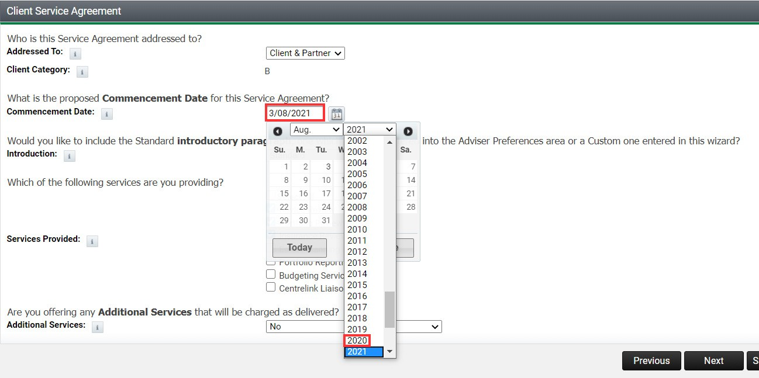

- Navigate to the Conclusion page and merge a new Final Agreement. A new CSA Case will be commenced, and the CSA Wizard scenario will automatically be linked to the new CSA Case.
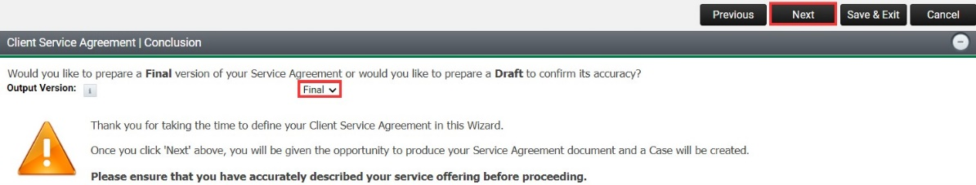

- Navigate to the Cases filter screen to confirm your existing Case has been aborted and your new Case has been activated and that the CSA Wizard scenario has been linked to the newly activated Case.
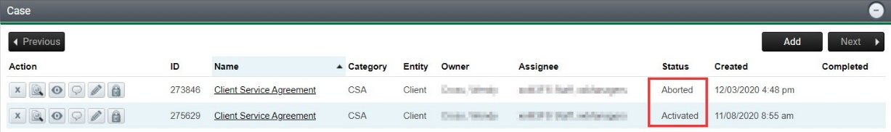

Overdue Client Authorisations
When a new CSA case is created, a “Commencement Date” is specified. Clients should be authorising the Agreement before the commencement date and certainly before any corresponding fees are deducted.
Once received, the authorisation must be saved to XPLAN and linked to the relevant benchmark within the CSA Case.
You can check the status of your Agreement authorisations to see if any are past their “Commencement Date” by referring to M7 in Tab 1 – ‘All Cases’. This field identifies those CSAs with no authorised agreement attached and the number of days into the Agreement period.

Any active Agreements without a linked Authorised Signed Agreement need to be rectified by completing the Authorised Signed Agreement Benchmark as follows:
Upload your signed Authorised Agreement to the Notes area of Xplan and then link the document to the Case from within the Document Note.

- Navigate to the applicable Client > File Notes > Add
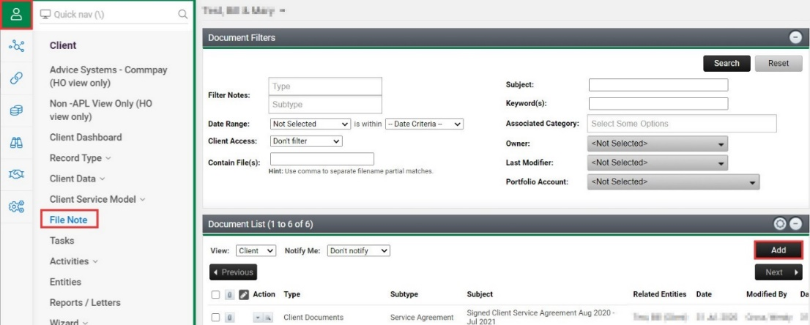

2. Select the Type and Subtype applicable to the document you are wanting to load for the service being provided.
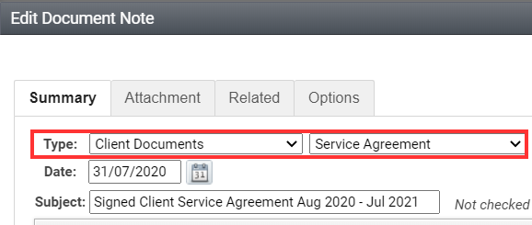

3. Upload the document to the Attachment tab.
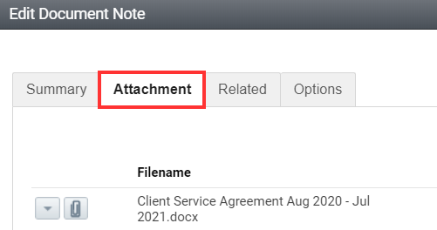

4. Select the Options tab, click into the Case box and select the Client Service Agreement option. Select Save and Close
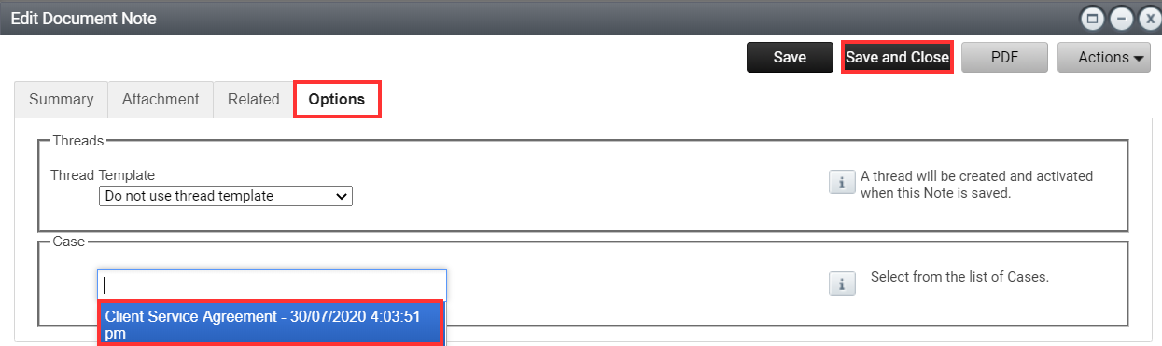

5. The associated benchmark item within the Case will now be updated to complete.
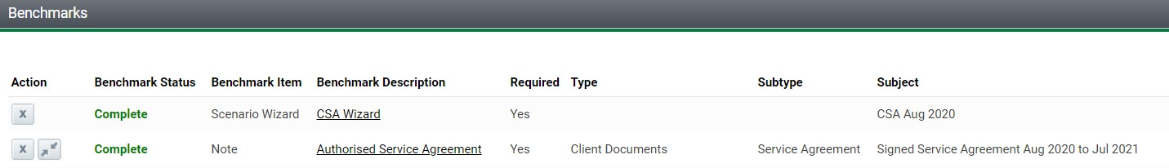

Editing existing File Note
Where you have existing File Notes saved that you are yet to link to the Case, you can simply edit the File Note to select the Options tab and select the Client Service Agreement Case.

1. Navigate to the applicable Client > File Notes and select and open the file note containing the document you wish to link to the Case.
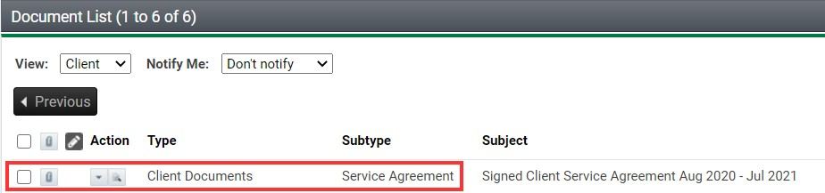

2. Select the Options tab, click into the Case box and select the Client Service Agreement option. Select Save and Close.

3. The associated benchmark item within the Case will now be updated to complete.

