Client Service Agreements Xplan Guide
Xplan Setup and Preferences
1/07/2025

Table of contents
Customising Agreements 2
My preferences 3
Introductory text 3
Additional services list 4
Additional Services sets 6
Tiered pricing model 7
Document preferences 9

Customising Agreements
Within Xplan you can add customised text and preferences for inclusion in the Agreements which will be available to select within the CSA Wizard. If this is not setup then standard text will apply.
 | Important: Preferences need to be set at the Servicing Adviser profile for the client, not the user who is generating the document.

My preferences
If you have any standard preferences that you want to make available across multiple clients, then you can set the following preferences against the Servicing Adviser profile:
- Introductory paragraph text
- Additional Services lists
- Additional Services sets
- Tiered Pricing Models
- Specific Document formatting
Once these have been setup against an Advisers Xplan profile these can then be applied against your clients in the CSA Wizard.

Managed field content
Managed Field Content (MFC) is the ability to set up templated text within XPLAN that can be selected and used within Wizards and documentation. For information on how to create templates for your practice, please refer to Managed Field Content User Guide. If your practice wishes to use customised text options within your Agreement, the following areas can be used:
- Introductory paragraph text
- Service names and descriptions

My preferences

Introductory text
This is a personalised introduction for your practice, service offer and value proposition. This can be set up as an Adviser Preference that can then be selected in the CSA Wizard to include within the Agreement.
- Under the Advisers Xplan profile, navigate to the Advisers My Preferences menu > My details > Client Service Agreement.
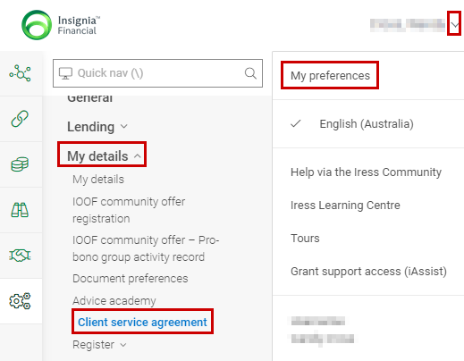

- This opens the Adviser Preferences screen where you can enter your personalised introduction text by selecting Edit.
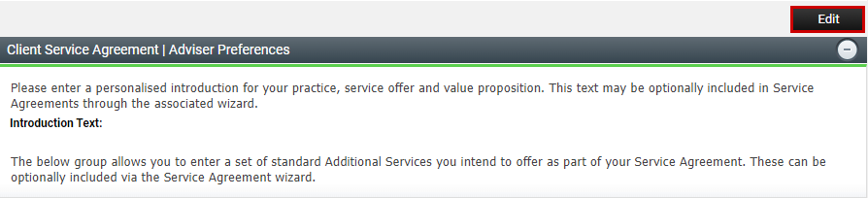

- Enter your personalised text in the Introduction Text field and select Save.
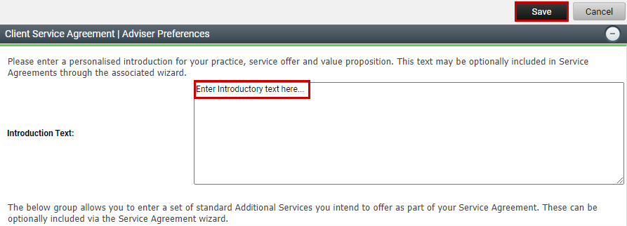

Additional services list
This is a list of additional services that sit outside the core services being provided to clients. If you have any additional services that you are including in your Agreements to clients, then adding them here can save you time entering them individually within the CSA Wizard.
            - Under the Advisers Xplan profile, navigate to the Advisers My Preferences menu > My details > Client Service Agreement

            - This opens the Adviser Preferences screen where you can navigate to the Additional Services section and select Add
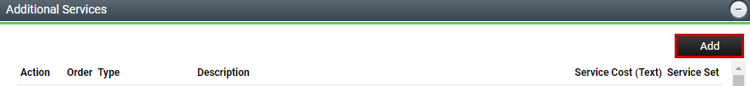

            - Within the Additional Services screen you can enter the criteria for each of your additional service items that you wish to add. Select the type of service from the Type dropdown box, then enter a description of the service and the cost. Each additional service will require a separate entry. To add a custom additional service, from the Type dropdown menu select Other, and then enter the Service Name, Description to appear within the agreement and associated text related to the cost. Check the Add More box if you wish to continue entering additional services to the list and then select Save. Repeat this process until done.
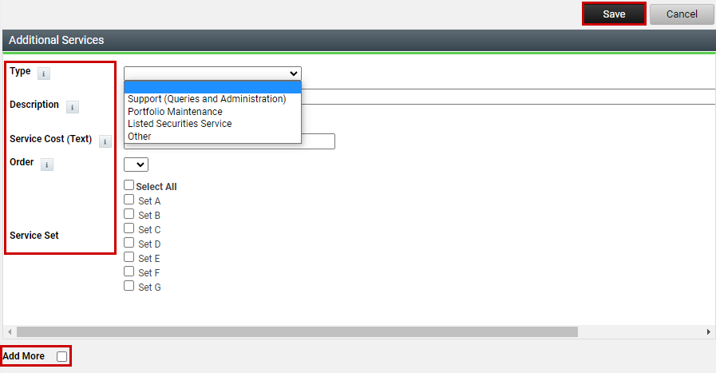

- Your Additional Services are now listed ready to pull through to the CSA Wizard. You can edit these if needed by selecting the icon.
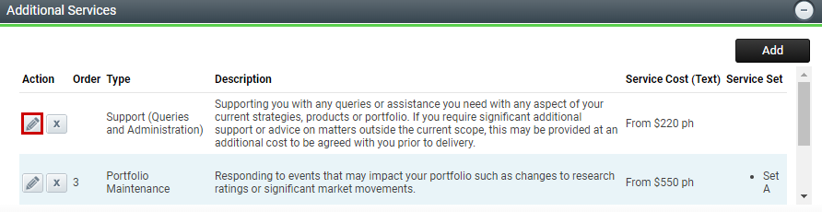

Additional Services sets
You also have the option to create sets of additional services that can be included in your Agreement, saving you time selecting individual preferences within the CSA Wizard.

            - Simply navigate to My Preferences > My Details > Client Service Agreement as outlined above and when entering your Additional Services, select the Type of Service, Description, Service Cost and then select the Order it will appear in the Set and which Set this service will belong to.
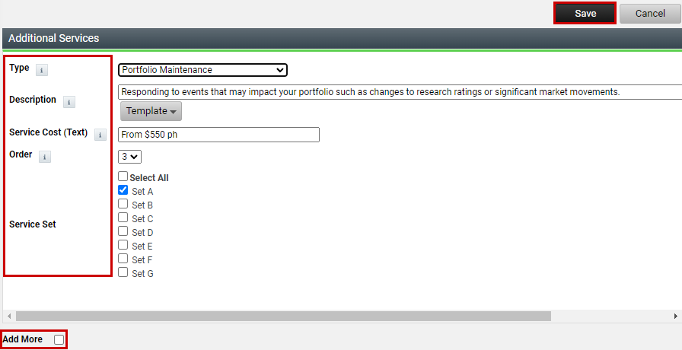

            - Continue to add Additional Services to Set A until you are satisfied with the Services contained in Set A, you can then create Additional Services for Set B. Your Sets are now ready to pull through to the CSA Wizard.

            - Within the CSA Wizard select Yes - Adviser Preferences (Service Sets) and then tick the appropriate Service Set you wish to pull through.
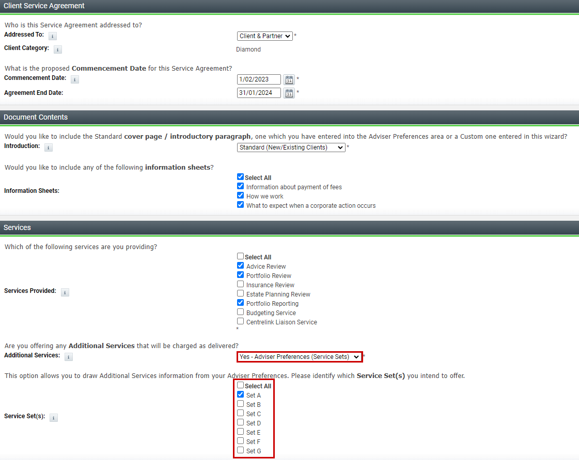

Tiered pricing model
If your Practice wishes to set up a Tiered Pricing Model using Asset Based fees applied against clients FUM, then you will need to add your Tiered Pricing Model under the Advisers XPLAN profile.

              - Under the Advisers Xplan profile, navigate to the Advisers My Preferences menu > My details > Client Service Agreement.

              - This opens the Adviser Preferences screen. Navigate to the Tiered Pricing – Model Details section and select Add.
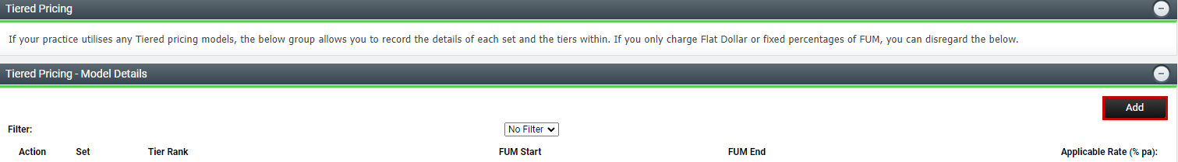

              - Within the Tiered Pricing – Model Details screen you can create different sets of tiered scales. The Tier Set Choice allows you to identify the specific fee set which applies. Any set prefaced by Adviser Preferences will draw on any tiers of the same set identifier from the Adviser Preferences page of the Client Adviser associated with this entity.
The Tier Rank determines the sequence of the tier scale, so the first tier is the first/lowest tier. Enter the applicable rate and FUM start amount and FUM end amount. Check the Add More box and Save to open a new criteria screen and continue entering details until all tiers/levels for your scale have been created in that set. You can choose to add additional fee sets if applicable.
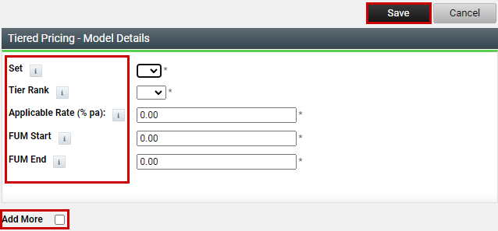
              - Your Tiered Pricing Model is now listed here ready to pull through to the CSA Wizard. You can edit these at any time by selecting the icon.
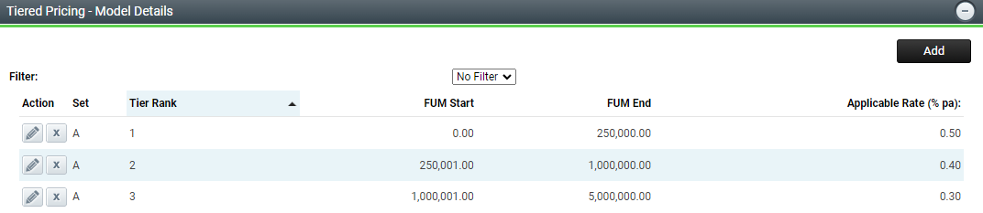

Document preferences
If your Practice wishes to set up document preferences (e.g. a Cover page image, colour schemes) to be applied against your Client Service Agreements, then you will need to add your document preferences under the Advisers Xplan profile. These can be found under My Preferences menu > My details > Document preferences.

