Client Service Agreements Xplan Guide
CSA Management Reporting
1/07/2025

Table of contents
CSA Management Reporting 2
Widgets 2
Suggested ‘Outstanding Tasks’ Widgets 4
Suggested ‘Workflow Tracking’ Widgets 5
Accessing & utilising management reporting 6
Accessing the CSA Management Report 6
Using the CSA Management Report 8

CSA Management Reporting
This section outlines how to manage your Agreements using Widgets on your Xplan dashboard screen for day to day workflow tracking and using the Management Report for managing Agreements across your client base.

Widgets
You can add one or more Workflow Tracking widgets to easily manage your Cases from the Xplan Dashboard.
1. On your main Dashboard, click the down arrow next to Main, then Add Widget
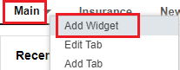

2. Add the Workflow Tracking widget
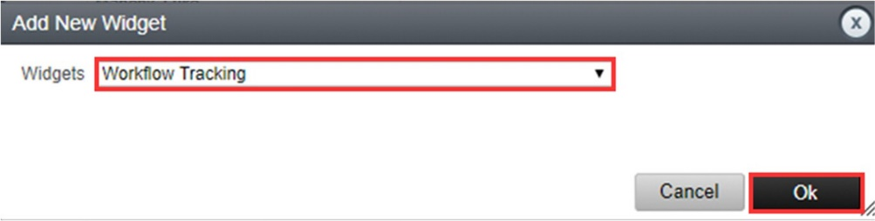

3. Choose the settings for your Workflow Tracking widget
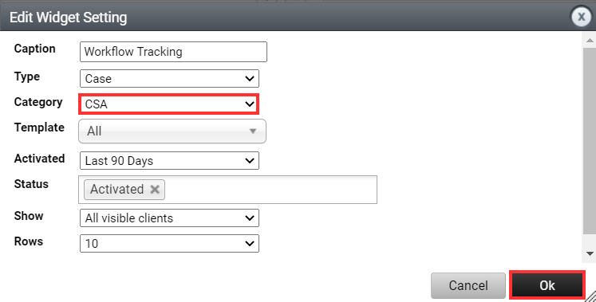

You can customise the settings of each widget:
Widget Settings
Setting | Description
Caption | Allows you to give the widget a custom title to easily identify what it displays
Type | Choose from Case, Thread or Lead
Category | Filter the items in the widget to a certain category of Case, Thread or Lead (note: all Insignia public workflows are under the ‘IOOF’ category)
Template | Filter the items in the widget to only show those created from a specific Case, Thread or Lead template (e.g. only show ‘Client Service Agreements’ Cases)
Activated | Filter to only show items activated in this many days (options ranging from 7 to 120+)
Status | Filter to only show items with one or more status (e.g. could remove ‘Complete’ and ‘Aborted’ to only show current Cases being worked on)
Show | Filter to only show items:  - All visible clients  - Created by me  - Assigned to me  - Cases/Threads with active tasks assigned to me
Rows | How many items to show in the widget (options ranging from 10 to 50)

Suggested ‘Outstanding Tasks’ Widgets
To show outstanding authorisations that need to be followed up and linked to the Case.
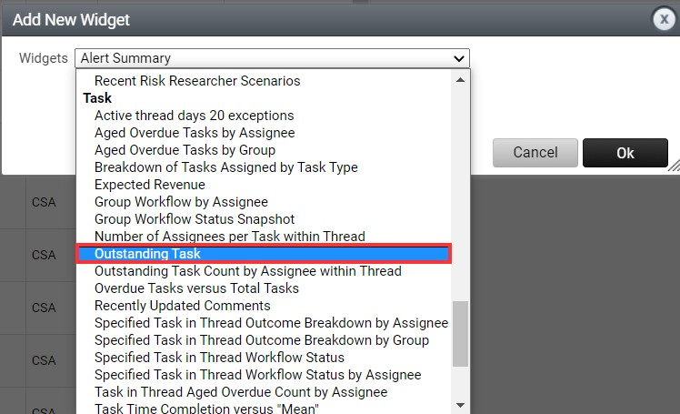

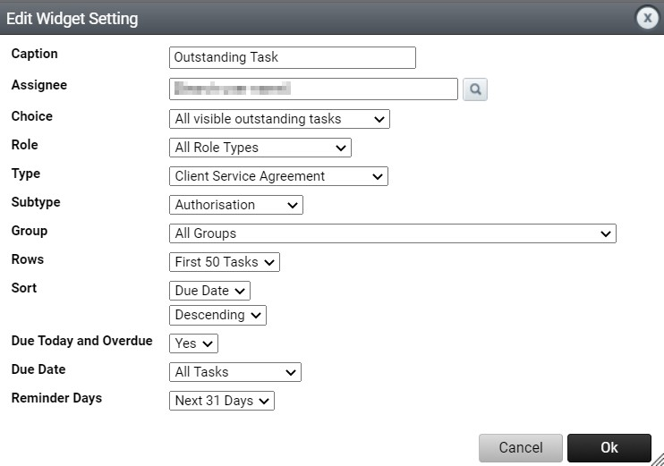

Suggested ‘Workflow Tracking’ Widgets
To show Cases that have been activated but not Completed or Aborted:
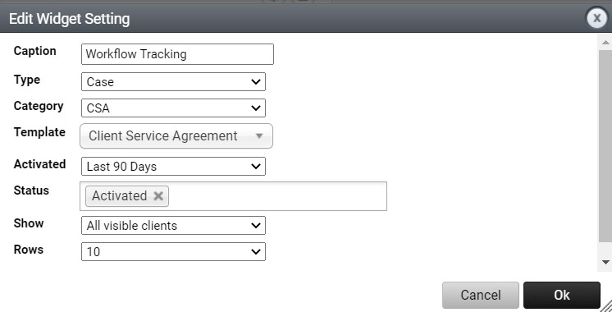

To show Cases that have been recently completed:
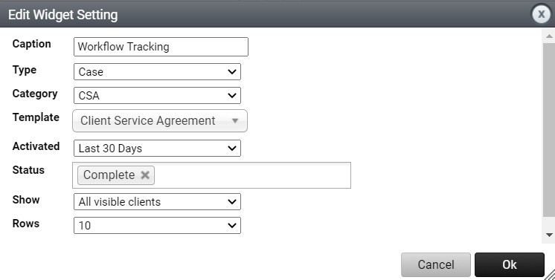

To show Cases that have been Created but not Activated:
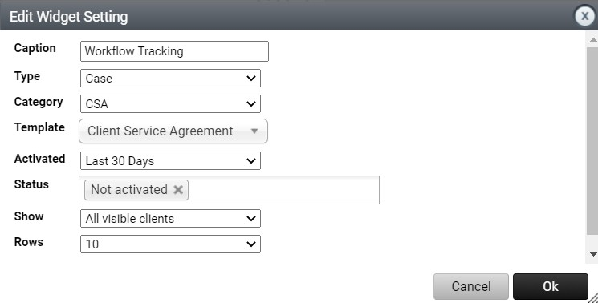

Accessing & utilising management reporting
This section provides an overview of how to access the Client Service Agreement Management Report and a brief description of each area of the report and how it may be used to manage your Client Service Agreements.

Accessing the CSA Management Report
- Navigate to the Search Clients box and select Full List
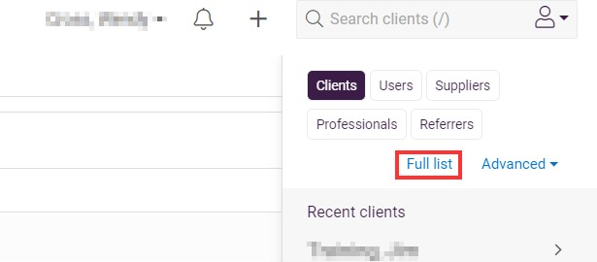

- Add Search Criteria – you have the option to add search criteria for your client list so as not to run the report across your whole client base. For example; you may select a client category from the filters screen, or you may wish to look up an Advanced Search or simply Add Criteria to create a new search at this point such as CSA Active or some other interest field.
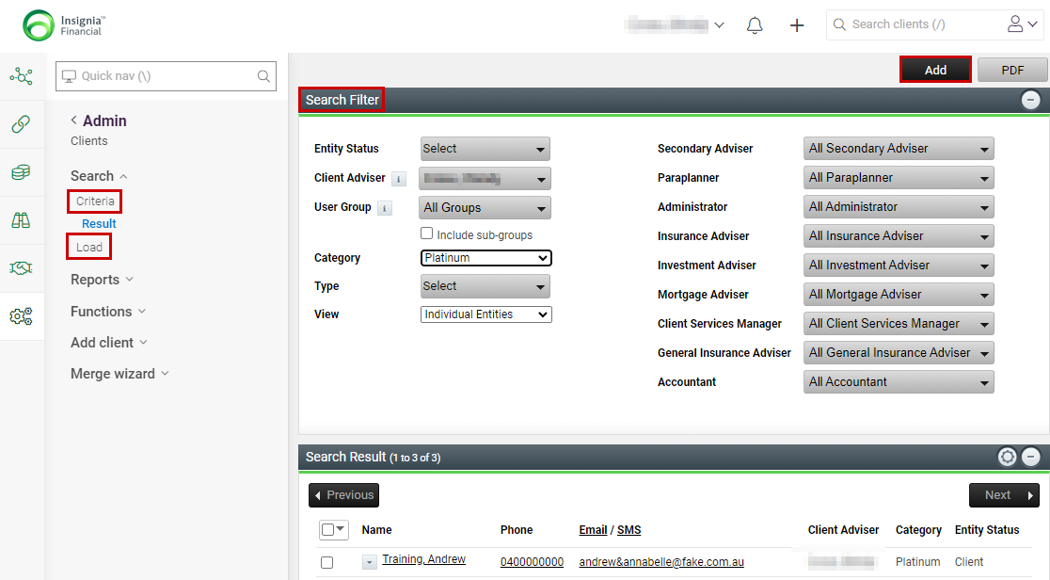
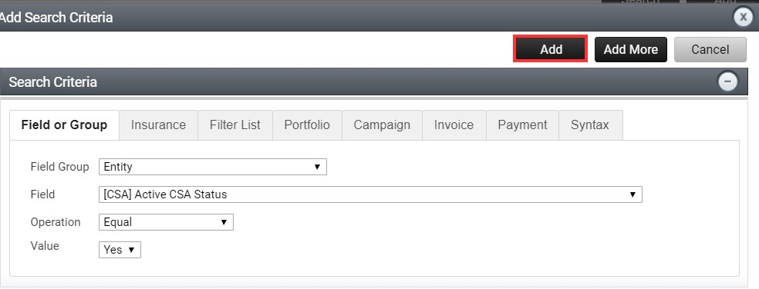
- Once the client list opens, navigate to the admin menu, and select Reports > Merge Report under Report Category choose IOOF – Management Reports and run Client Data – Client Service Agreements.
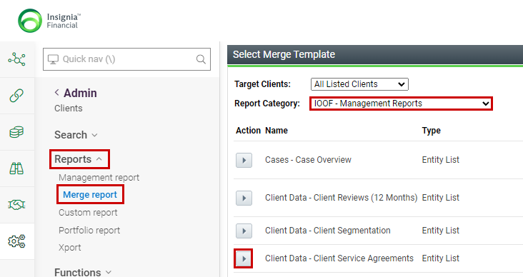

- Select Execute to generate the report.
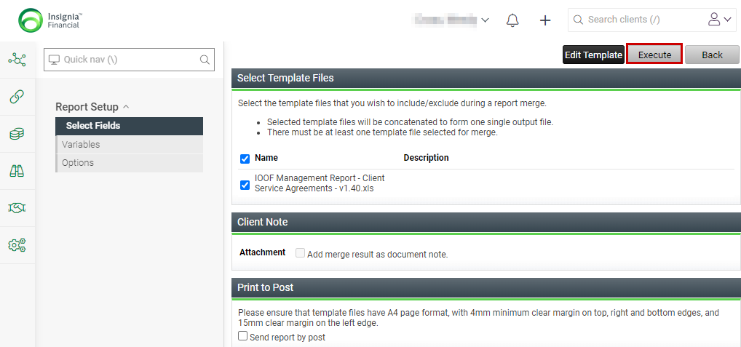

- The notification bell will highlight with a number to indicate the report is ready. Click on the Notification Bell to open the Download Report option and the report will download to an Excel file. Open the Excel file to view the report.
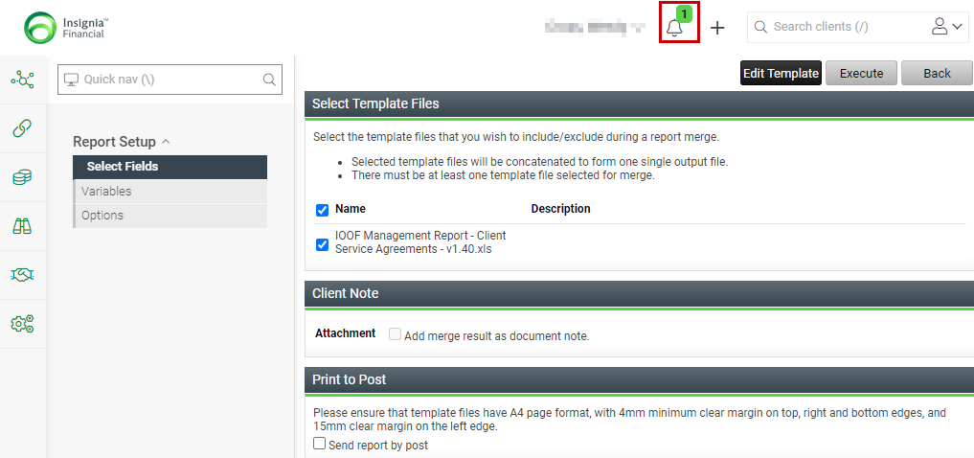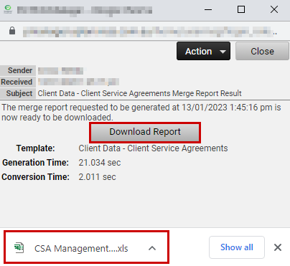

Using the CSA Management Report
The Management Report is produced into Excel and provides a series of worksheets for you to manage your Client Service Agreement deliverables, due dates and expected revenue by simply navigating to the appropriate worksheet and using the filters provided. A brief description of each worksheet available is outlined below:

Tab 1: All Cases
This sheet provides a list of all Cases that are completed or active. It excludes aborted Cases.
Use this list to review the names of the clients who currently have an active or completed CSA case across your entire database. You can also track key date information such as Service Agreement Commencement Dates, Implied Dates and whether the Signed CSA has been uploaded to XPLAN and linked to the CSA Case as well as tracking how many days until the end of the Agreement period. Also contained here is an overview of what Services have been Offered and the Status of the Services offered vs delivered.
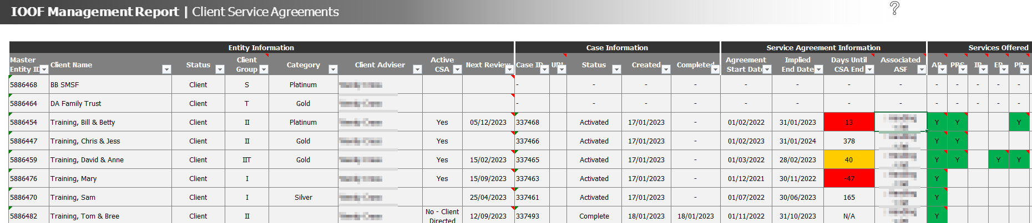
Note that as your Agreements are set at the master Client entity, you can view the related entities under the Client Group column within the report. Hover over the Client Group a comment box will open providing a legend for the different entities contained within the Agreement, as shown below.
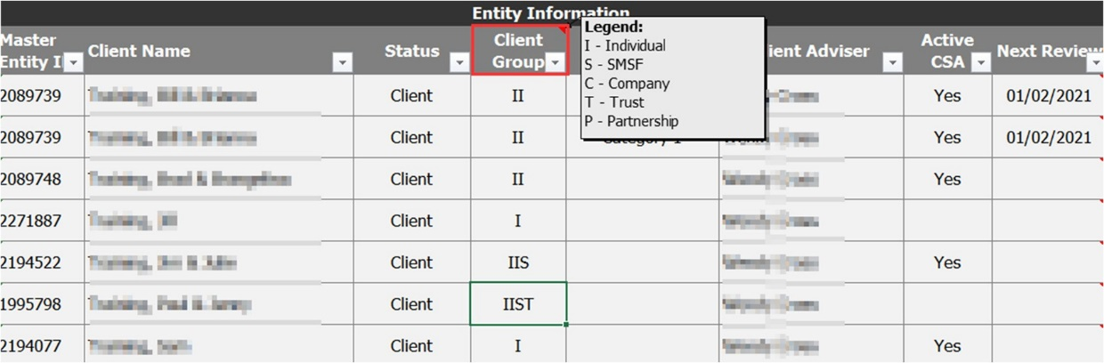

 | Important: If you have set your Agreement at the related entity level then it will NOT be picked up in the Management reporting. In this instance, you will need to take steps to Abort the Agreement and Case and redo under the Master Client entity.

You also have the option to hover over the Next Review date a comment box will open highlighting the next 5 and last 5 review dates contained in the Manage Reviews area of Xplan.
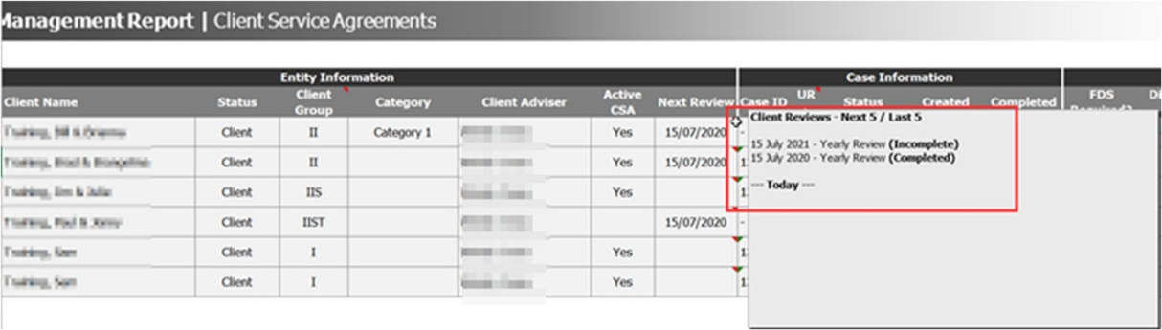

Tab 2: Service Pipeline
This sheet lists Cases within 90 days of end of agreement period, outlining any of the outstanding services that are to be provided.
Use this as a flag for clients nearing the end of the agreement and identifying services offered as part of their CSA that are still outstanding.
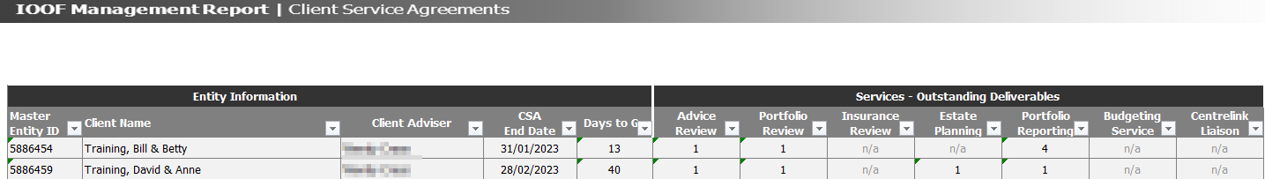

Tab 3: Fees Payable
This sheet provides a list of all fees entered into CSA’s via the Client Service Agreement Wizard with services being delivered within the next 12 months.
Note these fees are not sourced from CommPay or otherwise verified. Use this list to gauge expected revenue for the next 12 months.
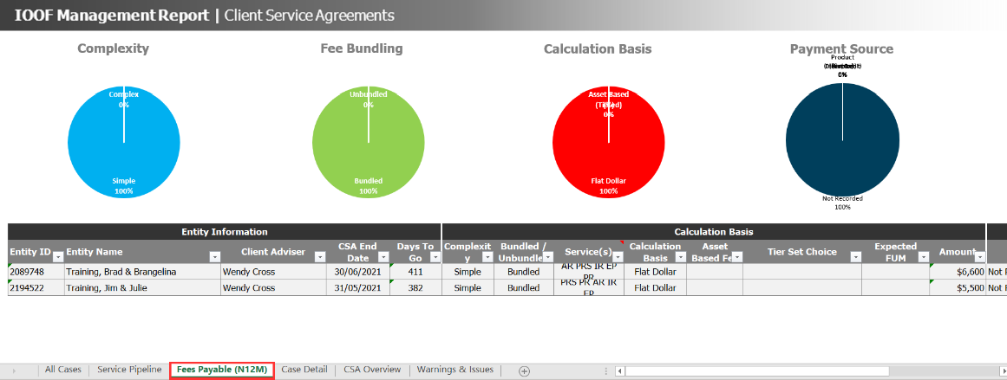

Tab 4: Case Detail
This sheet allows you to drill down into the individual CSA Cases that are open and see which benchmark items have been completed and which remain outstanding.
Use this area to track your service deliverables for each case being generated across your database.
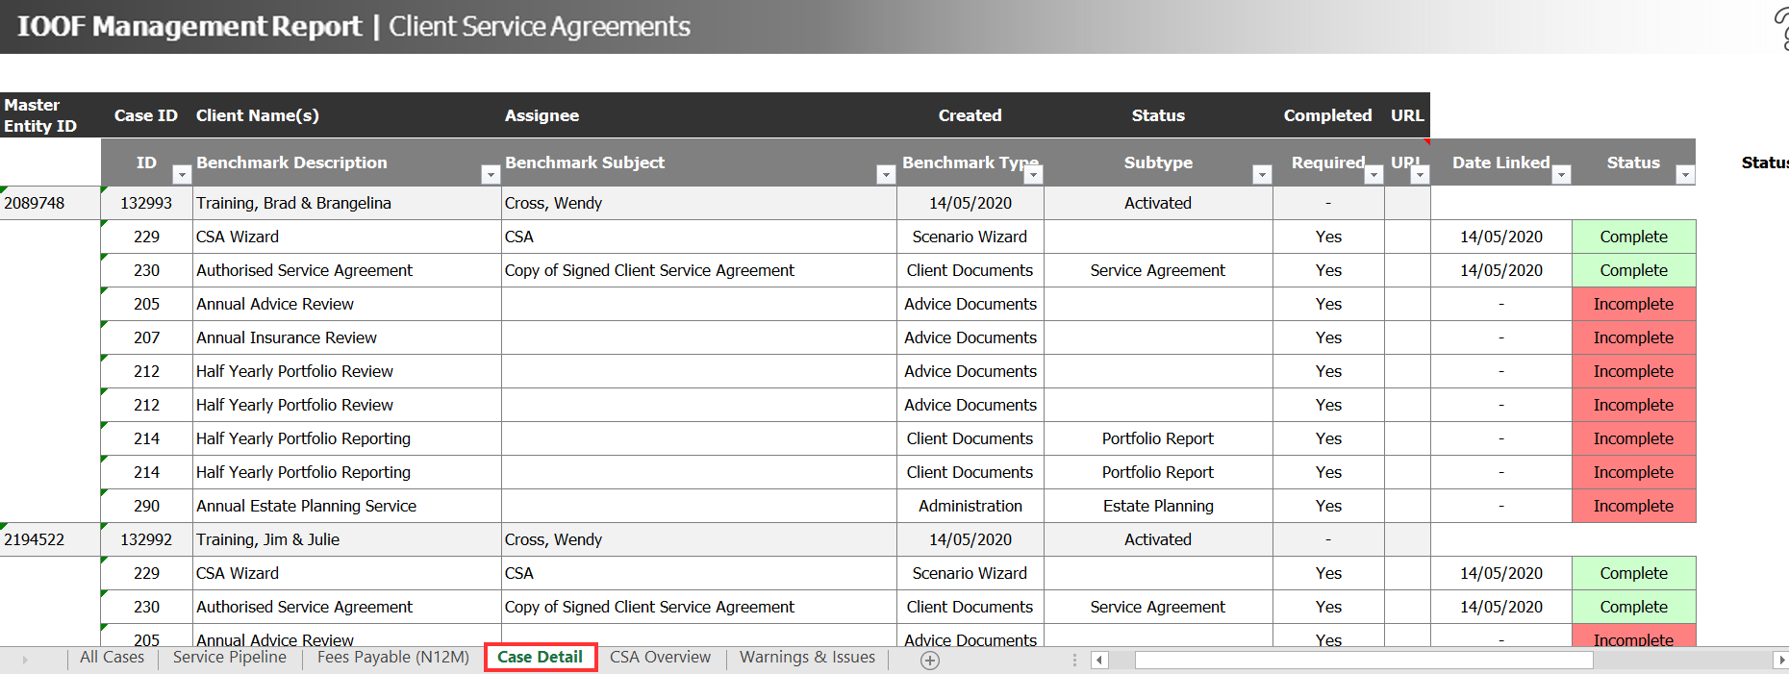

If you wish to filter down to view only those Agreements that have incomplete benchmarks, then simply select the filter option for the Status column and select both ‘incomplete’ and ‘blanks’.
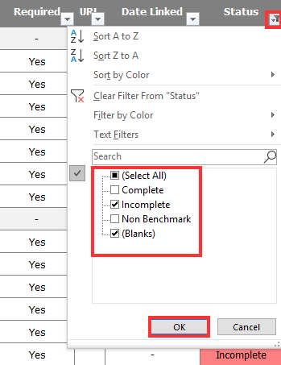

The report will then display only those clients with ‘Incomplete’ benchmark items, as shown:
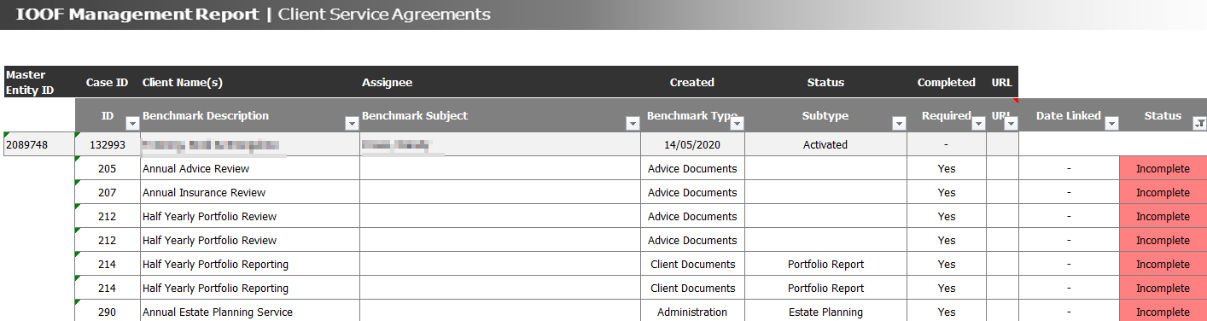

Tab 5: CSA Overview
This sheet provides a rough overview of when services you have committed to are expected to be delivered. For example, a bi-annual advice review with a CSA commenced in Jan will show the Advice Review being due June and December.
Use this area to determine and manage workflow periods within the business.
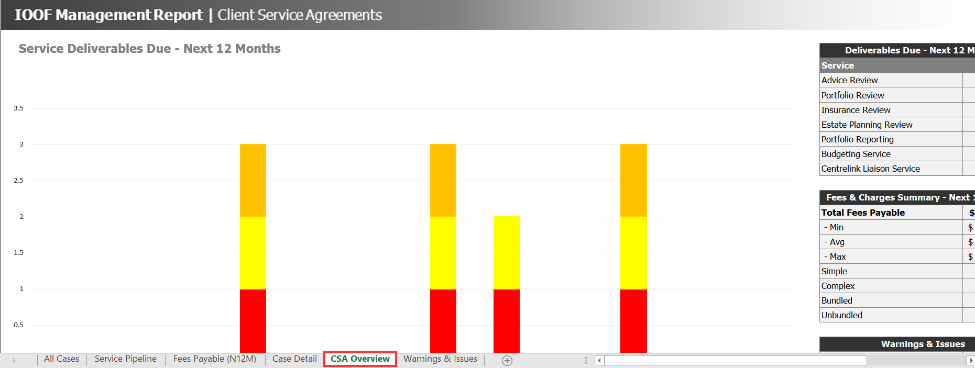

Tab 6: Task Tracking
This sheet allows you to track the progress of the Tasks associated with the CSA Case, Task 1 – Authorisations and Task 2 – Services Recorded.
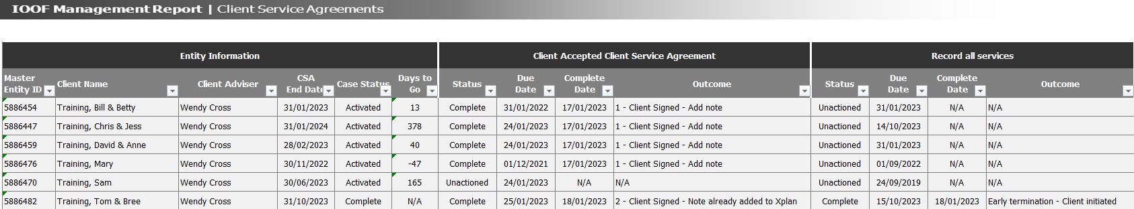

Tab 7: Warnings and Issues
This sheet allows you to identify issues with any of your generated CSA’s, allowing you to take appropriate action to manage the issue. Issues have been sorted into Critical, Minor, and Informational warnings and are detailed as follows:
- Critical Warnings identify certain issues with Client Service Agreements across your client list that do require your attention. Please review the Description and suggested Resolution. Clicking the blue hyperlink to the left will display the associated column on the 'All Cases' sheet, the filters on which can be used to show only the clients effected by each potential issue.
- Minor warnings are issues which you may wish to review. These are potential issues with your Client Service Agreements which may hinder your ability to effectively manage your requirements unless addressed.
- Informational warnings are non-critical issues which do not require your immediate attention. They simply provide a way in which you can filter your client list if you want to investigate certain issues further or ensure your CSA Cases are in order prior to an audit.
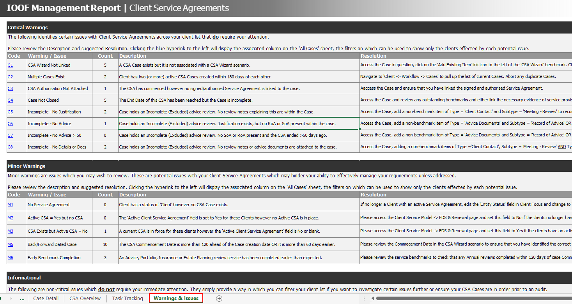

Warnings and Issues – what they mean?
Warning | Description
C1 | Although a CSA Case exists, no CSA Wizard scenario is attached to the Case. Please update the Case to ensure it is linked to the associated wizard.
C2 | Client has two (or more) active CSA Cases created and/or with commencement dates unexpectedly close to each other.
C3 | The CSA has commenced however no signed/authorised Service Agreement is linked to the Case.
C4 | The End date of this CSA Agreement has been reached but the Case is incomplete.
C5 | Incomplete – no justification. The Case holds an Incomplete (Excluded) advice review. No review notes explaining this are within the Case.
C6 | Incomplete – no advice. The Case holds an Incomplete (Excluded) advice review. Justification exists, but no RoA or SoA present within the Case.
C7 | Incomplete – no advice > 60. The Case holds an Incomplete (Excluded) advice review. No SoA or RoA present and the CSA ended >60 days ago.
C8 | Incomplete – no details or docs. The Case holds an Incomplete (Excluded) advice review. No review notes or advice documents are attached to the Case.
M1 | Client has a status of ‘Client’ however no CSA Case exists.
M2 | The ‘Active Client Service Agreement’ field is set to yes however no Active CSA is in place.
M3 | The current CSA is ‘in force’ for these clients however the ‘Active Client Service Agreement’ field is no or blank.
M5 | These Cases appear to be back or forward dated by a significant number of days.
M6 | These Cases appear to have an Annual or Half-Yearly service benchmark completed earlier than expected.
I1 | Bundled fee exists within these Service Agreements.
I2 | Fees payable for this CSA are identified as being sourced from a superannuation account (accumulation or pension).

 | - Run your report monthly to best manage your Client Service Agreements  - Add the Workflow Tracking Widget to your Dashboard – refer Widgets earlier in this guide for detailed steps.

