Client Service Agreements Xplan Guide
CSA Cases
1/07/2025

Table of contents
Managing and recording client authorisations and service delivery 2
Using Cases and tasks (workflow tracking) 2
Case workflow 4
Evidencing the authorised Agreement and Services provided 5
Evidencing multiple services with one File note 9
Marking services as not delivered 10
Completing the final Advice Review benchmark where advice document is provided outside of Agreement period 11
Fixing incorrectly linked items to benchmarks 12
To add non-benchmark items to a case (additional services) 12
Linking your practice templates to Cases 14
Re-producing, changing and aborting Agreements 15
Amending the Agreement (change to Services) 15
Amending the Agreement (no change to Services) 18
Aborting the case 18
Ending Agreements 20

Managing and recording client authorisations and service delivery

Using Cases and tasks (workflow tracking)
Using Cases and Tasks to evidence and track the delivery of your agreed services has been made available within XPLAN workflows. Upon generation of the Agreement a CSA Case and associated Tasks can be activated. The CSA Case contains a benchmark checklist of the services that need to be completed to evidence that you have delivered the agreed services within the Agreement period. The first task is to confirm whether the client has accepted the Agreement and the second task is to confirm if all services that were committed have been delivered and evidenced within the CSA Case.

Task workflow
The Task workflow requires an initial task to be completed that confirms whether the client has accepted or not accepted the Client Service Agreement.

- Navigate to Client Menu > Tasks > Client Authorised Agreement task and amend status from Unactioned to Complete from dropdown menu.
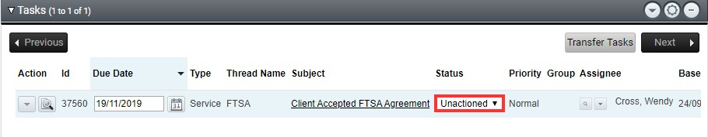
2. Within the Status screen select one of the following Outcomes:
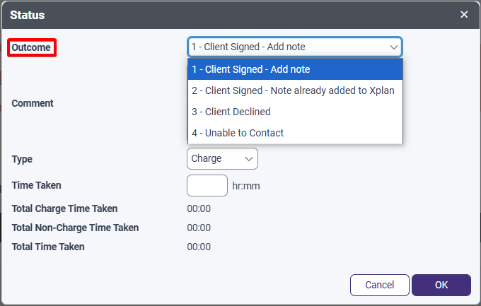
- Client Signed – Add Note – This will allow you to add the signed document to the case.
- Client Signed – Note already added to Xplan – Use this option when you have previously uploaded a signed CSA.
- Client Declined – this is the end of the process and you will need to abort the Case.
- Unable to Contact – this is the end of the process and you will need to abort the Case.
If the client signs the Agreement, the below task will appear as due 90 days prior to the CSA end date
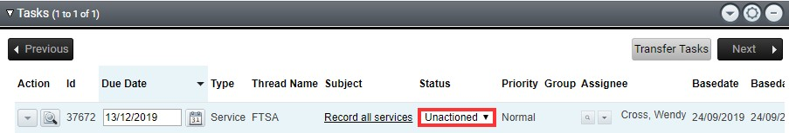

- The next task will prompt the confirmation of services delivered during the Agreement period. Within the Status screen select the Outcome dropdown menu and select the appropriate outcome for the status of your Agreement from the following options:
- All Services Delivered
- Early Termination - Adviser initiated
- Early Termination – Client initiated
- Early Termination – Deceased
- Early Termination – Unable to Contact
- No services delivered
- Some Services Missed
This task will become activated upon the completion of the first task with a due date of 270 days after the first task is marked completed. Given the first task should be completed around the Agreement commencement date this means the second task should have a due date around 90 days prior to the end date to prompt completion of remaining services.
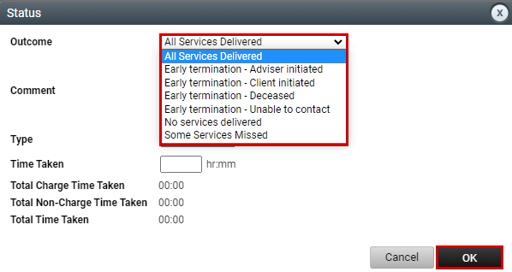
Once a selection is made this will complete the Case. In the event of early termination, the status of the Active CSA field will automatically be updated within Xplan to reflect the reason for termination.

Case workflow
Cases assist in guiding you through the end to end client service delivery including what must be evidenced within XPLAN.
1. Navigate to Client Service Model > Manage Cases to view the generated Case. Select the to edit the Case name. We recommend that you use the same name as the CSA Wizard scenario naming convention. This will allow for easy identification of Cases and their associated service periods when transitioning between Agreements.
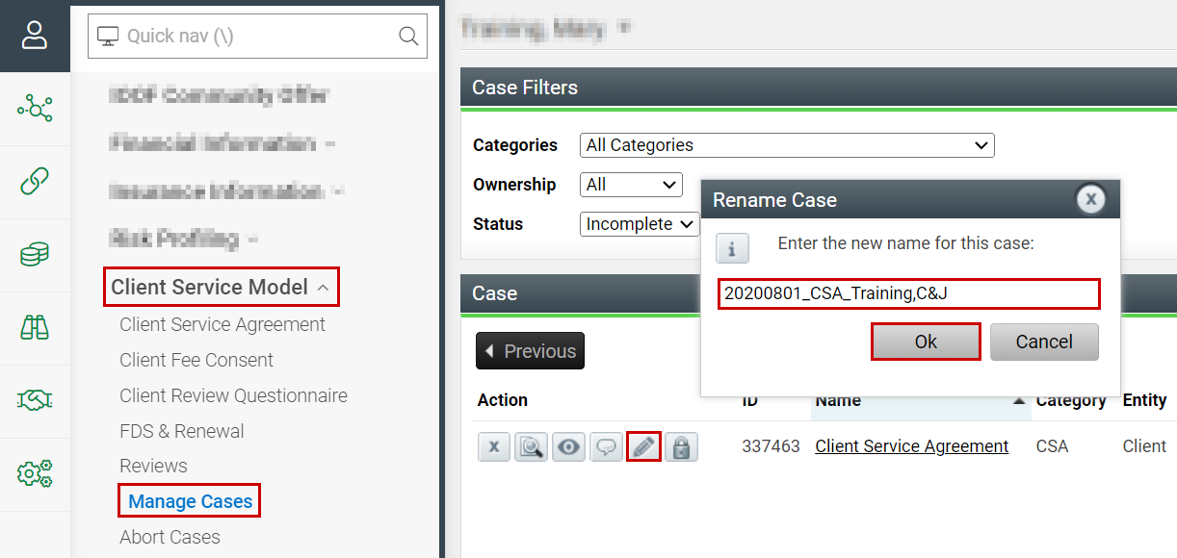
2. To view the Case Benchmark details, select the icon.
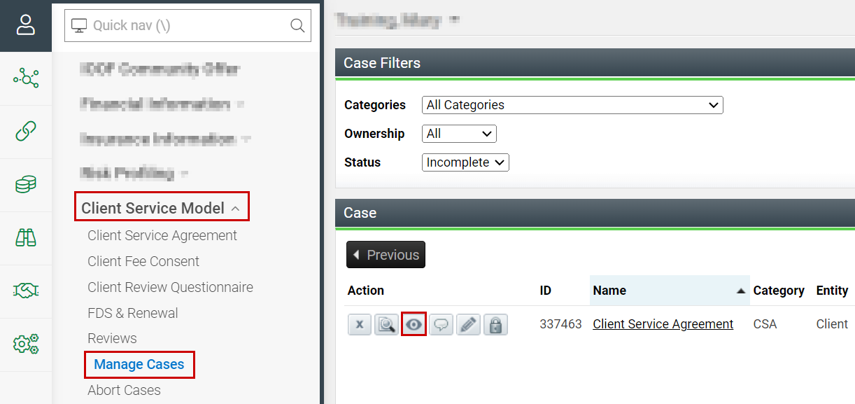

3. The Benchmarks screen displays a list of all benchmark items that need to be completed to evidence your service delivery in line with your agreement.
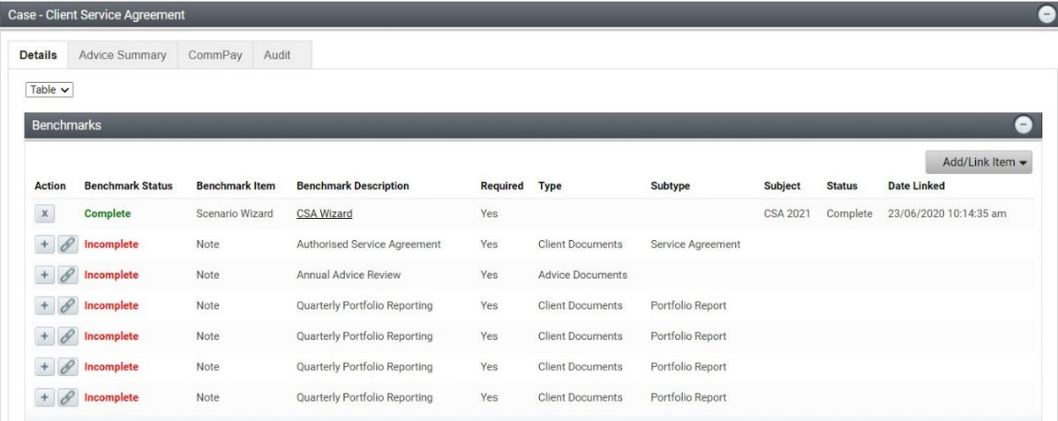

Evidencing the authorised Agreement and Services provided
Evidencing your authorised agreement and the services delivered is done by completing the benchmark items in the CSA Case at the master Client entity level. Firstly, the full and final authorised Agreement needs to be linked to the Authorised Service Agreement benchmark along with client response, followed by the uploading and linking of relevant documents to evidence services provided throughout the year.

 | Warning: Be sure that the evidence being linked to the CSA Case relates to the Agreement period. For example, an Advice Review provided as the final service under an existing Ongoing Service Agreement must not be linked as evidence of the completion of an Advice Review under the new Agreement. If this does occur, you can easily de-link as shown in the CSA Troubleshooting Guide.
Your documents should be saved in line with the File Note Type and Subtype as outlined under the Linking your practice templates to Cases section further in this guide. You should also have your preferences for the default client view in document notes set to ‘all related’.
There are several options available for you to be able to link the evidencing of your agreement and services to the CSA Case:
a. Linking documents to the Case from within the File Note
b. Adding documents to the File Note from within the Case
c. Linking documents already saved in File Notes from within the Case
Following any of these steps will ensure the linkage of the relevant documents in the Case. Instructions for each are as follows:

a. Linking documents to the Case from within the File Note
1. Navigate to the applicable Client > File Notes > Add
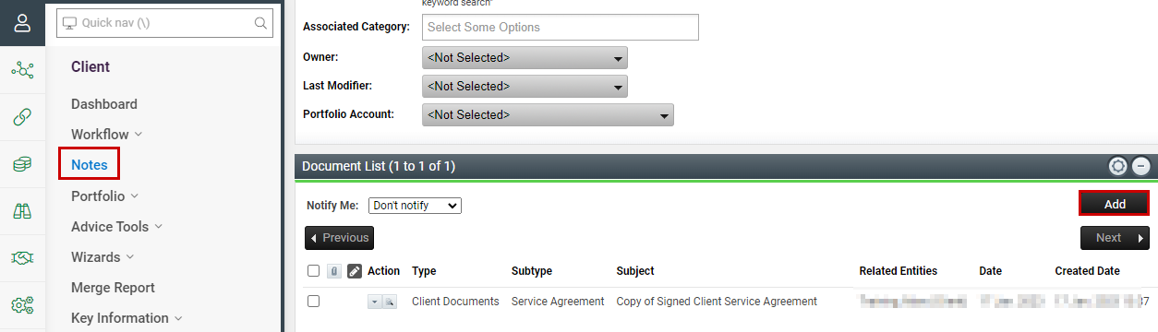

2. Select the Type and Subtype applicable to the document you are wanting to load for the service being provided.
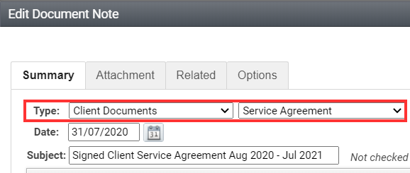

3. Upload the document to the Attachment tab.
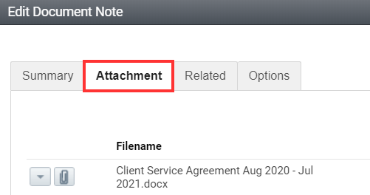

4. Select the Options tab and click into the Case box and select the Client Service Agreement option. Select Save and Close
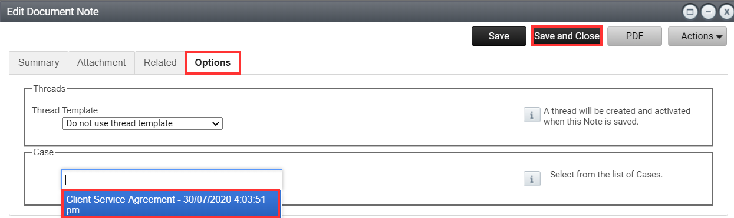

5. The associated benchmark item within the Case will now be updated to complete.
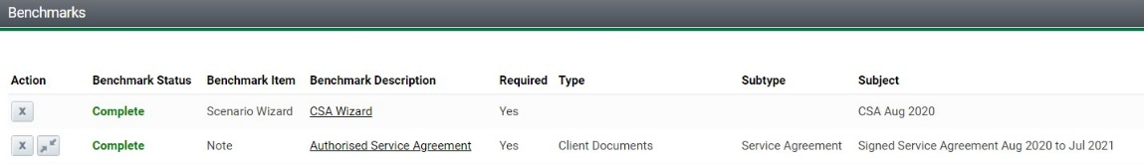

Editing existing File Note
Where you have existing File notes saved that you are yet to link to the Case, you can simply edit the File note to select the Options tab and select the Client Service Agreement.
1. Navigate to the applicable Client > File Notes and select and open the file note containing the document you wish to link to the Case.
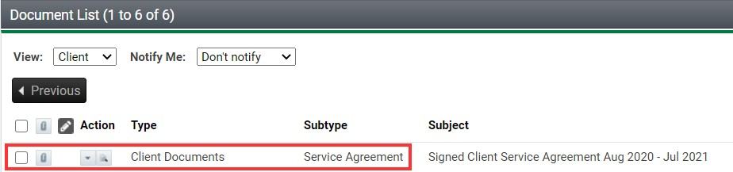
2. Select the Options tab and click into the Case box and select the Client Service Agreement option. Select Save and Close.

3. The associated benchmark item within the Case will now be updated to complete.
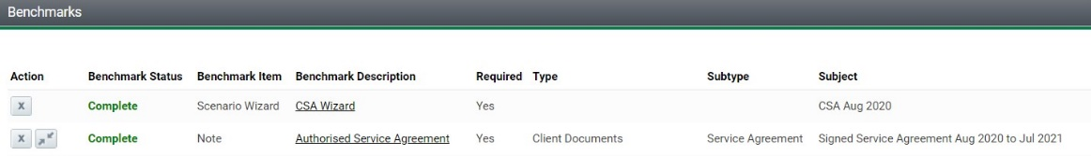

b. Adding Notes from within the Case
1. The button next to a Benchmark lets you add a new item to the Case relevant to that Benchmark. Select the icon to Add a Note.
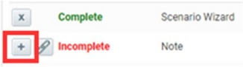

2. This will start a File Note with the appropriate Type and Subtype related to this benchmark item. Then add note details as you would normally complete a note. Select Save and Close
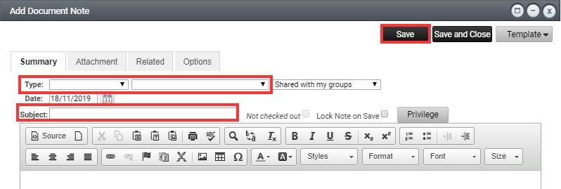

3. The associated benchmark item within the Case will now be updated to complete.
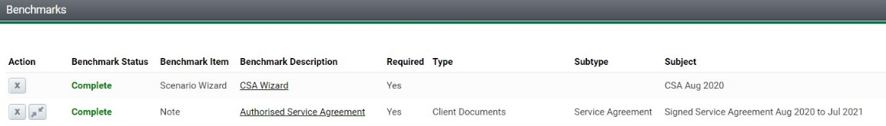

c. Linking existing Notes from within the Case
1. The button next to a Benchmark lets you link an existing item (e.g. a File Note you previously created) to the Case. Select the Link icon to Link an existing File Note already entered within the system.
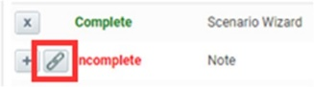

2. Each benchmark item has been mapped to the file note framework, so your existing notes should appear here if saved in line with the file note framework – refer File Note Framework Guide available on your intranet. Tick the box next to the note you wish to link and select Ok.
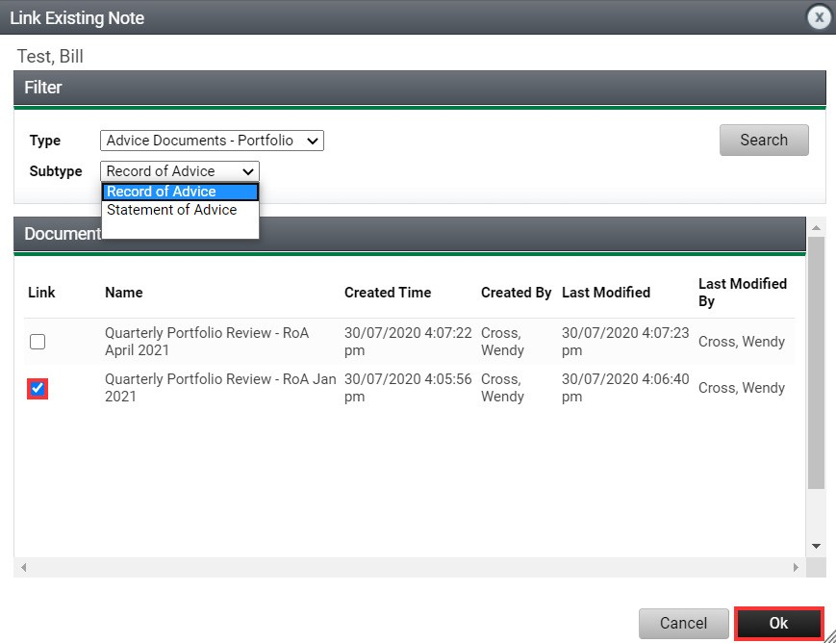

3. The associated benchmark item within the Case will now be updated to complete.

Evidencing multiple services with one File note
Where you are delivering multiple services in one meeting, for example an Annual Advice Review where you’re also reviewing the client’s insurances and portfolio and these services are all covered by a single RoA or SoA, XPLAN currently does not allow you to link one advice document to multiple service benchmarks.
In this situation, the advice document should be linked to the main service in this case the Annual Advice Review. The other Service benchmark items will need to be closed out by selecting the Comment button.
1. Select the Comment button

2. The Comment field will open, where you can explain that the service was provided as part of another service and refer to that benchmark for evidence. Then select the tick box to exclude this incomplete (Required) listing from the benchmark set to enable the Case to close upon completion of the second task. Select Save
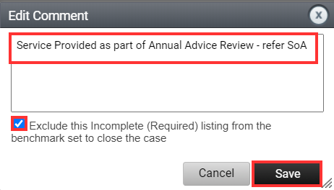

3. The benchmark item will then be updated to Incomplete (Excluded)

Marking services as not delivered
Where a service is not delivered, you can close out the associated benchmark item by selecting the Comment button.
1. Select the Comment button

2. The Comment field will open, where you can enter the reason for the service not being provided. Then select the tick box to exclude this incomplete (Required) listing from the benchmark set to enable the Case to be closed when the second task is completed. Select Save
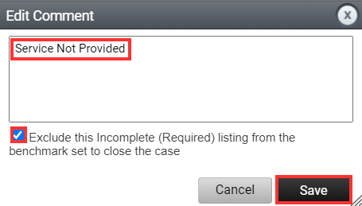

3. The benchmark item will then be updated to Incomplete (Excluded)

Completing the final Advice Review benchmark where advice document is provided outside of Agreement period
In limited circumstances, where a Review meeting is held prior to the end of the Agreement period and the Advice document is yet to be provided, you can close out the Case using the following steps:

1. Select the Comment button

2. The Comment field will open, where you can enter the reason for excluding the benchmark as ‘Review meeting held, advice document to be provided’. Then select the tick box to exclude this incomplete (Required) listing from the benchmark set to enable the Case to be closed when the second task is completed. Select Save
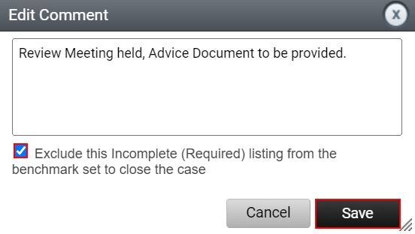

3. Upload a copy of the Review Meeting Notes to a Non-Benchmark item by selecting the Add/Link button on the righthand side.
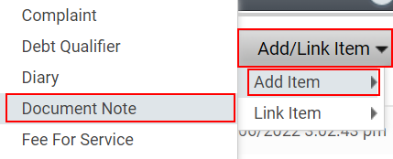

4. Complete Task 2 to allow the Case status to complete.

5. Once the Advice Document has been provided, navigate to the Completed Case, and upload a copy as a Non-Benchmark item by selecting the Add/Link button on the righthand side. Your completed Case should then look as follows:
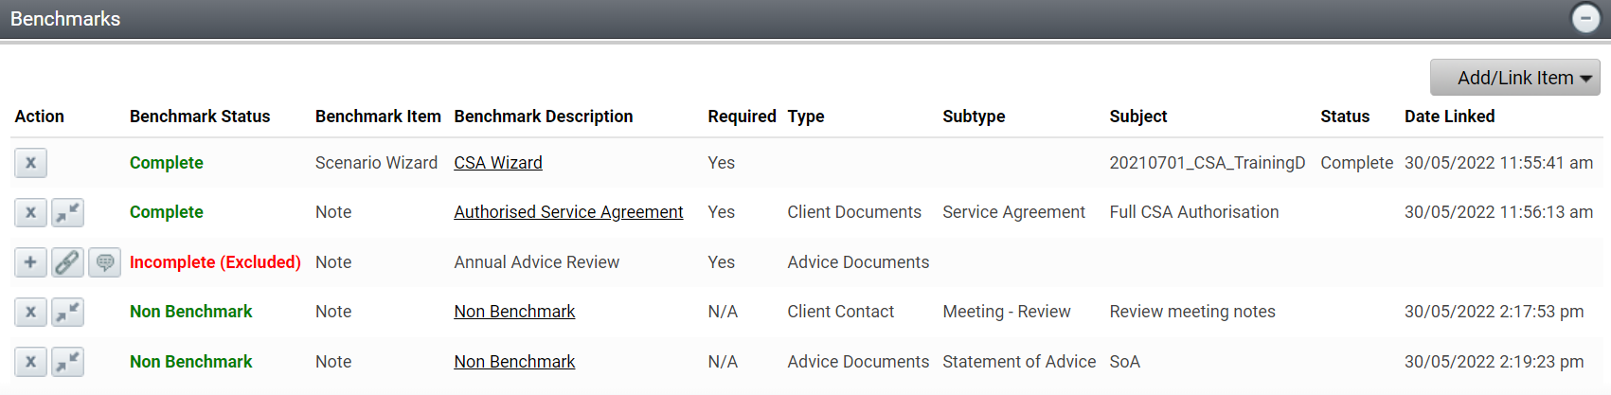

Fixing incorrectly linked items to benchmarks
If you should upload/link an incorrect item to the benchmark in the Case, you can simply de-link the item from the benchmark by selecting the and confirming that you wish to remove the item from the Case (it will not delete the item altogether). The benchmark status will then move back to incomplete. You can then simply add/link the correct item to the benchmark to complete the benchmark.

To add non-benchmark items to a case (additional services)
If you deliver Additional Services throughout the service period, you can add/link these to the Non- Benchmark items within the Case – this won’t affect your ability to close the case however allows you to keep all evidence points of service delivery in the same Case.

1. Navigate to Non-Benchmark area and select Add/Link Item > Add Item or Add Link
- Add Item allows you to create a note and upload attachments from within the Cases screen.
- Add Link allows you to select an existing note to the Case
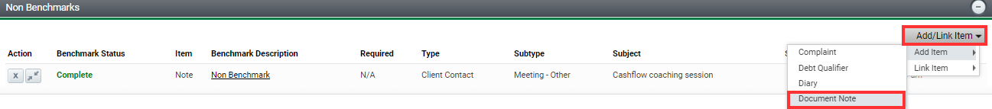

2. Selecting the Add Item, allows you to create a note and upload attachments from within the Case screen.

3. Selecting the Add Link, allows you to link an existing note to the Case. The note must be saved as the correct Type and Subtype in line with the File Note Framework – refer File Note Framework Guide on AdviserONE.
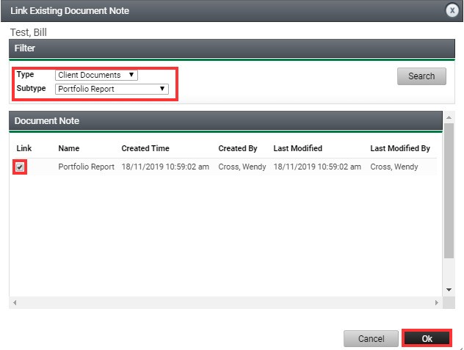

4. Alternatively, as you’re saving the File Note you can opt to link directly to the Case via the options tab – refer Linking documents to the Case from within the file note section outlined earlier in this guide.

 | Setup Outstanding Task and Workflow Tracking Widgets to track your Task and Case workflow – refer the CSA Xplan Guide – Management Reports for further guidance

Linking your practice templates to Cases
Workflow management using cases is a key component of managing your Client Service Agreements. Cases are covered earlier in this guide however it’s important to know that they have been designed with the flexibility for you to use relevant existing file note and email templates your practice may have to help you demonstrate how you have delivered your services.
To streamline the linking of file notes to service delivery within the Client Service Agreement case, you will need to ensure your templates are set with the correct file note types and subtypes as follows:
Service/Benchmark | Note Type | Note Subtype
Authorised Service Agreement | Client Documents | Service Agreement
Advice Review | Advice Documents | Statement of Advice or Record of Advice
Portfolio Review | Advice Documents – Portfolio Review | Statement of Advice or Record of Advice
Insurance Review | Advice Documents – Insurance Review | Statement of Advice or Record of Advice
Portfolio Reporting | Client Documents | Portfolio Report
Budgeting Service | Administration | Cash Flow Management
Centrelink Liaison Service | Administration | Social Security
Estate Planning Review | Administration | Estate Planning

File note templates
Within your file note templates, review and save the appropriate type and subtypes as shown.
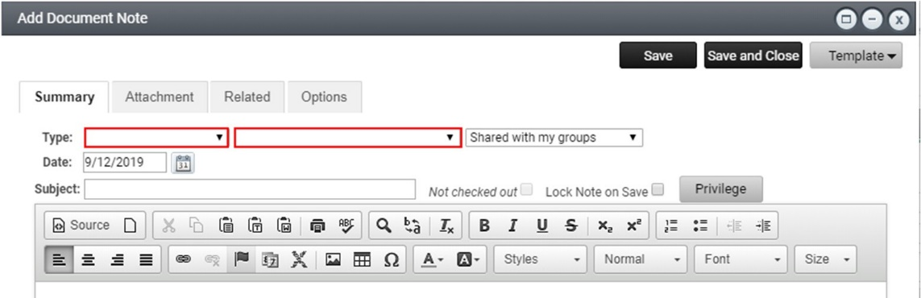

Email templates
Your relevant email templates also may need to be adjusted by navigating to Admin > Site > Templates > Email Templates. Proceed to the miscellaneous tab to adjust the type and subtype:
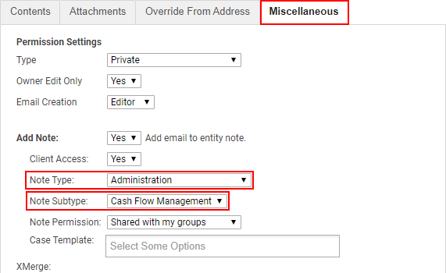

Once the templates match the File note framework options, you will need to contact Practice Support to link it to the Client Service Agreement Case. Please include the location and name of your template as well (screen shots help!).

Re-producing, changing and aborting Agreements
This section of the guide deals with re-producing or making changes to an Agreement in instances where you have agreed with your client a change to the services and/or fees or they don’t wish to proceed with the Agreement.

Amending the Agreement (change to Services)
Where a client has requested to change the services in the final generated Agreement, a new Case will need to be generated in order to adjust the Service benchmarks in the Case. You will need to firstly delink the CSA Wizard scenario and any other completed services from the current Case and then abort the Case before going back into the CSA Wizard scenario and making any changes to the services offered as outlined below:

1. Navigate to the associated Case and Delink the CSA Wizard scenario by selecting the icon and then selecting OK to the question do you want to remove this item?
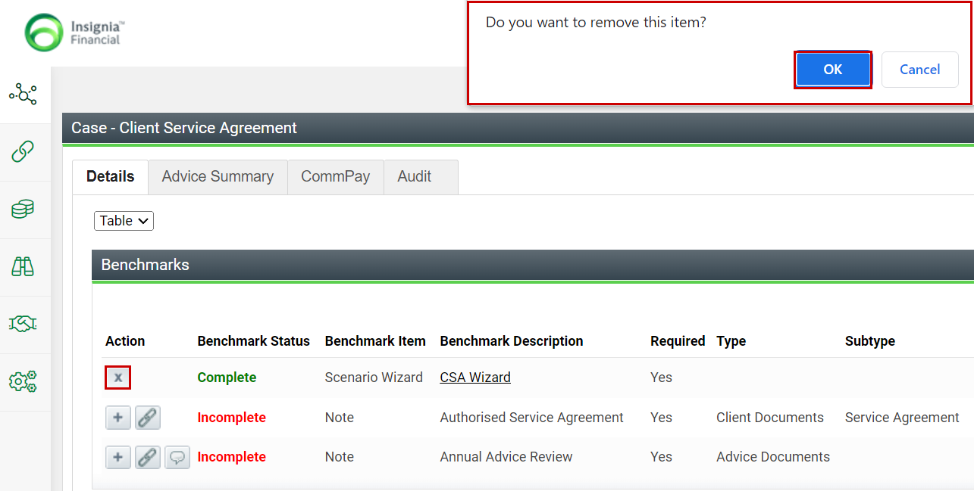

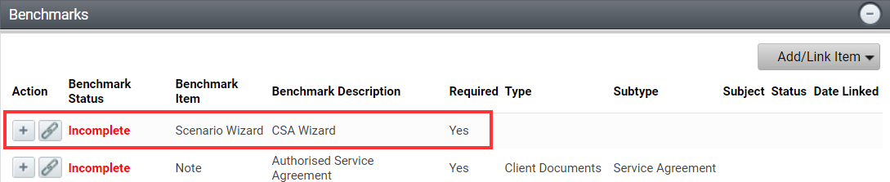

2. Once the CSA Wizard scenario and any other completed benchmark items have been de-linked, the Case is ready to Abort – refer Aborting the Case further in this guide.

3. Once the Case has been Aborted, navigate back into the CSA Wizard scenario, and amend the details of the services in the existing Agreement to fit the new Agreement requirements, and generate a draft Agreement to check details. When ready, generate a final new Agreement by selecting the Amend existing CSA (service changes) – case generated to initiate a new Case.
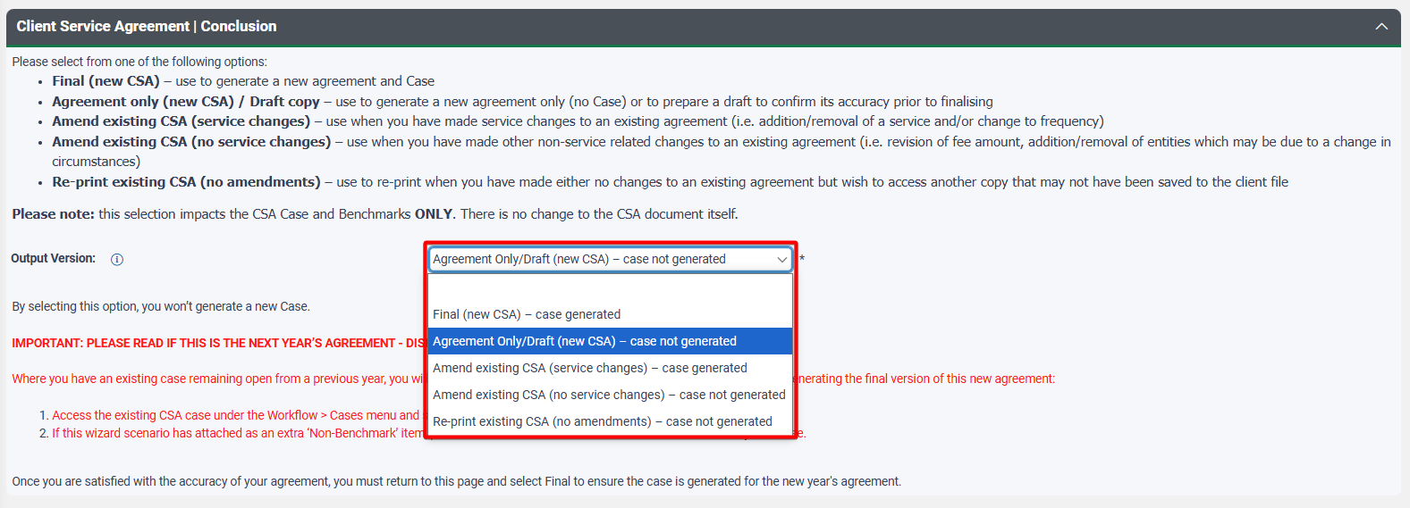
4. Navigate back to Cases and filter by all Cases so you can see both the newly activated Case and the aborted Case, as shown.
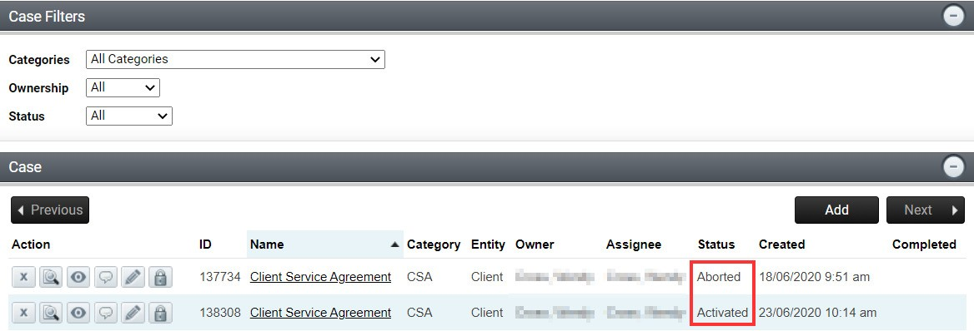

5. Select the icon of the newly activated Case to open the Benchmarks screen and confirm that the amended CSA Wizard scenario benchmark has been automatically linked and completed. If not, select the to link the CSA Wizard scenario to that benchmark item.
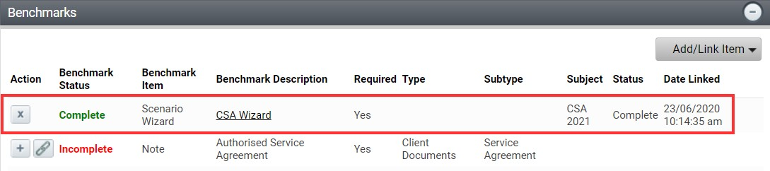

6. Once done, you can proceed with the completion of Benchmark items and Tasks as normal.

Amending the Agreement (no change to Services)
Where you wish to make an amendment to an existing Agreement that does not require a change to the Services offered, you can simply make the adjustments in the CSA Wizard scenario and then select Amend existing CSA (no service changes) – case not generated to generate your amended Agreement without instigating a duplicate CSA Case.

At any time you wish to simply re-print an existing Agreement, select Agreement only (new CSA) / Draft Copy – case not generated or Re-print existing CSA (no amendments) – case not generated and this will allow you to generate the Agreement without generating a duplicate Case.

Aborting the case
Where a client does not go ahead with a Client Service Agreement or requires a change to the Services in the Agreement and a Case has been generated, you will need to abort the Case so that it no longer appears as ‘Incomplete’ on the system. Any Tasks associated with the Case will also be aborted through this process.
1. Navigate to the associated Case and Delink the CSA Wizard scenario and any other completed benchmark items by selecting the icon and then selecting OK to the question do you want to remove this item?
The delinked benchmark will revert to incomplete status.

Once all items have been delinked the Case is ready to be aborted. Navigate to the Client Service Model Menu > Abort Cases and select the action dropdown arrow and select Abort.
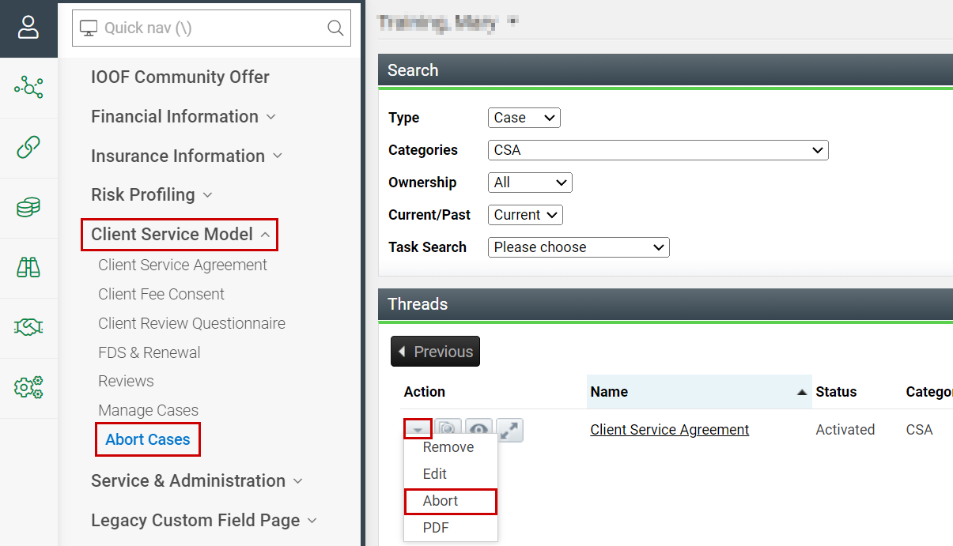

This will also terminate the associated Tasks.

Ending Agreements
You must terminate an Agreement:
- on request from the client
- upon being notified or made aware of the client’s death – in line with the guidance below
- upon being notified or made aware that a client has lost mental capacity and no valid Enduring Power of Attorney is in place – in line with guidance below
- upon becoming aware you cannot deliver to the terms of the Agreement
- where you terminate the Agreement with 30 days-notice (including under instruction from the Licensee)
- under any other event stipulated in the Agreement.
In these circumstances outstanding items should be reviewed to evaluate services that have/have not been completed in accordance with the Refunds section of the Fee for Advice & Service standard and Early Agreement Termination and Refund Guide.
Client Fees need to be turned off and the Active CSA status field within Xplan should be updated to No. Where the Record all Services Task has been completed to reflect the early termination, the active CSA status field will automatically be updated to No and the reason, e.g. No - Unable to contact.
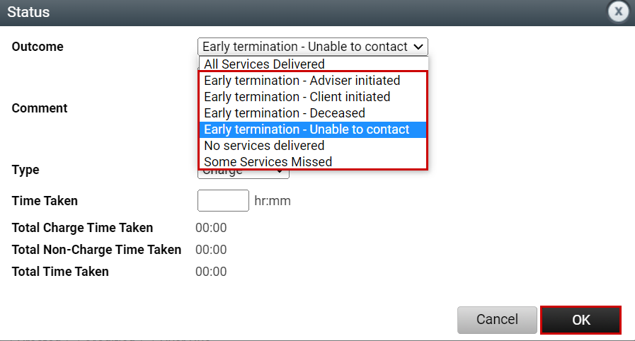
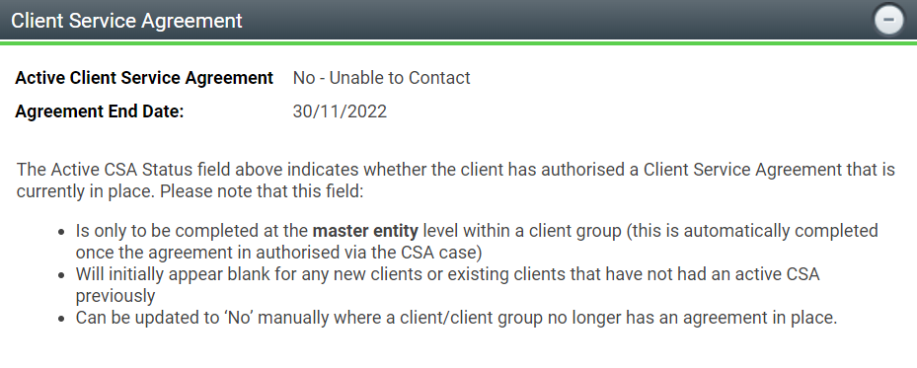

To manually update the Active CSA status field, within the Client Menu navigate to Client Service Model > Opt-in and FDS/FDS and Renewal and select Edit.
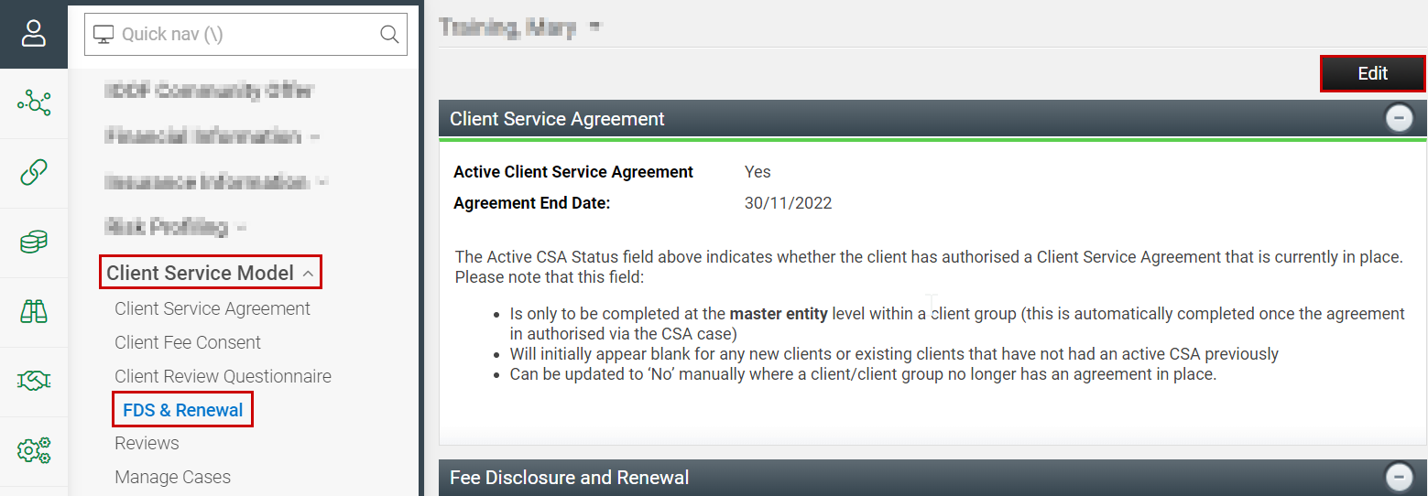

Select the Active Client Service Agreement dropdown menu and select the appropriate reason for the early termination. Ensure that the FDS/CSS Required section has also been updated to No. Select Save.
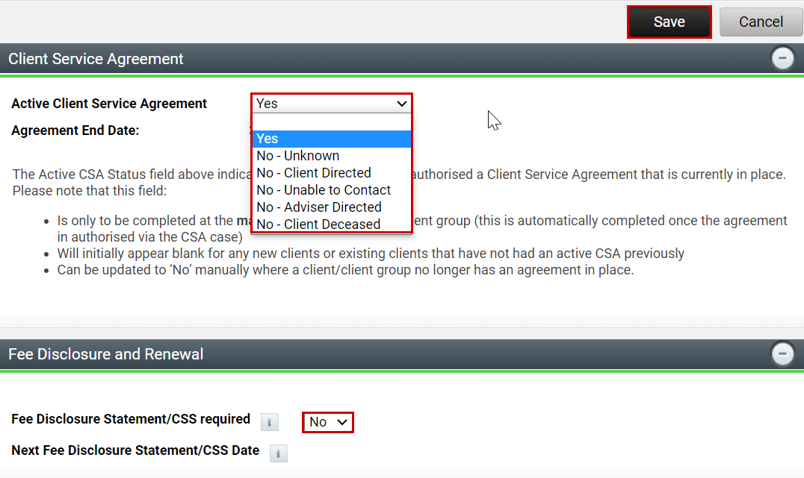

Where some or all services have not been provided follow the steps for Marking Services as not delivered section and ensure that you select the appropriate outcome in Task 2 ‘Record all services’ and the Case will be completed.

Case Benchmarks

Case benchmark – file note types and subtypes
Case Benchmark | Note Type | Note Subtype
Authorised Service Agreement | Client Documents | Service Agreement
Advice Review | Advice Documents | Statement of Advice or Record of Advice
Portfolio Review | Advice Documents – Portfolio Review | Statement of Advice or Record of Advice
Insurance Review | Advice Documents – Insurance Review | Statement of Advice or Record of Advice
Portfolio Reporting | Client Documents | Portfolio Report
Budgeting Service | Administration | Cash Flow Management
Centrelink Liaison Service | Administration | Social Security
Estate Planning Review | Administration | Estate Planning

